A Recommender System for Learning Resources Suggestion Based on Learner Characteristics
Pranay Das¹ and Dr. Rajendra B. Patil²
Student¹ and Head², Department of Information Technology, S. K Somaiya College of Science, Arts & Commerce, University of Mumbai, Mumbai
Abstract
Advances in Information Technology (IT) have explained data inadequacy, yet another issue has been achieved: data over-burden. One of the most suitable techniques to manage this issue is the utilization of recommender frameworks. A recommender framework can be utilized as an apparatus to help and in any event, for basic leadership. In spite of the fact that it can prescribe the fitting instructive assets in e-learning framework for the students, with the goal that they would have the option to pick the best instructive substance, however as indicated by the ongoing investigations, such a recommender framework has once in a while been utilized in e-learning. A recommender framework dependent on synergistic separating approach is acquainted in this examination with prescribe the reasonable assets to the students and in this way spare their valuable time and encourage the learning procedure. In this examination, two gatherings of students are chosen from the equivalent instructive level. The principal gathering will be given no suggestions at all and they themselves need to pick their instructive assets. Be that as it may, the subsequent gathering will be upheld by the proposed recommender framework so as to choose their proper assets. The acquired outcomes show that the students in the subsequent gathering, who had been bolstered by the recommender framework, outflank the principal gathering and have an unrivaled learning experience.
I. INTRODUCTION
The incredible volume, yet developing measure of data on the web makes it difficult for clients to get the correct data, information and items. This issue has propelled the specialist to figure out how to beat this issue known as 'data over-burden'. One of these arrangements is the utilization of recommender frameworks [1].
There are different definitions for recommender frameworks. Liang thinks about RS (recommender framework) as one of the subcategories of DSSs 1 [2]. He characterizes them as data frameworks that can break down the past conduct to give proposals for the present issues.
1 Decision Support Systems
In another word, in recommender systems it is tried to predict the user‘s way of thinking (with the help of collected information from his/her behaviour or similar users‘ behaviour) to identify and suggest the most suitable and closest product to his/her taste. In fact, these systems simulate the same procedures in our daily lives and automatically implement them [3]. The people with tastes similar to ours are found and asked for their opinions about our selections. Suggestions that are recommended by the system can have two primary results: The first result is helping users for decision making (for example, which one of the options you have is good for you to pick). The second is increasing the awareness of the user about the items he/she is in search of (for example, the recommendations introduce new products to the user which he/she was not aware of before) [4].
1. Motivation: As per the past inquires about, recommender frameworks are once in a while utilized in e-learning. By the developing improvement of e-learning, the utilization of recommender frameworks is getting inescapable. Utilizing the recommender frameworks in e-learning has extraordinary potential. Offering discussions to the students, suggestions to teachers and scoring each movement of students are a few areas that recommender frameworks can be utilized in.
In the learning procedure, choosing the correct assets has direct effect on the learning. So one of the fundamental issues is offering the correct assets as indicated by the student attributes in the most brief time conceivable.
2. Contribution: As recently referenced, one of the fundamental issues of the students in e-learning frameworks is choosing the correct assets without sitting around and vitality. To take care of this issue and to spare time, a site is structured.
This site proposes suitable instructive assets to the clients by utilizing a synergistic separating suggestion strategy and in this manner spares time and decreases disarray of the clients. In this exploration, two gatherings of clients sign in to the framework inside explicit time interims.
The principal gathering will step through the exam subsequent to choosing three assets and remarking about them and will log out of the framework at last. The outcomes from remarks of the main gathering will be utilized for the second gathering that will sign in to the framework seven days after the fact without approaching the framework assets. Be that as it may, the framework will propose the assets to the objective clients by discovering 3 comparable clients from the main gathering. The framework will offer tests to the two gatherings.
The consequences of this task will show whether the students concentrating with self-managed learning strategy (first gathering) can have a superior comprehension or the students getting proposals from the framework (second gathering).
II. BASIC THEORY
It is important to think about the ideas beneath so as to comprehend the recommender framework.
Target User (Main User): In recommender framework, the client for whom the present recommendation is being handled and arranged in the framework is known as the dynamic client or the objective client [5, 6].
Self-managed learning technique: Self-paced or individualized learning is characterized as the learning guided by the people so as to meet individual learning destinations. In self-managed learning, the substance, learning grouping, the pace of learning and conceivably even the media are controlled by the individual [7].
Recommender framework: The development of the web and the quick conveyance of data on the web will offer ascent to the data over-burden. For this situation, the client can't oversee, get and update the accessible data on the web [8]. One of the answers for this issue is the recommender framework. These frameworks are attempting to display client's preferred data or assist them with customizing their encounters of the net. Recommender frameworks are commonly isolated into three classes: content-based strategy, information based technique and synergistic sifting strategy. There can be a fourth technique under the name of “hybrid recommender system” [9].
Cooperative Filtering Method: A methodology in recommender frameworks is utilizing CF or shared separating. In this methodology, rather than utilizing the substance of things, the conclusions and rankings proposed by different clients will be utilized for suggestions. At the end of the day, recommendations will be delivered by computing the similitude among interests and choices of the objective client and different clients [10].
User-based method: Client based technique is one of the most celebrated strategies for prescribing. Thing based technique: In Item-based strategy as opposed to utilizing the relationship among's clients and assessments of comparative clients, thing connection will be determined in a comparable way [11].
At that point, things like what the client was keen on before will be suggested. A significant point about this strategy is that not normal for the substance based techniques, things like the previous things that the client was keen on will be given without utilizing the substance of things and just by utilizing clients' intelligent information [12, 13].
III. RELATED WORKS
Recommender frameworks are compelling frameworks in directing and driving the client through the incredible volume of accessible alternatives toward the most alluring choice with the end goal that the system is customized uniquely for a specific client. CF calculations are one of the significant procedures to make proposal, since they don't fit in the area of things. The clients' propensities are communicated by things rate and suggestions are determined dependent on memberships of comparable clients. The specialized issues of this strategy are: cold beginning issue and shortage issue [14].
At the point when the framework doesn't have any data about the client interests, it can't give any suggestions. The explanation is that possibly the quantity of individuals that rate a thing in a specific base is exceptionally little comparative with the absolute number of things. This implies there is no particular similitude among clients and the nature of suggestion is low [15]. The sites like digg.com, reddit.com and Balatarin.com have recommender frameworks that gather and procedure remarks of clients, at that point channel them and offer them to the possibly intrigued clients. This is called “collaborative filtering” [16].
Likewise numerous strategies have been created to make a flexible web (versatile web). These techniques attempt to change and arrange the website pages progressively as per clients' inclinations.
Utilizing the recommender systems‖ in web is another methodology which is the premise of this exploration. Recommender frameworks are known as an instrument that encourages residents in utilizing the web. By utilizing recommender frameworks, one can look for the ideas that are not reachable by typical looking through procedures in electronic training [17].
IV. SYSTEM DESIGN
Confronting a wide scope of choices makes clients look for proposals. Recommender frameworks with community oriented separating discover the entirety of the choices that are as per clients interests. In this segment the recommender framework engineering for electronic training will be clarified. As should be obvious in Fig 4.1, the design of the recommender framework comprises of three significant parts: students, community oriented separating unit and learning assets. This framework has two sub-frameworks.
1. Examination of the students from first and second gatherings: Each gathering has 30 members in this investigation. These 60 people, who are signing into the framework during seven days, are the typical students and don't have any unique attributes. The assets in the site are not specific and they can be utilized by general students. These ten assets are about the ―hardware ergonomic‖ and they are recommended by a specialist.
The students of the two gatherings sign into the framework independently. The students of the primary gathering got into the framework in the main seven day stretch of April. The principal bunch didn't get any proposals from the framework and utilized the ―self-paced learning‖ method. The second gathering simply contemplated the assets that were prescribed by the framework.
The technique for prescribing relies upon the measurable qualities and social investigation of the previous students. This implies the framework will help the students by finding comparable students and prescribe the assets to them. In the main seven day stretch of April 2011, 30 students of the primary gathering got into the framework. In the second seven day stretch of April 2011, 30 students of the subsequent gathering got into framework.
2. Investigation of the assets in the framework: In this framework, 10 assets are accessible to the students. These assets are noticeable just to the primary gathering. Students ought to pick the correct assets that are identified with the fundamental idea. The fundamental idea is about appropriate utilization of equipment, for example, mouse, screen, console, and so forth. A dynamic is expounded on it in the area of "assets", so students can understand it. In the wake of perusing the conceptual and learning the idea, students ought to pick the correct assets as per the name of the asset.
Substance and spelling of these assets are unique from one another. There are only 5 assets identified with the conceptual and only 3 of them are great. So as a matter of first importance, students should peruse the name of the asset. On the off chance that it is near the substance of the dynamic, they should choose and understand it. In the wake of choosing the asset, students should remark about them.
In the "remarks" area, students should remark about the assets. This area has two sections. The initial segment has 3 inquiries regarding spelling, connection to the conceptual and culmination. However, the subsequent part is discretionary. Students can remark about the asset from an official reference. These remarks can be added to the accessible assets in the wake of being explored by a specialist.
V. SYSTEM ARCHITECTURE
1. Subsystem 1 Architecture: In this exploration two gatherings of students are signing into the framework inside explicit time interims. The principal bunch has the main seven day stretch of April to sign into the framework and step through the exam. The main students need to choose three assets out of 10 assets and put their remarks about them. At that point they need to take part in the test and at last log out the framework. The consequences of their remarks are being utilized for the subsequent gathering. Engineering for the primary gathering is planned as beneath:
Information Entry: The principal students ought to enter their name and surname in the enrollment area. It will be known as the username for them. At that point they will enter their email address and a secret phrase. There are 5 inquiries in this part and the student should answer them. These inquiries are to assess students and to discover comparative students.
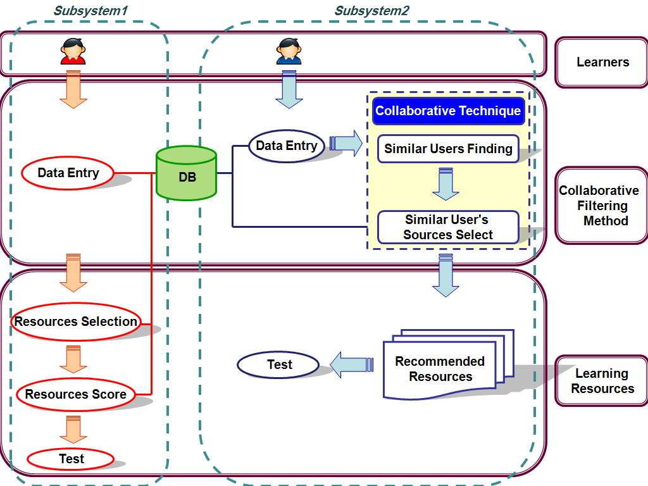
Figure-4.1: System Architectur
Resource Selection: The main students subsequent to perusing the method manual in the landing page will be guided to resources segment. They need to contemplate just 3 assets and put their remarks about them. It ought to be referenced that they approach every one of the assets in the assets segment.
Resource Score: After choosing the assets and going to "comments‖ segment, students should score the assets they have picked before."I remarks segment, there is a discretionary segment for remarks. Students can post their remarks.
Every one of the assets considered by the students with their scoring and their discretionary remarks are spared in their profiles which are recognizable.
Test: In the end the students of the primary gathering will go to the ―test‖ area .The test is about the assets. After that they will log out of the framework.
The aftereffects of the primary gathering will be utilized for the subsequent gathering. The subsequent gathering can sign in multi week after the main gathering. They won't approach the assets. The framework will discover comparable students in the main gathering for them and will recommend their assets to the students of the subsequent gathering. Scored data and assets by the main gathering will be assessed by the framework. By having assets and data from the students in the primary gathering, the framework will recommend assets to the students of the second gathering after their enlistment.
2. Subsystem 1 Architecture: The second gathering that will enroll in the subsequent week won't approach the assets. The framework will recommend 3 assets to them as indicated by their comparative students in the main gathering. At that point the students of the subsequent gathering will take part in the test and will log out of the framework. The examination of the outcomes will show whether the student can have a superior comprehension while utilizing the web without anyone else's input (first gathering) or by accepting suggestion from comparable students (second gathering). Engineering for the subsequent gathering is structured as beneath: Information Entry: (same as gathering 1)
Community oriented Technique: The 5 inquiries that students of the principal bunch replied in the enrollment area are being utilized as criteria for discovering ―similar users‖ for the objective client. The framework will figure 3 assets with most noteworthy scores by alluding to the assets contemplated by 3 comparable students and afterward will place them in focus on client's profile. In the following area it will be talked about totally.
Recommended Resources: After the learners of the first group log out of the system, it is the second group‘s time to log into the system. Learners of the second group will study the instruction manual in the ―home‖ section after they log into the system. By going to their profiles they are suggested 3 resources by the system. Learners should read 3 recommended resources.
Test: The learners of the second group will be navigated to the test and after doing that they will log out of the system.
VI. PROPOSED METHOD FOR LEARNER CLASSIFICATION
One of the fundamental issues of community oriented sifting is gathering the premiums of the students. The perfect condition to make the framework dependable is that countless students rate the assets. This will be accomplished uniquely by investing an excess of vitality and time. As the framework might be fit for giving proposals with great quality when it has fundamental data, the students from the principal bunch are not profoundly energetic toward the start. Be that as it may, 30 students were picked for the principal gathering to conquer this issue.
Client based technique is one of the most well known and initiatory strategies for the communitarian separating suggestion strategies. There are numerous techniques created by this model. The principle thought behind this technique is that when an individual requests a proposal for an item (for instance a book), he/she will be progressively deferential about the recommendations of the individuals who have a lot of comparable interests for books as him/her. Albeit algorithmic recommendations are progressively productive, by and large students would incline toward their companions' proposals to the algorithmic recommendations.
After the students of the principal bunch log out of framework, it is the subsequent gathering's an ideal opportunity to sign into the framework. The 5 inquiries that students of the main gathering replied in the enlistment area are being utilized as criteria for finding similar learners‖ for the objective client. Connection (1) is characterized for finding comparative clients from the principal gathering (learner(i)) to the objective client from the subsequent gathering. The framework will analyze each answer from student a client from the primary gathering) with the appropriate responses of the objective client.
Learner(i) Score = 2Q₁ + 2Q₂ + 4Q₃ + 6Q₄ + 6Q₅
Qi = {0, 1} (1)
For example the target user chooses c for the first question in the registration section. The system will study the answer of the first question of the learner i. If he/she chooses c then the system will assign 1 to Q1 in (1). But if he/she chooses another option then the system will assign to Q1. For question 2 if the learner i chooses an answer similar to the target user‘s answer, then the system will assign 1 to Q2 and this procedure continues like that
The more learner ‖ answers similar to the target user the more scores he/she will have. It means that it will be more probable that learner i is similar to the target user.
Numbers written in the relation (3-1) are scores that are given to each question according to their importance. In the end 3 learners from the first group with the highest scores (highest similarity) will be calculated for the target user.
VII. RESULTS
1. System Pre-Evaluation: After the members of both groups finished their tests, now it‘s time to compare the results. The comparison of the results will show whether the learners with self-paced learning technique are having better understanding of their studies or the second group that were receiving recommendation.
If the first group yields better results, some changes should be made in the algorithm and formulation of the system. If the second group yields better results, the research goal is achieved and efficient resources are presented to the learners in the least possible time. Decreasing the time is the most important point that should be achieved according to the phenomenon of information overload. Learners will show less behavioural disturbance against the information overload when they are receiving recommendations from the system.
Recommending the educational resources to the learners is one of those points that are not taken into consideration until now. Therefore, a system was developed to study this problem and to present strategies to solve it. By using collaborative filtering recommendation, the system recommends efficient educational resources and prevents learners from wasting their time and getting confused in finding efficient resources.
2. Analysis of resource selection of the learners of first and second groups: In this section the main issue is that how many learners are successful in selecting the resources that are close to the mentioned issue of the abstract. It will be checked whether the resources suggested by the system to the second group are the suitable resources or not!
Three optional resources were added by three members of the first group and an expert accepted just two of them for the resources of the system. So the resources increased from 10 to 12. These two resources were commented by 6 learners. The resource that was rejected by the supervisor didn‘t have proper similarity to the abstract.
Resources number 1, 7 and 10 have the full scores (average 5). This shows that the learners who chose these 3 resources can answer all of the questions in the test section. Resource number 3 has score 4, resource number 6 has an average score of 3, resources number 2,5,11,12 have an average score of 2 and resources number 4,8,9 have score 1. Selecting resources number 3 and 6 helps the learners to answer more than half of the questions. Resources number
2,5,4,8 and 9 can barely help learners to answer the questions. Because these recourses have little information related to the abstract.
Now the main question is that if the resources with
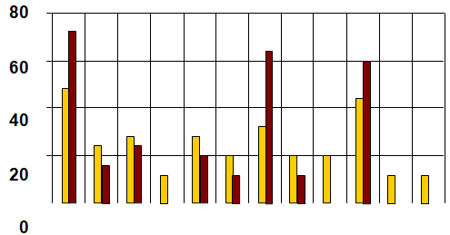
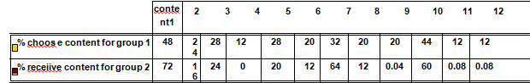
Diagram: 7.1 Percentage study of resource by group 1 and 2
After the individuals from the two gatherings completed their tests, presently it's a great opportunity to think about the outcomes. The correlation of the outcomes will show whether the students with ―self-paced learning‖ procedure are having better comprehension of their investigations or the second gathering that were accepting suggestion.
On the off chance that the principal bunch yields better outcomes, a few changes ought to be made in the calculation and detailing of the framework. In the event that the subsequent gathering yields better outcomes, the examination objective is accomplished and proficient assets are introduced to the students at all conceivable time. Diminishing the time is the most significant point that ought to be accomplished by the marvel of ―information overload‖. Students will show less social unsettling influence against the data over-burden when they are accepting proposals from the framework.
Prescribing the instructive assets to the students is one of those focuses that are not mulled over as of recently. Consequently, a framework was created to think about this issue and to show techniques to unravel it. By utilizing collective sifting suggestion, the framework prescribes productive instructive assets and keeps students from burning through their time and getting befuddled in finding effective assets.
3. Result Analysis: Fig 7.1 looks at the asset choosing level of the principal gathering (left side) with the asset getting level of the subsequent gathering (right side). As it is self-evident, the asset perusing level of the objective assets (1, 4, and 7) in the subsequent gathering is a lot higher. It very well may be inferred that if the assets or things are not chosen by the students, those things and assets won't be proposed to the new students.
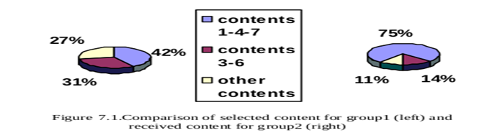
In the test segment 10 inquiries were introduced and the students of the two gatherings addressed them. In this part the inquiries of the test and the assets are talked about. The test aftereffects of the two gatherings are appeared in chart 7.2 which looks at the right answer rates of students of the two gatherings in the ―test‖ segment. The even hub shows the inquiries of the test.
The vertical pivot shows the right answer rates of the students of the first and the subsequent gatherings.
Clearly in all inquiries (aside from question number 1) there is a major contrast between students of the second and first gatherings. For responding to the main inquiry, the students didn't have to examine any assets and they had the option to address that question by their own insight. The students of the subsequent gathering would do well to results than the students of the primary gathering. The recorded outcomes in the framework show that 53.33% of the students of the primary gathering had the option to answer the greater part of the inquiries accurately while 77.77% of the students of the subsequent gathering addressed the greater part of the inquiries effectively. This outcome is helpful in light of the fact that the students will invest less vitality and time.
Recommending the educational resources to the learners is one of those points that are not taken into consideration until now. Therefore, a system was developed to study this problem and to present strategies to solve it. By using collaborative filtering recommendation, the system recommends efficient educational resources and prevents learners from wasting their time and getting confused in finding efficient resources.
VIII. DISCUSSIONS
2. Analysis of resource selection of the learners of first and second groups: In this section the main issue is that how many learners are successful in selecting the resources that are close to the mentioned issue of the abstract. It will be checked whether the resources suggested by the system to the second group are the suitable resources or not!
Three optional resources were added by three members of the first group and an expert accepted just two of them for the resources of the system. So the resources increased from 10 to 12. These two resources were commented by 6 learners. The resource that was rejected by the supervisor didn‘t have proper similarity to the abstract.
Resources number 1, 7 and 10 have the full scores (average 5). This shows that the learners who chose these 3 resources can answer all of the questions in the test section. Resource number 3 has score 4, resource number 6 has an average score of 3, resources number 2,5,11,12 have an average score of 2 and resources number 4,8,9 have score 1. Selecting resources number 3 and 6 helps the learners to answer more than half of the questions. Resources number
2,5,4,8 and 9 can barely help learners to answer the questions. Because these recourses have little information related to the abstract.
Now the main question is that if the resources w
After the individuals from the two gatherings completed their tests, presently it's a great opportunity to think about the outcomes. The correlation of the outcomes will show whether the students with ―self-paced learning‖ procedure are having better comprehension of their investigations or the second gathering that were accepting suggestion.
On the off chance that the principal bunch yields better outcomes, a few changes ought to be made in the calculation and detailing of the framework. In the event that the subsequent gathering yields better outcomes, the examination objective is accomplished and proficient assets are introduced to the students at all conceivable time. Diminishing the time is the most significant point that ought to be accomplished by the marvel of ―information overload‖. Students will show less social unsettling influence against the data over-burden when they are accepting proposals from the framework.
Prescribing the instructive assets to the students is one of those focuses that are not mulled over as of recently. Consequently, a framework was created to think about this issue and to show techniques to unravel it. By utilizing collective sifting suggestion, the framework prescribes productive instructive assets and keeps students from burning through their time and getting befuddled in finding effective assets.
The yellow columns show the resource selecting percentage from learners of the first group. The brown columns represent the resource receiving percentage of the learners of the second group. The learners of the first group studied different resources. The resources number 4, 11 and
12 were selected by 3 learners from the first group. These 3 resources achieved the low average scores of 1, 2 and 2 respectively. Resource number 4 was automatically deleted and was presented by number 0 in the graph. This means that resource number 4 is not presented in the second step to any learners of the second group. Resources number 11 and
12 were only suggested to 2 learners of the second group. Resource number 9 that was selected and studied by 5 learners was suggested to only 1 learner because it had a low score.
As it is presented in diagram 7.1, resources number 7 and 10 are recommended to 75.33% of the learners in the second group, while 51.33% of the learners in the first group selected them. In fact, the learners of the second group experience an efficient resource selection. They were benefited from the experiences of the members of the first group. Here, without evaluating the test, it's obvious that the main goal is achieved.
3. Result Analysis: Fig 7.1 compares the resource selecting percentage of the first group (left side) with the resource receiving percentage of the second group (right side). As it is obvious, the resource reading percentage of the target resources (1, 4, and 7) in the second group is much higher. It can be concluded that if the resources or items are not selected by the learners, those items and resources are not going to be suggested to the new learners.
In the test section 10 questions were presented and the learners of both groups answered them. In this part the questions of the test and the resources are discussed. The test results of both groups are shown in diagram 7.2 which compares the correct answer percentages of learners of both groups in the ―test‖ section. The horizontal axis shows the questions of the test.
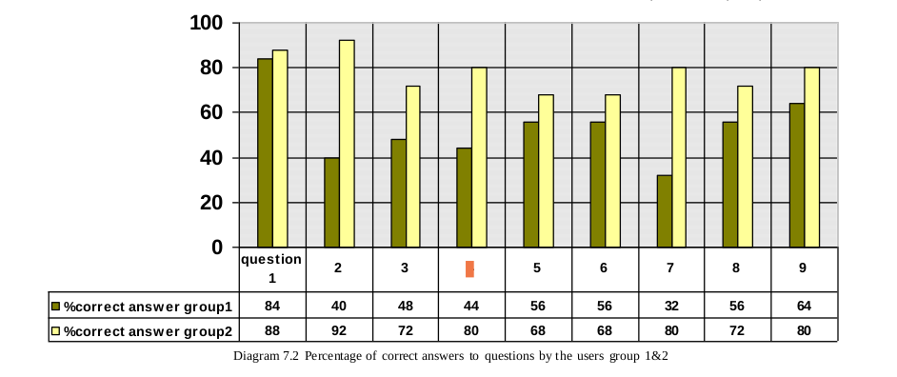
The vertical axis shows the correct answer percentages of the learners of the first and the second groups.
It is obvious that in all questions (except question number 1) there is a big difference between learners of the second and first groups. For answering the first question, the learners didn‘t need to study any resources and they were able to answer that question by their own knowledge. The learners of the second group had better results than the learners of the first group. The recorded results in the system show that 53.33% of the learners of the first group were able to answer more than half of the questions correctly while 77.77% of the learners of the second group answered more than half of the questions correctly. This result is very useful because the learners are going to spend less energy and time.
VIII. DISCUSSIONS
The web has given an extraordinary volume of information as an open door for its clients. In any case, if there is no proficient administration for such a mass of information, this open door will transform into a hindrance to the clients. These days a recommender framework is fundamental to manage clients toward their ideal items and administrations in such a consistently expanding volume of data and information.
As indicated by the ongoing investigations, such a recommender framework has once in a while been utilized in e-learning. The aftereffects of this undertaking indicated that the student can have a superior comprehension while accepting proposals from the framework.
So a framework was planned which had the option to prescribe instructive assets to the students and in this manner spared time and cost. The principle objective for leading this undertaking was that a student in an e-learning condition could get proposals and suggestions as indicated by his/her attributes at all conceivable time and choose the best alternative for utilizing the assets.
Restrictions of this Study: According to the CF calculation, the framework can't prescribe great quality proposals and suggestions on the off chance that it has not many students. In this manner, by expanding the quantity of students what's more, remarks the nature of the suggestions will increment. A few volunteers of the framework didn't show any enthusiasm for considering the assets. On the off chance that this framework is utilized in an instructive domain and the educator powers understudies to utilize the framework, at that point the restlessness of the students will transform into high inspiration and students can profit by the site to an ever increasing extent.
IX. CONCLUSION
The internet learners are always facing information overload and time waste. One way to overcome these problems is to use the recommender systems. In this study a recommender system was designed as a new and efficient strategy to open a new path in e-learning. It prevents the learners from wasting too much time in order to have better access to the content with higher speed and better quality. It is advised to create the culture of using the recommender systems before implementing these systems in the educational systems. It is quite beneficial to put these systems in the highly visited websites like banks‘ websites so everyone will get used to these kinds of systems. It is obvious that in this case we are not going to face the problem of cold start. So interaction between these systems and learners will be much higher.
If students get scored for each activity, they will show more interest. If new resources are added to the system, the interaction in the system will be increased. Therefore, the learners of the first group will be able to receive recommendations just like the learners from the second group.
REFERENCES
- ReferencBurke Robin; ―Hybrid Recommender Systems: Survey and Experiments‖, California State University, 2007.
- Adomavicius Gediminas; Tuzhilin Alexander; ―Toward the Next Generation of Recommender Systems: A Survey of the State-of-the-Art and Possible Extensions‖, IEEE, pp.1 -16, 2005.
- Woerndl Wolfgang.; Groh Georg; ―A proposal for an agent -based architechure for Context-aware Personalization in the Semantic Web‖, Nineteen International Joint Conference on Artificial Intelligence, pp.75-79, 2005.
- Jesse Vig, Shilad Sen, John Riedl," Tagsplanations: Explaining Recommendations Using Tags "Grouplens Research University of Minnesota, IUI‘09, February 8 - 11, 2009, Sanibel Island, Florida, USA.
- Mortensen Magnus; ―Design and Evaluation of a Recommender System‖, INF-3981 Master's Thesis in Computer Science, University of Troms, 2007.
- Rosta Farzan , " Adaptive Socio-Recommender System for Open Corpus E-Learning", Intelligent Systems Program, University of Pittsburgh, Pittsburgh PA 15260, USA, Conejo, R. (eds.) Proc. of Second International Conference on Adaptive Hypermedia and Adaptive Web- Based Systems (AH'2002) Proceedings, Málaga, Spain 242-252
- F. Maxwell Harper, Daniel Moy, Joseph A. Konstan, "Facts or Friends? Distinguishing Informational and Conversational Questions in Social Q&A Sites",GroupLens Research, University of Minnesota, {harper, dmoy, konstan}@cs.umn.edu
- sh ilad Sen, Jesse Vig, John Riedl, "Learning to Recognize Valuable Tags", Grouplens Research,University of Minnesota, ssen@cs.umn.edu, jvig@cs.umn.edu, riedl@cs.umn.edu
- John O‘Donovan, Barry Smyth ,"Trust in Recommender Systems", Adaptive Information Cluster Department of Computer Science, University College Dublin, Belfield, Dublin 4 Ireland, {john.odonovan, barry.smyth}@ucd.ie
- E. Reategui , E. Boff , "Personalization in an interactive learning environment through a virtual character", Departament of Computer Science, Universidade de Caxias do Sul, 95070-560 Caxias do Sul, RS, Brazil, J.A. Campbell, a b Departament of Computer Science, University College London, Gower, St., London WC1E 6BT, UK, Received 21 February 2007; received in revised form 29 May 2009.
- Huiyi Tan1, Junfei Guo3, Yong Li2,"E-Learning Recommendation System", International School of Software,Wuhan University, Wuhan, China, Information School, Estar University, Qingdao, China, tan6043@gmail.com
- Mohammed Almulla, "School e-Guide: a Personalized Recommender System for E-learning Environments", Kuwait University, P.O.Box 5969 Safat,First Kuwait Conf. on E-Services and E-Systems, Nov 17-19, 2009
- Vinod Krishnan, Pradeep Kumar Narayanashetty, Mukesh Nathan, Richard T. Davies, and Joseph A. Konstan, "Who Predicts Better? – Results from an Online Study Comparing Humans and an Online Recommender System", Department of Computer Science and Engineering, University of Minnesota-Twin Cities, RecSys‘08, October 23–25, 2008, Lausanne, Switzerland.
- Mirzadeh, N., Ricci, F., Bansal, F. "Feature selection methods for conversational recommender systems". In Proceedings of the IEEE International Conference on e-Technology, e-Commerce and e-Services, Hong Kong. IEEE Press, 29 March - 1 April 2009
- Thompson, C.A., G ِ ker, M., Langley, P. "A personalized system for conversational recommendations.‖ Artificial Intelligence Research.2008 ,428–393 :21
- Riedl, J., Schafer, B., Konstan, J. "Recommender systems in e-commerce." Proceedings of The First ACM Conference on Electronic Commerce, pages 158-166, .2009
- Krulwich, B. "Lifestyle recommenders: Intelligent user profiling using large-scale demographic data.‖Artificial Intelligence Magazine, 2007 ,45-37 ,(2)18
FUTURE OF AI IN EDUCATION
Sumitha Gnanamalar¹ and Hiren Dand²
Student¹ and Head², Department of Information Technology, Mulund College of Commerce, University of Mumbai, Mumbai
ABSTRACT
A normal machine can be an AI based machine when we give them the capability to learn and think. Artificial Intelligence (AI) is all about providing knowledge to the computer systems so that the system can learn new things and respond to it just like humans do. The use of AI technology is very high now-a-days. It changes a normal human life as everything is controlled by these machines and the scope of AI goes high in every area.
In this research paper, I got the opportunity to do some research on the topic Future of AI in Education. As we can see our scientists have made humanoid robots which interacts with humans efficiently. In this research paper, we will see what are the problems and the solutions and also the change in literacy rate because of AI technology in the field of Education.
Index Terms: AI, Changes in AI Knowledge, Literacy rate, Teaching.
NOMENCLATURE
- AI-Artificial Intelligence
- CAI-Computer Assisted Instruction
- ICAI- Intelligent Computer Assisted Instruction
1.0 INTRODUCTION
According to global literacy survey conducted by Max Rozer and Estiban the current rate of literate people over the globe has increased. They have given a detailed structure where they predicted that the literate people at the period of 1800 is 12.05% and the current update of literate people is 86.25%. Hence, the global literacy rate has increased. In olden days, letters were the only medium to talk to a person but now we have updated our self and technology that we can see the person from where we are.
When we think of the first Computer, it occupied the entire room and had less storage memory but now, we have smartphones, which occupy less space and has a large storage memory. Here we can get an idea of how fast the technology is developing. According to some research we found that technologies have helped in changing the world. Internet of Things, Personal Computers, Nano Robotics are one among them. An Artificial Intelligence (AI) was a myth or story where the machines will perform the tasks that a normal human being do. In order to change the myth to fact, scientists from all the fields came together and started making an artificial brain. AI games were introduced and many programs were made and the main goal of scientist was to allow these computers to communicate in natural languages. Finally, this ended up creating a complete humanoid robot. Now, Artificial Intelligence is predicted to change the world further.
2.0 REVIEW OF LITERATURE
Author name: Marlene Jones
Abstract: Computers have been active within the field of education for many years, often with unsatisfactory results. However, current research within the field of artificial intelligence (AI) is having a positive influence on educational applications. For example, there now exist ICAI (intelligent computer-assisted instruction) systems to explain or tutor many different subjects; several such systems are deliberated here. In addition to CAI (computer-assisted instruction) systems, we discuss the expansion of learning environments that are intended to allow student-initiated learning. A third major application is the use of expert systems to assist with educational analysis and assessment. During the development of the discussion of these three major application areas, we specify where AI has already played a major role in the development of such systems and where more research is mandatory in order to overcome present limits.
Conclusion- Although the systems discussed here still fall short of what we would like to see placed within the regular school environment, they determine the effect that recent Al research is having within the field of education. For example, current ICAI systems are an enormous development over the traditional frame-based CAI systems. Advances made within the central AI research areas, such as knowledge representation, natural language understanding, reasoning/ inferencing, and
FUTURE OF AI IN EDUCATION
Learning/discovery, will surely last so as to simulate within the educational field, particularly in instructional and analytic systems.
Author name: Mr. Nitin Borge
Abstract: In educational system, managing artificial intelligence (AI), in teaching and learning process, had an amazing evolution. The educational goals can be better attained and accomplished by new technology of education. Using AI, we can have better study of each and every student in a class who is a slow learner or who is lazy enough to understand the topics which has been enlightened by lecturer. Analysis will give clear knowledge about student’s understanding on each and every topic. If student is covering in some areas or the student is not able to recognize few topics then AI analysis would showcase this report to lecturer or teacher or parents so that proper action can be taken. AI analysis should also mention the topics with basic examples or in an easy manner to student so that they can recover their skill in the particular area where he/she is uncomfortable.
Conclusion- The capability for information systems to offer this level of understanding not only saves time, but can offer the level of detail that may not be noticeable or possible for teachers to identify at face value. Classroom AI tools have abilities in analysing several sources of data and linking them to known patterns. This can recognize the root causes for problems, and also drive towards more constant results across different classes, irrespective of the experience of teaching staff.
3.0 RESEARCH IN EDUCATION
3.1 Literacy Rate
Many online exams are given by students and the results are announced soon. This shows the replacement of teachers. Teachers assess all the papers and the results are announced within few months but now it is issued within fraction of second. As we can see that the students are more interested in the technology and their grasping power is high when taught using technology. Virtual learning environments are created for student which helps the student to learn according to their interest and the students can select the quality teacher so that they can understand the lessons with deep knowledge.
As mentioned before the literacy rate across the globe has increased. In this research paper, I have done the research on the use of current AI technology that are used for education. The technology used in education has increased the interest of the student in learning. In this research paper, I have determined the literacy rate of people which has changed using the AI technology in the field of education.
FUTURE OF AI IN EDUCATION
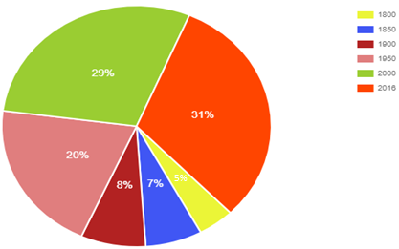
Fig-1: Literacy rate around the globe.
In the above diagram we have the literacy rate across the globe from the period of 1800 to 2016. This is the overall literacy rate, which started from 5% and has now increased up to 31%. AI is being accepted globally and the teachers believe that the printed notes will be vanished soon. Everything is available digitally and even now we can see that student prefer to have pdf than the hand written notes. As the researchers of AI in 1965 predicted that, “In twenty years the machines will be capable of doing what a normal human can do”, similarly now the machines are replacing human being.
When we see the graph, the literacy rate has increased more from the period of 1950 and this is the period when AI was introduced. AI is the main reason for enhancement in education. The literacy rate gradually increases until now and the AI technology has brought a drastic change in the literacy rate. The Logics were introduced in AI research by McCarthy in 1958
The new approach for creating the thinking process of AI which is similar to human thought process was coined when they saw that the machines could manipulate numbers and also the symbols.
3.2 Human Robots:
When we compare the Humans and the Robots, we that the robots are smarter. Why is this so? Even the robots are made by humans.
This is because human now-a-days depend too much on Internet. Dependence on Internet and robots had made human lazier physically and mentally.
Initially to develop a project, more time is required to get detail knowledge about the topic and recall all the things that are learned earlier. Now-a-days we have online lectures which is recorded and the student can view as and when required. The time for searching and recalling has been reduced. But the student memory power also reduces because they depend too much on the online videos.
Even for a simple project the students refer the online readymade projects and this can reduce the thinking capacity of the students. It is advisable to have simple online exam after each session and also before continuing with the other session so that students can recall what they have learned. The student should give maximum right answers in order to continue with the next session. This can improve students thinking power and they can recall all the lessons they have learned. The exam should also include the question about having innovative idea for the problems and the ideas given by students should be encouraged. If we have syllabus-based questions the students won’t be interested much but if it is based on their own opinion and their innovative ideas this can make them think about the problems more deeply.
4.0 CONCLUSION
The enhancement of AI technology in the field of education is supported by everyone but the enhancement should help in improvement of the student future scope. It is necessary to use the technology but we should not be too dependent on the technology too much. The solutions provided in this research paper will help the students to improve their thinking capacity and we will get some innovative ideas from students. Technology improvement is must but it should be used wisely.
APPENDIX
In the below mentioned reference, Literacy written by Max is all about the graphical representation of the literacy rate from the year 1800 to 2016. When we analyze the graph, we can clearly get to the point that the literacy rate has increased after AI evolution. The Literate world population became 56% in the period of 1950. The time when AI came into education the literacy rate has been increased.
REFERENCES
1. “Jones. M, (1985). Applications of Artificial Intelligence within Education.”
2. “Nitin. B, Artificial Intelligence to Improve Education / Learning Challenges.”
3. “Max. R, & Esteban. O, (2013). Literacy.”
4. “Adrien. S, (2017). How AI impacts Education.”
5. “Bernard. M, (2018). How is AI used in Education—Real world examples of today and a peek into future.”
6. “Kurtis. B, (2018). Will AI replace teachers?”
7. “Alyssa. J, (2019). 5 Ways AI is changing the Education Industry.”
Smart Parking System using IOT
Ashwinkumar Jaiswar¹ and Pournima Bhangale²
Student¹ and Head², Department of Information Technology, V.G. Vaze College of Arts Science and Commerce, University of Mumbai, Mumbai
Abstract
In today’s world, majority of individuals travel vehicles, the cities have reached their full occupancy. thus most of the time folks pay their precious time in sorting out parking heaps. victimization automatic sensible parking system we are able to scale back the time and additionally human efforts. Our system relies on net of things (IOT). IOT may be a construct wont to connect all our close things to a network and communication with one another. it's generally classified into 3 classes sensing, process and property. Our system is cloud based mostly system that contains Optical device to sight empty parking slots and send this knowledge to server, this knowledge are often accessed by the users.
Keywords: Internet of Things (IoT), Optical Sensor.
INTRODUCTION
The machine-driven parking system exploitation IoT that you simply develop is enforced in lined parks, open parks and additionally street facet parking. The sensible parking system can have a cloud service supplier that gives cloud storage to store info concerning the parking standing within the slots. there'll be a centralized server that stores the data concerning the amount of parking slots, availableness standing and additionally the parking time.
LITERATURE SURVEY
Smart Parking System exploitation web of Things (IOT) to beat troubles of finding vacant parking spot in close parking. whereas developing this they’ve used Raspberry Pi as a hardware platform and that they maintained their, info on a central server. They perpetually captured snaps of car park to determine that slots ar empty and that one ar occupied. ANDROID based mostly good PARKING SYSTEM exploitation SLOT ALLOCATION & RESERVATIONS in urban center, India. Their system comprised of 3 sections viz., Driver request process center, good parking allocation center and Parking resource management center. They utilized in depth Slot allocation rule to assign and reserve user a slot from obtainable parking slots. They used IR detector to find actual occupancy of parking slot and that they half-track time that user occupied any slot. they need conjointly used golem platform to produce user ease to order a slot. A Survey on good Parking System”. during this they’ve mention several papers and analysis that has been conducted on good Parking System. They mentioned that until then most systems used ZigBee, GSM, RFID technologies to transfer information from sensors to info. conjointly in some cases image process is employed to work out whether or not slot is empty or not. Smart Parking System with Bluetooth Access .The author proposes robotic garage (RG) exploitation Bluetooth which might be wont to absolutely alter the position of a automotive within the slot while not the help of the driving force. The system mechanically checks the distinctive number keep within the Bluetooth chip to ascertain if the new vehicle must be position. this technique may be a vertical parking arrangement for the vehicles with sensors that make sure placement of the automotive. numerous alternative sensors ar wont to make sure that there aren't any passengers left within the vehicles so the system moves the vehicle to hold using rack and pinion (Rap) mechanism. Automatic Parking Management System and Parking Fee assortment supported range Plate Recognition., Intelligent Transport System (ITS) and Electronic toll assortment (ETC) exploitation optical character recognition (OCR) creates a record for all coming into vehicle. This creates tag less entry for all vehicles within the parking zone, however it doesn't assign a slot to the user. A universal OCR algorithmic program isn't obtainable, creating it troublesome to form aforementioned records. Smart parking reservation system mistreatment short message services (SMS). In today’s world parking tons became redundant and wishes heap of personnel to handle and maintain it. These parking tons don't seem to be user friendly and don't give information relating to accessibility of free areas. several researchers have contributed to the current issue and formalized with numerous strategies to higher optimize the parking zone to serve the requirements. The author projected good parking reservation system mistreatment short message services (SMS), for that he uses world System for Mobile.
PROPOSED SYSTEM
Presence of car at parking slot is set by Optical sensors, can provide output per lightweight incident on them. If vehicle is gift then thanks to Shadow of car output are LOW. Whenever Vehicle isn't gift thanks to incident lightweight output of Sensors are HIGH. This Output is then given to Microcontroller GPIO pin. Specifications For Headers and Footers
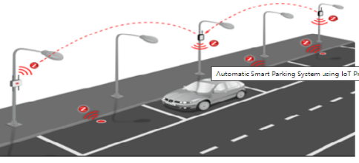
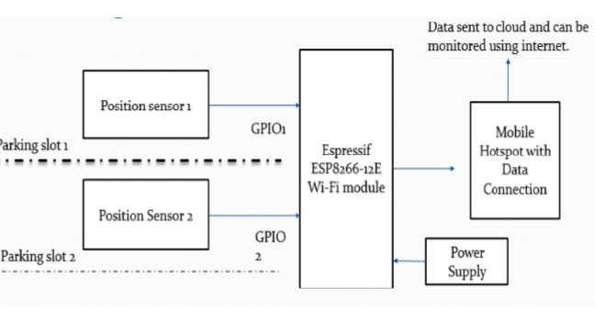
The functionalities of the elements of machine-controlled parking system project square measure as follows,
Centralized server: This maintains the knowledge regarding the parking slots and its handiness
Raspberry Pi: can this may this can act because the microcontroller for the project and every one the opposite sensors will connected thereto
Camera: The Pi camera are going to be connected to the microcontroller and can be accustomed validate the parking slots as either empty or occupied
IR sensors: it'll be accustomed sense the presence of auto within the parking slots by causation out IR radiations
Navigation system: this can provide the signals that may guide the users to navigate and head to the closest obtainable parking slot
Display device: this can be the screen that displays the standing of the parking slots and alter period of time
User device: this will either be the movable or an internet site which may be utilized by the user to induce the supply of parking slots directly.
Major steps involved
- The IR sensors or Pi cam ought to be placed within the acceptable places to obviously cowl all the parking slots
- The parking slots ought to be befittingly numbered to mark them on the system
- These marked points can act because the management points and can be integrated as slots within the cloud
- Then the setting are going to be saved and therefore the microcontroller are going to be programmed to show the information on-line consequently
CONCLUSION
This designed automatic sensible parking system that is easy, economic and provides effective answer to scale back carbon footprints within the atmosphere. it's well managed to access and map the standing of parking slots from any remote location through browser. so it reduces the risk of finding the parking slots in any parking space and conjointly it eliminates gratuitous motion of vehicles across the stuffed parking slots during a town.
REFERENCES
- Zheng, Y., Rajasegarar, S., & Leckie, C. (2015, April). Parking accessibility forecast for sensor-enabled car parks in savvy cities. In Cleverly Sensors, Sensor Systems and Data Handling (ISSNIP), 2015 IEEE Tenth Worldwide Conference on (pp. 1-6). IEEE.
- O. Dokur, S. Katkoori, N. Elmehraz, "Inserted framework plan of a real-time stopping direction framework", Yearly IEEE Frameworks Conference (SysCon), pp. 1-8, 2016.
- Li Junhuai, An Yang, Fei Rong, Wang Huaijun, "Smartphone-Based Car-Searching Framework for Expansive Parking Part", IEEE 11 th Conference on Mechanical Hardware and Applications (ICIEA), 2016.
- Abdul Ahad, Zishan Raza Khan, Syed Aqeel Ahmad,“Intelligent Parking System” Scientific Inquire about Distributing, Vol.4,No.2, pp. 160-167, May 2016
- Suprit Atul Gandhi, Hasan Mohammad Shahid,” Shrewd Stopping System” Asian Diary of Meeting in Innovation, Vol.4,No.1,May 2017
- M. M. Rashid, A. Musa, M. Ataur Rahman, and N. Farahana, A. Farhana, “Automatic Stopping Administration Framework and Stopping Charge Collection Based on Number Plate Recognition.”, Worldwide Diary of Machine Learning and Computing, Vol. 2, No. 2, April 2012,Published 2014.
- Youngtae Jo, Jinsup Choi, and Inbum Jung, "Activity Data Procurement Framework with Ultrasonic Sensors in Remote Sensor Systems," Universal Diary of Disseminated Sensor Systems, vol. 2014, May, 2014.

Application of Blockchain in Advanced Study Centre
Durgesh Rajdev Vishwakarma¹ and Dr. Hiren Dand²
Student¹ and Head², Department of Information Technology, Mulund College of Commerce, University of Mumbai, Mumbai
Abstract
Blockchain is the technology that can be used to create and manage secure, distributed ledger that can record transactions done between any two parties or individuals very efficiently, in a secure, verifiable and permanent way. Blockchain came into limelight in 2008 when Cryptocurrency Bitcoin was invented by Satoshi Nakamoto (or group of people). In modern world we are applying Blockchain in many fields such as Smart contracts, Healthcare, Real Estate, Cryptocurrency, and Education, Supply chain, Businesses and many other fields. This is all because of blockchain’s decentralization, immutable, secure and openness data storage structure.
In this research paper I will discuss about the application of Blockchain technology in Advanced Study Centre (ASC) system to enhance features.
Keywords: Blockchain; Educational System, Advance Study Centre, ASC, Educational Software.
- Introduction
Blockchain technology allow us to create a de-centralized environment, where transactions and data blocks are not under control of any third-party organization. The transaction completed between any two parties or individuals recorded in a block and then permanently stored in distributed public ledger, refer Figure 1 given below.
Blockchain technology uses three basic terminologies: Transaction, Block and Chain to provide transparent, decentralized, distributed and secure structure for data storage.
Three basic terminologies in Blockchain technology:
- Transaction
The transaction is an operation of adding or removal of items from public ledger, which always leads to change in the structure and status of the ledger.
- Block
The block stores result of all the transactions done between two parties or individuals in particular amount of time.
- Chain
The chain is a chronological string of the blocks arranged by cryptographic method.
- The Blockchain technology can be implemented in following way
First, we need to create a distributed ledger in the network which only allows addition of new data in the distributed ledger i.e. data from ledger cannot be deleted, this will ensure the non-tamper ability of the data in ledger.
The blocks are interlinked into chain to form a chronological structure of string of blocks. Each block in structure stores the hash value of previous block, as shows in Figure 1. When anyone try to add new block of the transaction in the ledger then entire system will records the transaction and link it with the ledger. Meanwhile block is broadcasted over network and confirmed by all the nodes, which make block undeletable from ledger. In this way the data or block cannot be falsified or forged in system.
Therefore, the Blockchain technology has a transparent, decentralized, secure and distributed structure for data storage. After combining cryptographic technique with Blockchain, it guarantees that the data from ledger cannot be falsified or tamper, can be easily backtracked for transaction and data verification.
Figure-1: Structure of Ledger in Blockchain
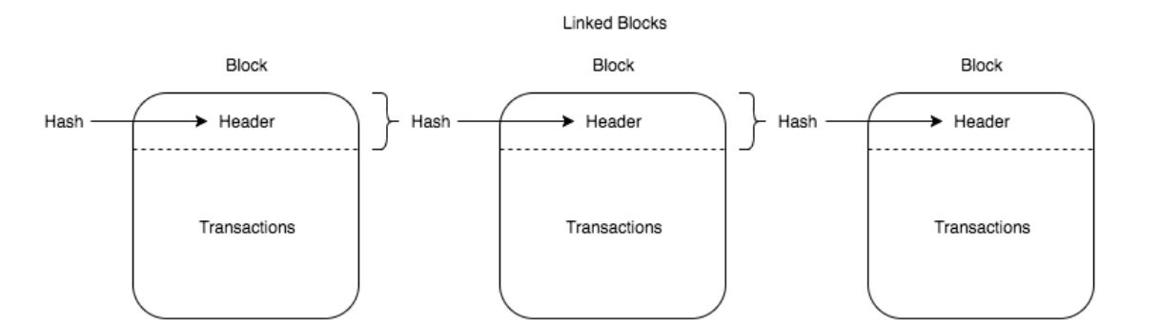
- Advance Study Centre (ASC)
Advance Study Centre is an educational software, which is developed using conventional technologies such as PHP, JavaScript, MySQL and PostgreSQL. ASC system stores records in a central database located in the Linux server.
Refer Figure 2 for the context diagram of Advance Study Centre software.
In ASC or any educational system, we have some common fields such as Attendance, E-Learning, Results, Student Data Manage, Announcement and Financial records. We can apply Blockchain technology to enhance features of these fields to make educational software better.
Most of educational systems are still facing some common problems such as online record sharing, course creditability, student privacy, and course sharing. We can minimize these problems by combining Blockchain with educational system. In this paper I will discuss about this briefly. Also, we can add some new features in ASC system with more secure manner such as e-Certificates, e-Diploma, and online records and study material sharing.
Online sharing of academics certificates published by Blockchain technology allow everyone to verify certificates over web on trusted servers.
Use of Blockchain make these academics records non-tamper and unfalsified. We can even trace back from any point to verify any transaction performed on student’s educational, personal, attendance or financial records in ASC.
- Literature Survey
The literature research was done on seven different research papers and multiple websites given in reference section. The research string included different types of strings like “Application of Blockchain Technology”, “Online Education”, “Blockchain-based Educational Record Repository”, “Blockchain Opportunities and Challenges”, “Blockchain in Virtual Education” and “Exploring Blockchain technology and its potential applications for education”.
- “Application of Blockchain Technology in Online Education” research paper presents the idea of Blockchain to enhance online exams which we can implement in ASC or any educations software.
- “A Blockchain-based Educational Record Repository” research paper can be applied in ASC to store educational records more effective and secure way using Blockchain technology.
- The Blockchain can be applied in ASC or any educational software to create and distribute digital certificates of students on web, which can be stored and verified easily at any point. This will help in reducing time for verification of academic certificates of students and provide trustworthiness.
- MIT has developed Blockchain based application that can issue and verify official records known as “Blockcerts Wallet”. This application allows creation of a certificate wallet for students. Students can get their e-certificates and e-diplomas instantly on their smartphones, laptops or any other internet connected smart device.
- The University of Nicosia is the first higher educational institute that issues student’s academic certificates which can be verified through the Blockchain technology globally.
- “Exploring Blockchain technology and its potential applications for education” research paper shows potential of the Blockchain technology has for educational system like ASC.
Figure-2: Context Diagram of Advance Study Centre
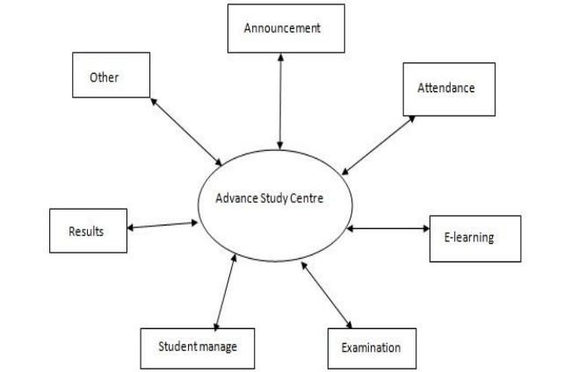
- Application of Blockchain in ASC
- Results
We can apply Blockchain technology in ASC to enhance results field. It will allow us to create and distribute academic results in trusted, secure, and open manner. These certificates will be stored with hashing algorithms present in Blockchain, which will make it non-tamper and highly secured.
- Attendance
We can also add Blockchain to manage attendance records of students in more efficient way. Attendance records of student can be stored in a block and then linked with previous blocks to form a distributed ledger, as shown in figure 1.
Distribution and non-tamper feature of Blockchain ensures that there is no falsified data present in attendance records in ASC database or ledger.
- Examination
Examination is the field where Blockchain can help a lot to manage data integrity. Examination data generate academic performance, certificate and results of students. Data in examination must be very secure and should not allow any modification without any prior reason. Blockchain allow us to back trace a block in distributed ledger from any for verification of data of any student to ensure data integrity and validate transactions performed on examination data stored in ASC.
- Financial Records
Blockchain is an accounting technology too. It is concerned with the transactions performed on financial records and maintain a ledger of accurate financial information. Blockchain has the potential to enhance the accounting profession by reducing the costs of maintaining and reconciling ledgers and providing absolute certainty over the ownership.
- E-Learning
In E-Leaning field, Blockchain can help ASC or any educational system to distribute learning material such as PDF, Documents, Files, Software, Videos, Links, etc. over web with data integrity and creditability of owner.
It will help students to get study material without any modification and credits to the owner of that study material.
- Distributed Storage
Currently ASC is storing data in a central PostgreSQL database. If someone successfully hacks central database of ASC, then he can alter actual data of ASC database easily. Data integrity will be lost here. We can minimize this problem by adding Blockchain technology in ASC.
Blockchain stores data in distributes and crypto-graphic manner. So, if someone want to hack data in ASC’s Blockchain ledger then he needs to hack and modify all the nodes in the ledger, which is near impossible, if we have secure and large number of nodes in ledger. This also avoid single-point-of-failure problem in central database of ASC too.
- Academic Record Verification
In K-12 and postsecondary verification of academic results, certificates and achievements remains largely a manual process i.e. heavy on paper documentation and checking case-by-case records. This problem can be easily resolved by Blockchain technology where anyone can verify academic documents easily on trusted sources. Records can be easily broadcasted across network, which will help employer & institutes to validate and verify records. It will help to globally recognize and verify records.
- Conclusion and Future work:
In this paper I have proposed implementation of Blockchain technology in Advance Study Centre (ASC) to enhance features of an educational software. This can be also applied in other similar educational software like ASC to form a global Blockchain ledger with uniform data storage and verification structure.
Blockchain will ensure the security and integrity of data in ASC application. Also, it will reduce time for data verification and provide a uniform ledger where multiple colleges, institutes and universities can verify academic data of any student.
In terms of future work, we can evaluate the scalability issue and impacts associated with deployment of huge repository. The final aspect to be considered is to bring stockholders such as teachers, students, employees and contractors in a way that they can interact with each other on wide-spread and trustable network.
- References:
- “Application of Blockchain Technology in Online Education” by 1. Sun, Han 2. Wang, Xinge 3. Wang, Xiaoyue published on 15th September 2018.
- “A Blockchain-based Educational Record Repository” by 1. Bessa, Emanuael 2. Martins, S. B. published on January 2019.
- “The Blockchain and Kudos: A Distributed System for Educational Records, Reputation and Reward” by 1. Sharples, Mike 2. John published in year 2016.
- “Exploring blockchain technology and its potential applications for education” by 1. Guang Chen 2. Bing Xu, 3. Manli Lu 4. Nian-Shing Chen published on 03 January 2018.
- “Blockchain in Education” by Anthony Camilleri published in December 2017.
- “Blockchain Technology and its Applications for Virtual Education” by 1. Mavaluru, Dinesh 2. Arishi, Hamzah 3. Ra, Mythily published in October 2018.
- “Understanding Blockchain Opportunities and Challenges” by Holotescu, Carmen published in April 2018.
- https://en.wikipedia.org/wiki/Blockcain
- https://www.forbes.com
- https://dataconomy.com/2019/01/how-will-blockchain-transform-the-education-system/
- https://www.bacancytechnology.com/blog/blockchain-in-education-sector/amp/
- https://www.researchgate.net/
- http://www.vpmthane.org/adc/index.htm

Chatbot Application Using Artificial Intelligence
Sachin S. Bhosale¹, Dr. R. B. Patil² and Hasham Khupe³
¹H.O.D. and Student³, Department of I.T., I.C.S. College, Khed, Ratnagiri
²H.O.D, Department of I.T., S. K. Somaiya College of Arts, Science and Commerce, Mumbai

Abstract
In today’s era of technology Chatbots are now replacing some of the tasks that are traditionally performed by a human. With the use of Artificial Intelligence, the performance of chatbots is improving. A chat-bot is an interaction agent where a computer software is used to simulate an intelligent conversation. It is in the format of taking inputs in form of text or digits. Chatbots can “chat” nowadays as like human being. Experience indicates that the conversation between chatbot and computer are mostly short but also indicates that it is accessible anywhere at any time. In this article, we will have a technique for developing an android application chatbot which will co-operate with operator using text.
Keywords: Artificial Intelligence, Chatbot, Computers, Application, Technology
I. INTRODUCTION
Since last few years, Chatbots are playing a protuberant role as human-computer interaction.
Chatbots consist of three major components: the user interface, an interpreter and a database.
Laven [1] defines Chatbot as a platform that efforts to simulate typed discussion, with the goal of at least provisionally tricking the social into thoughtful they were speaking to other person. Actually, chatbot is a conversational agent that cooperates with operators for a given topic using the natural language. Till date several chatbots have been organised on the internet for the determination of education, consumer service site, supervision, entertaining, etc. The famous existing chatbots are ALICE [2], Siri and Ok Google.
The AI based chatbots are famous because they are light weight, easy to configure as well as at low cost. In our paper, we are going to have an application for college purpose which will provide all the information related to college and student queries.
Firstly the bot analyzes user triggered message to the chatbot program, then according it matches reply from the MySQL database, the answer is formulated and send back to the user. Students must select the category listed in a drop down fashion having various options such as admission, faculty details, syllabus, exams etc. Hence, this will avoid student’s direct enquiry to college. If any new applicant enquirers for admission and the particulars about any section of the college this bot will assistance to get the answer of enquiry of the applicant. The chatbots that are currently been live in market uses text, voice and emotion intelligence as the input. In this paper, we have used the text as user input. If the present proposes need to be improved, we have to provide some options. For the same, we restart from the basics. There is always need to rethink about the fundamental abilities on which intelligence works.
a) Arithmetic
The power to compute is the fundamental of intelligence. It contains arithmetic processes like addition, subtraction, division and so on. Today’s machineries do well on this portion. They can help carry out even complex calculations within no time.
b) Comparison, Logic and Reasoning
The choice of AI becomes wider when a structure has the capability to apply logic and make Assessments. Current generation PCs can accomplish logical operations nicely with the Values of Boolean algebra.
c) Education, Heuristics and Memory
The main objects of AI will be a tool to remember past incidents, learn new things and gain experience. Heuristics implementation in newer software has given the ability for machines to grow, learn and gain experience.
d) Senses
It helps to know the environment around us. We humans are lucky enough to have really efficient and effective set of senses. Some animals like dogs are said to have even greater abilities to sense. A working machine with correctly installed equipment’s to sense the surroundings will prove to be a great body for its intelligent brain. But for example, even a caterpillar can outstand machines in the ability to know about their nearby environment.
e) Perception
The output of senses is then processed here. This leads to creativity along with intelligence. We can call a machine with a perception as a distant dream of AI.
f) Consciousness
It is a most difficult content to be detailed on. Most difficult task to implement in a machine. Take for an example - How can a physical system come to notice the presence of itself in the world? This question is really very difficult to answer for. Everyone will have their own views.
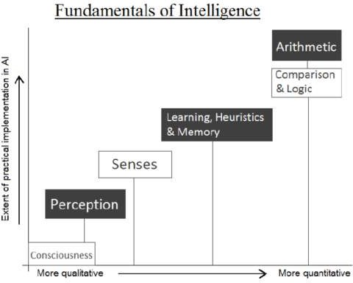

Figure-1: Analysis of Fundamental Traits of Intelligence and Today’s AI
ARTIFICIAL INTELLIGENCE / MACHINE INTELLIGENCE
This paper intends to offer summary concerning Artificial Intelligence application such as chatbot.
a) Partially Intelligent Systems
Any engine, system or application taking some of the overhead registered basics of intelligence is a Partially Intelligent System. For example, chatbots exhibition some of above listed characteristics, specifically Assessment, Logic & Intellectual and Learning, Heuristics & Memory. If there is an option for additional module, they may display some more qualities also, like ability to perform arithmetic operations. Therefore, chatbots are Partially Intelligent Systems.
b) Completely Intelligent Systems
Any machine, structure or database enlightening all of the mentioned basics of intelligence completely will be considered a Completely Intelligent System. Such a unit will represent the true power of AI.
c) Performance Factor
The Performance Factor of a system is a degree offered for representing the capability of an intelligent system in terms of the vital qualities of intelligence it holds.
IV. LITERATURE SURVEY
Eliza is been considered as the first chatbot which works on the pattern matching system. It was developed by Joseph We izenbaum in 1964 [3]. ALICE [2] is a rule-based chatbot based on the Artificial Intelligence Markup Language (AIML). It has several categories, where each category has combination of pattern and its response.
The need for college inquiry system comes up due to multiple reasons which include the slow nature of college website, an outsider would not know where to search for a particular piece of information, difficult for the person outside college’s domain to extract information. The smart solution for all the drawbacks leads to the need of the system. This chatbot will deliver the reply by summarizing the enquiry and then output responses, it also delivers selective info what the user needs. A chatbot will distribute all answers connecting to domains such as admission, inspection cell, notice board, attendance, placement cell and other numerous domains.
The major features of the chat bot are
- College admission related queries could be answered through it.
- Viewing consumer profiles and recovers attendance and grade/ pointers.
- College students can get info about inspections to be held.
The objectives of this application are
- To analyse users queries and understand users message.
- To provide an answer to the query of the user very effectively.
- To save the time of the user since s/he does not have to personally go to the college for inquiry.
- This system will help the student to be updated about the college activities.
V. APPLICATIONS
- It allows the students to be updated with college related activities.
- It helps to saves period for the students as well as teaching and non-teaching employees.
- It provides us a readily available information source without taking any physical efforts for any task.
- It provide ease to use and access, saving time and cash also.
VI. CONCLUSIONS
It is really impossible to get all the required data on a single interface without the complications of going through multiple forms and windows. The present college chatbot intends to remove this difficulty by providing a common and user-friendly interface to solve basic queries of college students. The purpose of a chatbot system is to pretend a human conversation. The students can freely ask queries to bot any time. The chatbot provides quick and effective search for answers to the queries. The database holds information about questions, answers, keywords, and logs. We have also developed an interface which will have two parts, one for users and the other for the administrator.
VII. FUTURE ENHANCEMENTS
Other than AIML based chatbot, other algorithms can be implemented. We can also take in voice-based queries. The users need to give voice input and the system will give the output in form of text. Moreover, post successful execution of chatbot in college sector, we can implement it in other fields like medical, forensic, sports, etc. It will be valuable in all the fields as without spending much time, we are accessing the relevant information and that too without any sorting.
VIII. REFERENCES
- Artificial intelligence Written By: B.J. Copeland
- B. Iftikhar, A. S. Alghamdi, “Application of artificial neural network in detection of dos attacks,”
- Daniel B. Neill, “Using Artificial Intelligence to Improve Hospital Inpatient Care”.
- https://becominghuman.ai/10-powerful-examples-of-ai-application https://en.wikipedia.org/wiki/Artificial_ intelligence
- http://www.nber.org/papers/w24449
- ISSN: 2277-3754 ISO 9001:2008 Certified International Journal of Engineering and Innovative Technology (IJEIT) Volume 4, Issue 10, April 2015 Artificial Intelligence and its Application in Different Areas.
- Kowalski, 2011. Robert Kowalski. Computational Logic and Human Thinking – How to be Artificially Intelligent. Cambridge University Press.
- N Ramesh, C Kambhampati, JRT Monson, PJ Drew,“Artificial intelligence in medicine”, 2004

CLOUD SECURITY: DISTORTION CONTROL AND PRECAUTION TECHNIQUE
Yadnesh Sachin Shimpi¹ and Prakash Patil²
Student¹ and Head², Department of Information Technology, K. J. Somaiya College of Science and Commerce, University of Mumbai, Mumbai
Abstract
Cloud Computing Security allude to the security implementation, deployment, and the precaution to defend against the security threats. Cloud Security deployment of security tools such as application firewall, controlling the policies and hardening the infrastructure. Though cloud computing is offering lots of services with the flexibility, efficiency, and also find threats in cloud services which is vulnerable. It allows the access to personal and shared resources with minimal management. Perfect example for cloud computing is Amazon Elastic Cloud Compute (EC2), which is highly capable, low cost and flexible. The purpose of this paper is to provide a comprehensive overview of latest advance and existing literature covering varieties of dimensions in cloud security. The paper also includes various attacks faced on cloud services and the methods to overcome on it is also been mention in this paper.
Keywords: Cloud security, Physical Security, Cloud deployment, Tools for preventing from attacks, Deployment, IT management.
Introduction
Cloud Computing Technology is nowadays most popular, because of its ability , flexibility and mobile support. Cloud Computing allows the access to the personal and shared resources with minimal management. It often relies on the internet. But there is third party cloud solution available which saves from expanding resources and maintenance. As we know the most trending example for cloud storage is Amazon Elastic Cloud Compute (EC2), which is highly flexible and capable along with low cost.
Some of the major features of cloud computing includes
▪ Automated Management
▪ Virtualization
▪ On-demand self-service
▪ Rapid Elasticity
▪ Measured services
▪ Distributed Storage
Types of Cloud Computing Services
⮚ Infrastructure as a service (IaaS)
⮚ Platform as a Service (PaaS)
⮚ Software as a Service (SaaS)
o Infrastructure as a Service (SaaS):- It is been used for accessing, managing process and monitoring. This infrastructure services (IaaS) also known as Cloud infrastructure service basically a self-service model. We can take an example like, Instead of purchasing additional hardware such as networking device, firewall, server and spending money on management, maintenance, deployment, IaaS model offers cloud based infrastructure to deploy the remote data center. Most common and popular examples of IaaS are AMAZON (EC2), Microsoft Azure, Google Compute Engine (GCE), Cisco Metapod.
o Platform as a Service (PaaS):- It allows the users to develop, run and manage the applications. PaaS offers Development Tools, Deployment platform, Configuration management, and migrate the app to the hybrid models. It basically helps us to develop and customize applications, manages OSes, virtualization, storage and networking, etc. Examples for PaaS are Intel Mash Maker, Google app Engine, Microsoft Azure, etc.
o Software as a Service (SaaS):- SaaS is the one of the most common type of cloud which is been used in cloud computing is widely than other services. On demand Software is centrally hosted accessible by user using client through browsers. An example for SaaS is office software such as office 365, Cisco WebEx, Citrix GoToMeeting, Google Apps, DBMS, ERP, CAD, HRM, messaging software, etc.

Cloud Deployment Models for Cloud Services are as follow
1. Public Cloud- Public Cloud are hosted by the third party which offers them different types of cloud computing services.
2. Private Cloud- Private Cloud are hosted personally & individually. Corporate companies usually have their own private clouds services due to their security policies.
3. Hybrid Cloud- Hybrid Clouds are combination of both private and public cloud respectively. Private cloud is used to enhance their sensitive and public cloud capabilities and services.
4. Community Cloud- They are accessed by the multiple parties having common goals and shared resources.
Benefits for Cloud Computing
▪ Increased speed- Cloud Computing environment has dramatically reduced the time and cost of new IT services the increase speed for the organizations to access the IT resources.
▪ Low Latency- In the using of cloud computing, the customers have the facility of implementing their applications with just few clicks, so they can do their task easily at minimal costs, i.e., not more time consumed as well as minimal latency is been produced.
▪ Security- In the terms of security, cloud computing is always been very efficient. Highly recommended advantages include less investment over security with the effective patch management and security updates. Disaster recovery, dynamically scaling defensive resources and other security services also provides with the protection against cloud computing threats.
▪ Less Economic Expense- This is the major advantage in cloud computing. No need to purchase any kind of external hardware for particular function. Data Centre, Networking, and other services can be easily virtualized over cloud saving the cost of purchasing any hardware, configuration and management complexity and less maintenance cost.
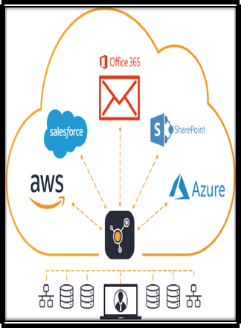
Working
Cloud computing consists of some activities that have been taken for the service provider end as well as the action that should be taken under the user end.
Cloud Security working under some control layers, which have been discussed below:-
✔ Application Layer
There are some security mechanisms, devices and the policies that provide support at different cloud security control layers. In the application layer, Web application firewall are deployed to filter the traffic and observe the behavior of the traffic. Likely, Software Development Life Cycle (SDLC), Binary Code Analysis, Transactional Security provides the security for online transactions, etc.
In cloud computing , to provide confidentiality and integrity of information that is being communicated between client and server, different policies are configured to monitor any kind of data loss. These policies includes Data Loss Prevention (DLP) and the content management framework. DLP is the feature which generally offers to prevent the leakage of information to the outside network. Traditionally this information may include company or organizations confidential data, proprietary, financial and other secret information. DLP also features ensure the enforcement of compliances with the rules and regulations using Data Loss Prevention policies to prevent the user from intentionally or unintentionally sending this confidential information.
Security of Cloud Computing regarding management is performed by different ways to approaches the Governance, Risk Management, and Compliance (Grc), Identity and Access Management (IAM), Patch and Configuration Management. These approaches helps us to control the secure access t the resources ad manage them.
✔ Network Layer
The next generation of intrusion prevention systems, known as NGIPS, is one of the efficiently active components in integrated threat protection solutions. NIIPS provide a robust security layer with deep visibility, enhanced security intelligence, and enhanced security against emerging threats to secure the network's complex infrastructure. The CISCO NGIPS solution provides deep network visibility automation, security intelligence and next level security.
It uses the most advanced and effective intrusion prevention capabilities to reach emerging sophisticated network attacks. It continuously collects all the information regarding the network, including the operating system, files and applications information, users and device information. This information helps NGIPS to determine network maps and host profiles which lead to contextual information to make better decisions about intrusive enhancements.
✔ Trusted Computing
The Root of Trust (RoT) is established by validating each components of hardware and software from the end entities up to the root certificate. It makes ensure that only trusted software and hardware can used while still retaining the facilities and also retaining the flexibility.
✔ Computer and Storage
Computer and Storage in cloud Computing can be secured by implementing Host-Based Intrusion Detection or prevention system HIDS/HIPS. Configuring Integrity Check, File system Monitoring and log file analysis, connection analysis, Encrypting the storage, Kernel Level Detection, etc.
Host Based IPS/IDS is normally made for the protection of specific host machine, and it works closely with operating system Kernel of the host machine. It creates the filtering layer and some kind of filters which make them to purify any malicious application call to the OS.
✔ Physical Security
Physical Security is always been the required priority to secure anything. It also the first layer OSI model, if devices is not physically secured, any sort of security configuration will not be effective. Physical security includes protection against man-made attacks such as damage, thefts, unauthorized physical access as well as environmental impact such as dust, rain, fire, power, failure, etc.
Experiments
In clouds computing the most common attacks that are being used by an attacker to exploit or extract sensitive information such as gaining an unauthorized access. The attacks are as follow-
● Service Hijacking using Social Engineering Attacks-
As we know about the social engineering attacks. Using social engineering techniques, an attack can be attempted to guess the password. Social engineering attacks occur when unauthorized access to uncover sensitive information according to the compromised user's privilege level.

● SQL Injection Attack
SQL injection attacks allow attackers to lose identity, cause damage to existing data, and also causes counter attack. Issues such as transactions or changing balances allow full disclosure of all data on systems, destroying data or otherwise being unavailable, and becoming administrators of database servers.
● Domain Name System (DNS) Attack
Domain Name System (DNS) attack include DNS Poisoning, Cybersquatting, Domain hijacking and Domain Snipping. An attacker may attempt to spoil the DNS server or cache by poisoning it to gain internal users' credentials. Domain Hijacking mainly involves in stealing cloud services domain name. Similarly, through Phishing scams, users can be redirected to a fake website
● Session Hijacking using XSS Attack
By launching Cross-Site (XSS), the attacker can steal cookies by injecting malicious code into the website.
● Cryptanalysis
Cryptanalysis is the science of encoding and decoding codes. It is used more benignly, to find and correct weaknesses in encryption algorithms, to violate authentication schemes, and to break cryptographic protocols.
● Dos/DDoS Attacks
DOS / DDOS attacks are being done to create a machine or network. Temporarily unavailable and indefinitely interrupted service of host network to connect to server
● Session Hijacking using Session Riding-
It is been use to intend for session hijacking. An attacker may exploit it by attempting cross-site request forgery. The attacker uses currently active session and rides on it by executing the request such as modification of data, erasing data, online transactions and password change by tracking the user to click on malicious link.
● Service Hijacking using Network Sniffing
Using Packet Sniffing tools by placing them in the network, then attacker can capture sensitive information such as password, session ID, cookies, and another web service related information such as UDDI, SOAP, and WSDL.
Tools used to detect & prevent those attacks are as follow-
o Core Cloud Inspect
Core security Technologies offers “Core CloudInspect”, A cloud Security testing solutions for the Amazon Web services (AWS). This tool has been helping to make the profits from the core Impact and core Insight Technologies to offer penetration-testing as a service from Amazon Web Services for EC2 users.
o CloudPassage Halo
CloudPassage Halo provides a broad range of security controls. It is focused Cloud Security solution which prevents attacks and detect the indication of compromise. Cloud Passage Halo operates under ISO-27002 security standards and is audited annually against PCI level 1 and SOC 2 standards. Cloud Passage Halo is the only workload security automation platform that provides speed and scale to on-demand delivery of security control speeds across data centers, private or public cloud, virtual machines, and containers. Unlike traditionally security systems, Halo and its secure APIs integrate with popular CI / CD toolchains and processes, providing periodic feedback to fix vulnerabilities in the development life cycle. This allows DevOps teams to perform security teams by providing the validation they need. Halo integrates easily with popular infrastructure automation and orchestration platforms allowing Halo to be easily deployed to continuously monitor workload security and compliance posture.
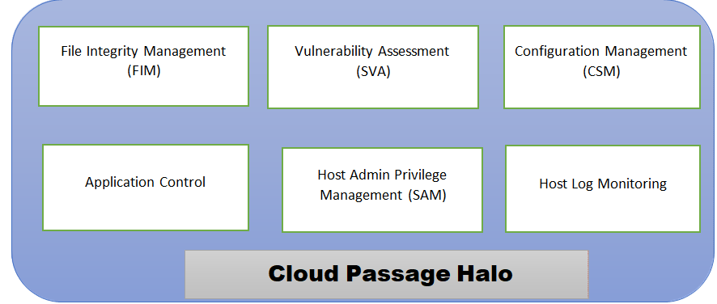
Fig: CloudPassage Halo
Conclusion
In Research studies, there should be a bond of trust and privacy between the service provider and the client. Security must be seen as a continuous process to meet the changing needs of a highly volatile computing environment. There is a need to have a holistic view of cloud computing security methodology, which can be used in any service model in general, as long as the customer is not using the service. There should also be self-awareness from the client about self-protection. In view of these observations, this study provided a detailed review of the existing literature and offered several research areas based on existing research work where future work is required. The paper can provide an important aid for obtaining research areas where further work is required, especially for entry-level researchers. The responsibilities provided by the service provider should be consisted of web application firewall, secure web gateway, load balancer, application security and virtual private network. Cloud service clients should be aware of public key infrastructure, firewall, encryption, security development life cycle (SDLC), and others.
References
- Cloud Computing in a general perspective.- Journal of computing and management studies- January 2019.- ISSN 2516-2047 Issue 1 – Volume 3
- A survey on Cloud Cloud Computing and Hybrid Cloud.- International Journal of Applied Engineering Research ISSN 0973-4562 Volume 14, Number 2 (2019) pp. 429-434 by M.P.Vaishnavve
- Hindwai Wireless Communication and Mobile Computing, Volume 2019, Article ID 8204394 introduces “Recent Advances in Cloud Aware Mobile Fog Computing”
- “Measuring Information Security and Cybersecurity on Private Cloud Computing.” By Wendy, Wang Gunawan published on Journal of Theoretical and Applied Information Technology- January 2019 at ISSN 1992-8645
- Journal of Analysis and Computation (JAC) –ISSN 0973-2861. D.Sakthpriya an Assistant Professor Introduces “Security Issues In cloud Computing”
- The Calculus of Cloud Computing.- Research Centre of Big Analytics and Intelligent Systems (BAIS) By”Zhaohao Sun”Bias 4(11):1-6
- Study on Cloud Storage and its Issues in Cloud Computing.- International Journal of Management, Technology And Engineering ISSN 2249-7455 by Dr. K.Sharmila
- Improving Database Security in Cloud Computing.- Journal of Applied Science and Computation ISSN 1076-5131 by Mrunali Sangar Professor at B.A.Kelkar.
Studying Dark Web a boon or an imprecation
Rishabh Rajendra Ghodke¹ and Pournima Bhangale²
Student¹ and Head², Department of Information Technology, The Kelkar Education Trust’s V. G. Vaze College of Arts, Science and Commerce, University of Mumbai, Mumbai

What Is the Dark Web?
What if I told you that all your demands in this world, no matter what will be completed here. What if you become the bad guy you fantasize to be and don’t get your hand dirty?
Let me make you understand the darkest region of the internet, Darkweb. So what the heck does all of that mean? Well, consider that everything you do on the Internet is based on long-established standards. There are dozens of different web browsers, but they ALL work the same way. They all use the same ports and protocols to request, transfer and view data on the Internet. Think of it like a business that is run by the mob. There is a store that is a real and fully operating store that anyone can walk into and shop from. But then there is the back of the store where other things are happening. It may be criminal in nature, or it may simply be a place where people can have a conversation that will not be monitored by anyone else. In order to get into the back area of the store, you need to say a password to the guy working in the front. Well, this is really all the Darkweb is. You use special software, such as TOR (The Onion Router) or Freenet which creates these non-standard connections and allows you to browse around (often using your regular browser, but modified to work on the Dark Net). These Dark Net applications are also heavily focused on keeping you absolutely anonymous. Most people think they are anonymous on the regular web, but in actuality your browser provides tons of information to reveal who you are and where you are.
So the ultimate goal of the DarkWeb is to provide 100% anonymity. There is nothing inherently sinister about the Darkweb, and people who write the software which creates these connections are primarily motivated by trying to allow people living under extremely oppressive governments to have access to all of the news and information that those of us living in free societies take for granted. Unfortunately, that is also exactly the sort of environment which attracts criminals, terrorists, and all manner of individuals who wish to share such dubious content as illegal pornography.
If you do decide to explore the DarkWeb, you just need to be EXTREMELY careful! It is very much a lawless environment, and you could very easily have your computer compromised and not even realize it.
Dark Web. Yes, this is the place. A mysterious virtual world, loaded with the darkest secrets of humanity, Mecca of people seeking an adventure sitting at home.
First came across the term when I went for a MUN a year ago about Contraband Trafficking. (I am 'unexplainably' good at MUNs that's different.) Back then the word made no sense to me. What I cannot access how do I know what it is? I was too ignorant back then to even put decent research in this topic. Most of them are dead, because the deep web sites keep shifting from one URL to the other and they are too complex to be kept in memory.
On the first day (rather night)I found these things: 1. Online anonymous chat for people using deep web. 2. 1000000+ warnings about child porn saying it's illegal. 1000000++1 people in chat rooms wanting links for child porn sites. 3. Used DuckDuck Go search because Google tracks you. 4. Got notEvil, a TOR search engine. Day by day I discovered more:
- A guns and ammo store
- A site selling Kamagra, Viagra.
- Site selling stashed iPhone and electronics.
- From this I got the link to a drug trading site. H
- Another link to a site where you can apparently hire Hitmen to do the dirty job for you.
- Then comes the main deal.
I found a site, claiming to supply forbidden information. I found there stuff as: · Lock picking tutorial. A text fileYou need a lock pick for it and I haven't got any idea how to buy one) · Burglary, robbing, shoplifting tutorials. All text files. Interesting little text file. · Tutorials on cannibalism, how one butchers a human corpse for human consumption, the criterion for choosing the right “animal” and how to treat it before killing. You get a bonus recipe too, for cooking it. Was reading it in a public bus, feeling like an anarchist plotting his move.
Tutorials on fighting , being a Hitman, assassination guides. · Entire collection of Islamic propaganda Dabiq magazine. · Jihad Snuff Videos- The ones where people are shot and beheaded. Got them in a torrent. Watching one disgusted me so much I got rid of them in one go. This really makes you feel the reality of terrorism even when you are sitting in the comfort of your home. I have never seen anything so horrible.
There are more to that site I haven't found all of them. Here are some more things I found on while I was searching the deep web with notEvil:.
- Porn: the ones on the deep web are nothing special, just like surface web sites though they load slower in deep web because of th multiple proxy servers
- Sites which claim to supply counterfeit driving licences, ID proofs, credit cards and other fake IDs. 4. Child porn. Yea a debated topic. You keep on hearing about sites like Lolita City but they are most probably closed now because the people behind these sites have been but behind the bars. However, I came across child nudity when I least expected to. I searched for Vintage and I ended up with child porn. Never visited that site again.
- Red Rooms
The one that is most persistent is the myth of the "Red Room" - live streaming of torture/rape that ends in the murder of the victim and which people can pay to watch, or even bid to type in commands for the torturer to carry out (highest bid wins!). The most famous was the “ISIS Red Room” pictured above, where people could provide instructions to torture captured terrorists -
People have this idea of Hostel with webcams exist all over the darkweb, but you just need an invite to get into them. It's ridiculous. They don't exist. They certainly wouldn't exist on Tor. But people are desperate to believe and they always come back with "You can't prove they don't exist, people are crazy, therefore they must exist." Picture my eyes rolling here.
2. Hitman sites
I don't think many people are taken in by the hitmen sites anymore, though the press loves playing up the fact that there are sites offering up hitman services. But every single one of them has turned out to be a scam, especially Besa Mafia, the one that did the most marketing. Again, you can read about it at the same link as above.
3. Exotic animals
People are always asking where they can find markets for exotic animals. Obviously the illegal trade in exotic animals exists, and some communications and transactions may well take place over Tor, but there are no markets like the drug markets where you can go and look at a picture and then put a tiger or ocelot or something into your basket and buy it with bitcoin.
1.2 SO WHAT DOES HAPPEN ON THE DARKWEB ?
1. People buy and sell drugs.
The drug markets are more busy than ever. You have probably heard of Silk Road, the most famous online drug market that got busted a few years ago and the owner sent to prison for two consecutive life terms? A lot of people thought that was the end of drugs being sold on the darkweb. In fact, darkweb sales of drugs have tripled since the shutdown of Silk Road.
The reason people buy drugs this way is that for many they offer a safer alternative for people who are going to do drugs anyway. There is no possibility of any violence. The vast majority of the time a buyer knows exactly what they are getting, because of the feedback and rating system. That's not the case in a nightclub, or even friends-of-friends, where you just blindly accept that the pill, powder or tab is what the seller says it is.
2. People buy and sell other illegal things
Mostly they buy and sell stolen credit cards and financial information, fake IDs (though lots of these are scams), personal information, “dumps” of hacked data and fraud-related items. For a long time, a seller was making a fortune selling fake discount coupons that really worked.
3. People access and create childporn
Unlike the other markets, the CP market is generally not for money, but rather they are groups who swap vile images and videos for free. The worst of the worst is called “hurtcore’. Thankfully, most of the people behind the worst sites have been arrested and put in jail.

4. People talk about stuff
There are plenty of sites, forums and chatrooms where people talk about all sorts of things - conspiracies, aliens, weird stuff. They take advantage of the anonymity.
5. People anonymously release information
Whistleblowers use the darkweb to release information and make sure their identities won't be compromised. You will find Wikileaks, for example, on the darkweb.
6. People surf the web anonymously
The number 1 thing people use the darkweb for is just to surf the web completely anonymously. Not everybody wants to be tracked by advertisers.
There are a lot of things that are happening there. A lot of them are bad. Some most popular illegal activities down there are:
- Trading with firearms
- Hired hitman services
- Trading with drugs
- Childporn
- Terrorists' pages and footages
- Confidental data leaks
- Sharing ideas on how to rule the world
- "How to make amfetamine at home" etc.
- Explosives manuals
- Advices for beginner assasins
And many other. I've even heard of websites, all dedicated for necrofils (those who like dead bodies). Really, there are so many weird websites, that a lifetime is not enough to find and visit them all. Is there anything good in the Deepweb then? Yes, but when comapared to the "bad" part, it's almost nothing.
Why can't we stop it then? Well, it's quite complicated
1.3 Who controls the Darkweb?
First of all be clear with the fact that dark web is that part of internet which can’t be accessed by the browsers in their normal configurations or has certain special protocols that need to be followed for having access to it. So if today I create a browser of my own that follows protocols other than what we us usually have and create host some websites that can be accessed only by the browser that I created those websites will be part of dark web.
Most commonly known dark web includes onion websites or TOR network which you access using TOR browser. Even freenet and I2P are not well known to public.
So I will keep the answer limited to TOR project and onion websites aka TOR network.
If you have been using github you must be aware of open source codes and their management. Well TOR project is open source and everyone has equal privilege for suggesting any changes in it (changes should be meant for its betterment or improving its functionality and privacy level with time). Again I say its an open source so anyone can read its source code and also the changes that are being brought. Its a peer to peer network (and not a client server system where server is the central party) so there is no centralisation. So anyone can become a relay or node in this network, anyone who wants to improve the experience of its users. Many individuals and organisations are relay in TOR network at the date.
So no one controls the TOR but public as a whole (nodes are what your traffic passes though to privide you anonymity, by default your traffic will pass through 3 nodes but you can configure manually the number and the nodes also).
The Tor Project, Inc - a non profit organisation works for maintaing the tor browser and that doesn’t mean it controls the TOR network. TOR network is not controlled by any single person or organisation.
Also note that American agencies are known for looking into privacy of users accross the internet and many of nodes or relays could be of these agencies especially the exit nodes. Also because these agencies are known for gathering “fingerprints” of users (it involves a lot of details related to your device and activities say time zone, language settings, Operating system, installed plugins, screen resolution etc) and suppose today you go to google and search TOR download all your fingerprints will ne stored by these agencies corresponding to the fact that you must be a TOR user (of course they can also check if you visited TOR download page later and activity you did there). But that diesel mean they control TOR web that simply means they also became a part of it and are trying to fugure our notorious persons. Anyways surfing TIR web is not a crime unless you do surf illegal websites like child porn or human trafficking or drug dealing etc. Also TOR browser itself keeps improving and handles your anonymity at its best (best encryption) and also includes fingerprints ( TOR browser is configued so that user’s fingerprint is identical to every other Tor browser and is no different from common fingerprints across the we ). Also there are other several tools to spoof fingerprints.
I did a survey to understand if people really know what is dark web or have they ever tried to access Dark web.
Following were the questions asked to students from different age categories and different streams.
- Do you know what is Dark web?
- Do you know why dark web is used?
- If yes tell us why it is used.
- Have you tried to access dark web?
- If yes, why ?
- If no, will you access dark web? why ?
- According to you what makes dark web different from surface web?
The results were quite surprising.
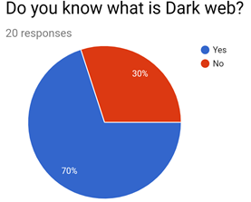
Diagram 1.1
From the above pie chart we understand that 70% of people know what is Darkweb. whereas 30% of people are unaware of Dark Web which is quite shocking because nowadays because of the tremendous use of technology and internet the risk of our personal information or private information can be hacked or stolen if ever people try to access dark web without proper knowledge or precautions. Dark web is full of illegal and harmful data which can harm your device or harm your mental health because of cruel, graphic and pornographic content.
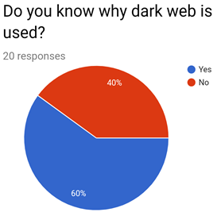
Diagram 1.2
Looking at the above piechart we understand that the people who know why dark web is used is more i.e 60%. That means 10% of the people have heard about Dark Web and are unaware why it is used.
40% of the people are not aware why dark web is used.
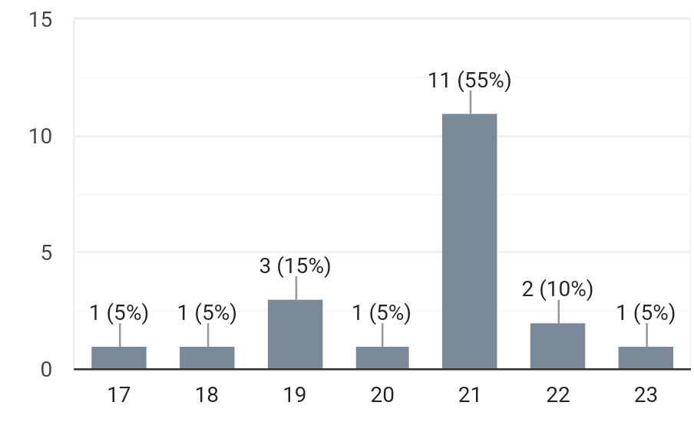
Diagram 1.3
The survey was conducted between the age group of 17 to 23
People who know what is dark web are aware about the illegal activities that take place.
Dark web is used for illegal trade where bitcoins are used to pay for goods or any service which aren't free.
According to my survey, these are some inferences which I have drawn.
Dark web as a website is quite common, however not much people know about its actual purpose. It is seen that people are extremely curious about the Dark web or want to access it to browse about its actual content. Along with curiosity, many have opted to access it for fun as well.
On the other hand, reasons to not access the Dark web are quite common.
Mostly those are because of ethics and it being illegal. People are also concerned about different viruses that can come with accessing the Dark web.
Popular opinion was that the Dark web is different from surface web (eg: Google).
Anonymity being an important aspect of the Dark web. Secondly, Dark web cannot be accessed by anyone. People highly regard it as a dangerous web surface because it is considered illegal.

1.11 Conclusion
We have the following conclusions:
First, while important for information search, the dark Web remains largely unexplored– At this point, it is neither well supported nor well understood. The poor coverage of both its data (by search engines) and databases (by directory services) suggests that access to the deep Web is not adequately supported. This survey seeks to understand better the dark web. In some aspects, the dark web does resemble the surface Web: It is large, fast growing, diverse and can be dangerous.

1.12 References
- N. Bertrand, 2015. “ISIS is taking full advantage of the darkest corners of the Internet,” Business Insider (11 July)
- M.W. Al Nabki, E. Fidalgo, E. Alegre, and I. de Paz, 2017. “Classifying illegal activities on Tor network based on Web textual contents,” Proceedings of the 15th Conference of the European Chapter of the Association for Computational Linguistics, pp. 35–43 23 April 2019.
- THE STATE OF CYBERSECURITY By Darren Guccione, star Advisor, Contributor, CSO | 4 JULY 2019
- NICOLE KOBIE “What is the dark web? How to use Tor to access the dark web” Sunday 19 May 2019
- Mohammed Farook Bin Rafiuddin, Hamza Minhas, Prethpal Singh Dhubb “A dark web story in-depth research and study conducted on the dark web based on forensic computing and security in Malaysia”, 2017 IEEE International Conference on Power, Control, Signals and Instrumentation Engineering (ICPCSI)
- Pranshu Ranakoti ; Saurav Yadav ; Aviral Apurva ; Shashank Tomer, Nihar Ranjan Roy “Deep web & online anonymity” 2017 International Conference on Computing and Communication Technologies for Smart Nation (IC3TSN)
- Greenberg, 2014. “Hacker lexicon: What is the dark Web?” Wired November 2019.
De-Duplication in Cloud Storage: A Review
Rohit Ganpat Kalambe and Kalpesh Anil Dalvi
Department of M.Sc.IT, S. S. & L. S. Patkar Varde College, University of Mumbai, Mumbai
Abstract
Now a days Cloud Storage is becoming popular not because of its cost efficiency but because of its provision of huge storage that’s why for user outsourcing data is easy. Based on surveys it is told that half of the storage on cloud is occupied by duplicate data or files [1]. So, it is necessary to learn new techniques for save bandwidth and disk space. It is challenge for cloud service provider to manage increasing huge quantity of data. To manage this increasing data many data management techniques are introduced one of them is De-Duplication. In deduplication it stores or keep only one physical copy of data instead of storing multiple copies of exactly identical data. Cloud storage services like Google Drive, Dropbox, Mozy choose deduplication technique [4].
Keywords: Cloud Service Providers (CSP), Data De-Duplication, Cloud Storage, Convergent Encryption
I. Introduction
The most important service in cloud is data storage service. Users upload their personal data on cloud and it is mange by cloud service providers. After looking at the increase in amount of data it is expected that 44 zettabytes of data will produce in 2020. Now a days the management and storage of this large amount of data is challenging.
De-Duplication technique attracted more attention to make data management more scalable. When same data is outsourced by multiple user’s deduplication is more effective [4]. De-Duplication is one of the data compression technique [4]. In deduplication it stores only one physical file of data and provide the pointers to the similar data holders. Because of deduplication 68 percent in standers file and in backup application 90-95 percent data storage reduce.
In cloud services the privacy and security of user data is important to maintain that privacy data is uploaded in encrypted format. When user encrypt data using traditional encryption technique deduplication not work on it, to overcome this problem convergent encryption technique is introduced.
II. Forms of Data De-Duplication
Data de-duplication has different forms [1]. Different organization use multiple strategies according to their need. Data De-duplication has three types.
- Compression
- Single-instance storage
- Sub-file de-duplication
- Compression
Data compression compress the given file and reduce the file size it does not eliminate duplicate files. It works within the file. It helps with identify empty space which appears in repetitive patterns and remove it. That data de-duplication is local to file and remain independent to data segments and other files. Data compression is available for many years but its advantages are limited it is isolated for each individual file. It cannot identify the duplicate file and remove it but it will compress each independent file
- Single-instance storage
As a name suggests the single-instance storage (SIS) keep only single instance of data and pointers are provided for other users who own the same file. The SIS can remove multiple copies of same file [1]. It can detect and eliminate multiple copies of identical file. In SIS system check the content of file before uploading it on cloud to determine the file is identical with existing file or not. The files which are stored as a unique in cloud using SIS there may be large number of redundancies in those files of file. The SIS check the whole file as a one so if new name is added to the presentation of same file it will declare that file as a different file without further deduplication even if the change is very small.
- Sub-file de-duplication
If redundant data exists in different file it can be avoid using sub-file deduplication. Using sub-file deduplication redundant data are removed even if duplicate data exists in nonidentical file. As a result, it removes duplicate data from data storage. The sub-file deduplication has two types of implementation.
- Fixed-length
- Variable-length
- Fixed-length
Fixed-length deduplication use the fixed length of data to search redundant data within file. This method is simple in design but many redundant sub-file data. Assume that if new name is added to the files title the whole content of that file will shift and it will result in failure in data deduplication. That means the small change in file cause the non-equivalencies in file.
- Variable-length
The variable-length implementation is not correspondent to the segment file. It matches the segment size and check duplication which are occurring within the file, so this method increasing the ratio of deduplication.
III. Data De-Duplication Process
Data deduplication is also called as Intelligent Compression means of reducing the data amount that need to store. The process of deduplication works with eliminating repeated or redundant data and store only first unique instance. If user tries to store the data which is already present in data storage then it creates the pointer rather than storing redundant data. Using hash algorithms such as SHA1 of MD5 the unique hash number is created for each chunk or file. The created unique hash value is compared with the existing hash value in the index. If the new hash number and existing number did not match then the data store in storage and the hash value of that data is added to that index. If the new hash value match with index hash value then it will not store data and the hash value it will update the data owner list and add new owner to that list. Sometimes the algorithm produces the same hash value for different chunks its call hash collision, it is necessary to avoid hash collision to prevent data loss. In Fig. 1 the de-duplication process is shown. In this process three users are involved. The users upload their data to the server. The file B1, B2 and B3 is common and hence when deduplication happens it will only store the one copy of B1, B2 and B3 and provide the pointers to the other owners who try to upload the same data file. The deduplication technique saves the storage space and bandwidth but also increase the speed of disaster recovery process and remote backup.
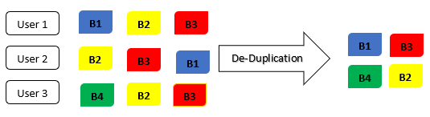
Fig-1: Data De-Duplication Process
IV. How De-Duplication works?
De-Duplication compares the data usually in files or blocks and remove redundant data which are already present in data storage. It keeps the data which is unique and eliminate the data which are not unique. The process is as follows.
- Divide the input data in blocks or chunks.
- The calculation of hash value for each block is needed.
- The hash values which are got is use to determine the blocks are already stored or not.
- Replace the redundant data with pointers or reference of the blocks which are already exist in database.
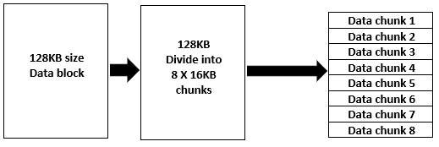
Fig-2: Division of blocks according to chunks
As shown in Fig. 2 the data block is divided in equal data chunks and for every data chunk the hash value is created as shown in Fig. 3. An index is created from the result of data chunk and using that index redundant data is found and eliminated. Only one copy of every data chunk is store in storage.
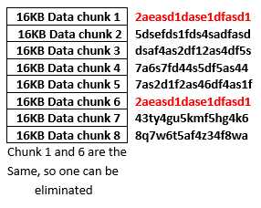
Fig-3: Hash number generation for data chunks
Once data divided into chunks, using the hash value of that chunk index can be created and using that index redundant data that will found is removed and only single file of every chunk will be store. The deduplication can implement in number of different ways. The duplicate data can be removed by comparing files and remove which is old and no longer needed.
V. Implementation
Using convergent encryption data confidentiality is provided in process of data deduplication. The convergent key is derived from the original file and either using SHA1 or MD5 the data copies are hashed and encrypts the data or file using generated encryption key. The tag is also derived from the original data copy, this tag will use for duplication detection or check. If the tags of two files are identical, it means their data copies are also identical. The user first sends the tag to the public cloud to check whether the given tag is previously stored or not. Both tag and convergent key are derived separately that’s why they are independent, thus using tag you cannot achieve convergent key thus data remain confidential. The encrypted data or file and its tags are store on server side. For define convergent encryption there are four functions as:
- KeyGen_{CE} (M) – K this function is for convergent key from M to convergent key K, for original data or file M function is use.
- Enc_{CE} (K, M) – C this function symmetrically encrypts original data or file take convergent key K using M as its parameter to form ciphertext C.
- Dec_{ce} (K, C) – M is the function which use for decrypt the data, it takes ciphertext C and convergent key K as an input parameter and then recover original data or file M.
- TagGen (M) – T(M) is the tag T generation algorithm, tag is generated from original data copy or file M.
VI. Data confidentiality and deduplication
- Traditional Encryption
Data deduplication which is beneficial for data storage due to it some security issue arises. Users sensitive data can be attack to prevent that some encryption is done which provide some data confidentiality but this encryption technique is not compatible with data deduplication. Specifically, traditional encryption is not compatible with deduplication because different users encrypt their data with their respective privet key. Because of this even if the data is exactly identical their ciphertext will be different that’s why deduplication cannot be done because the files are not exactly same, it means there is no scope for data deduplication.
- Symmetric Encryption
Symmetric encryption uses common secret key k for encryption and decryption. Symmetric encryption has three functions:
- KeyGen_{SE} (1^{λ}) – k is the algorithm which generates the key k using security parameter 1^{λ}.
- Enc_{SE} (k, M) – C is algorithm which use for symmetric encryption, it takes k secret key and M message is an input and give C ciphertext as an output.
- Dec_{SE} (C, k) – M is algorithm which use for symmetric decryption, it takes ciphertext C and secret key k as an input and give M message as an output.
- Convergent Encryption
Convergent encryption ensures the confidentiality of data in deduplication. User derive convergent key for each message M and using that convergent key encrypt the message. The tag is also derived from that message M which use to detect duplicate files. If two message M have same tag that means the messages are same then deduplication work on them and eliminate one of the messages and provide pointers. For define convergent encryption there are four functions as:
- KeyGen_{CE} (M) – K this function is for convergent key from M to convergent key K, for original data or file M function is use.
- Enc_{CE} (K, M) – C this function symmetrically encrypts original data or file take convergent key K using M as its parameter to form ciphertext C.
- Dec_{ce} (K, C) – M is the function which use for decrypt the data, it takes ciphertext C and convergent key K as an input parameter and then recover original data or file M.
- TagGen (M) – T(M) is the tag T generation algorithm, tag T is generated from original data copy or file M.
The convergent key is obtained from cryptographic hash values of the message M, this convergent key is use for the encryption and decryption of the message M. Using convergent key, the same cipher text obtains from the identical data of the different users which makes deduplication feasible with data confidentiality.
- Proof of Ownership
The Proof of Ownership (PoW) allow the user to prove the ownership of data M to storage provider. Proof of Ownership (PoW) is work as interactive algorithm between user and storage server. The Ф(M) is derive from the data copy M by storage server. Then user send Ф to the storage server to prove the ownership of data. If Ф=Ф(M) that means the user have the same data which is already available in the storage data and then the user is accepted as an owner of that data and added to the owner list.
VII. Conclusion
The data confidentiality is most important concern to the user and deduplication provides it. The data deduplication is very convenient and cost effective. Deduplication provides data protection while doing duplicate check. We see need for deduplication, how deduplication works, types of deduplication and how to make deduplication compatible with encryption. We see how the convergent encryption is better than the traditional encryption, we learn how the Proof of Ownership (PoW) confirm the ownership of data. Because of deduplication user is not charged for duplicate storage, it also provides security from insider and outsider attackers.
VIII. References
- Aarti Waghmare, “Data Deduplication in Cloud Storage”, National Conference on Advances in Computing (NCAC 2015), International Journal of Computer Applications.
- K. Akhila et al, “A Study on Deduplication Techniques over Encrypted Data”, Procedia Computer Science 87 (2016) 38-43.
- Johnson et al, “A Technique for Secure Data Deduplication in Cloud Storage”, International Journal of Advanced Research in Computer Science and Software Engineering 7(12), ISSN(E): 2277-128X, ISSN(P): 2277-6451, pp. 91-95.
- S. Supriya et al, “A Study on Data Deduplication in Cloud Computing”, International Journal of Advance Research in Computer Science, 8 (8), Sept-Oct 2017, pp. 209-213.
- Mishra et al, “Encrypted Data Management with Data Deduplication in Cloud Computing”, European Journal of Advances in Engineering and Technology, 2018, pp. 5(1): 43-49.
- M. SriRama Lakshmi Reddy and Dr. M. Janga Reddy, “A Survey on Secure Data De-Duplication in Cloud Storage”, Indian Journal of Computer Networking & Modern Technique, Volume 7, Number 1 (2019), pp. 23-31
- Saravanan Palani, Sangeetha E. and Archana A., “Implementation of Deduplication on Encrypted Big-data using Signcryption for cloud storage applications”, International Journal of Pour and Applied Mathematics, Volume 119 No. 12 2018, pp. 13409-13421.
- B. Tirapathi Reddy et al, “A Comparative Study on Data Deduplication Techniques in Cloud Storage”, International Journal of Pharmacy & Technology, Sep-2016, Vol. 8, Issue No. 3, pp. 18521-18530.
- R. Shobana et al, “De-Duplication of Data in Cloud”, International Journal of Chemistry and Science, 14(4), 2016, ISSN 0972-768X, pp. 2933-2938.
- Supriya More and Sharmila Gaikwad, “Secure Cloud using Secure Data Deduplication Scheme”, International Research Journal of Engineering and Technology, Volume: 5 Issue: 5, May 2018, e-ISSN: 2395-0056, p-ISSN: 2395-0072, pp. 793-799.
- Vaishnavi Moorthy, Arpit Parwal and Udit Rout, “Deduplication in Cloud Storage using Hashing Technique for Encrypted Data”, ARPN Journal of Engineering and Applied Science, Vol. 13, No. 5, March 2018, ISSN 1819-6608, pp. 1912-1917.
- Qun Tu, “Data Deduplication mechanism for cloud storage system”, International Conference on Cyber-Enabled Distributed Computing and Knowledge Discovery, 2015, pp. 286-294.

E-Banking Security & Encounters
Nishant Ramesh Sinha¹ and Prakash Patil²
Student¹ and Head², Department of Information Technology, K J Somaiya College of Arts and Commerce, University of Mumbai, Mumbai
Abstract
Banks are using traditional technology in the head of connecting technology to improve their products, services and efficiency. Banks are using electronic and telecommunication networks to deliver widespread range of value added products and services. Security and safety of e-banking transactions is the most vital area. Security issues include accepting internationally with best and smallest technology standards for access control, encryption / decryption (minimum key length etc.), firewalls, verification of digital signature, etc.
The monitor and operation issues can have various risk controller measures, advance warning system, Information technology assessment and re-engineering of operational procedures.
I. INTRODUCTION
IT revolution has introduced new technologies are being used in production and service sector. IT tools are used for the better performance and at a faster growth rate. Arrival of foreign and locally private banks with effective technology pressed banks to follow the latest technology to meet the growing competition and keep their customer satisfaction. Privacy in Internet banking is combination of both the computer and communication. The main aim of computer security is to preserve computing resources against illegal use, and to protect data from accidental and careful damage, release and modification. The purpose of communication security is to shield data during the communication in computer network and distributed system.
I. Protection privacy of an individual
Authentication: Process of verifying demanded identity of the user, machine and software component or other entity. An IP identifies a computer system on the Internet, just like a phone number recognizes a telephone. It is the responsibility so that unauthorized users do not enter, or for verify the sources from where the data are received. Its very important and it ensures approval and accountability.
Access Control: Process to control the access to the system and its facility and providing the access facility by allocating resources. It provides protection of the system resources against third party access. access control uses the authenticated characters of principals and the information about these principals to identify and grant access rights. It is done based on hand in hand with verification.
Data Confidentiality: It is process to provide protection of data from immoral expose is called data confidentiality. Internet is open to all, all data transfer can be monitored and read by others. It is difficult to monitor the transmission of data at random, because of different links and various un ethical practices. This may include different details such as credit card number, deposits, loans or password etc. Confidentiality is way beyond data transfer and includes various connected data storage system. Password and various access control approaches help in to secure data.
Data Integrity: It takes care that the data is not misused in wrong way or is changed. Loss of consistency of data can be done by human and hence it is human error. It can be intentionally tampered, or even disastrous events can occur. Delay in protecting the data can damage the data or even it can be erased or tampered. Efforts must be made to ensure the precision of data all the time. Access control, encryption and digital signatures are the methods used to confirm data integrity.
Non-Repudiation: Non-Repudiation allows creating a proof that the data sent by the sender has reached the recipient and is not false or the data received by the recipient is not false. To look that a transaction is safe, measures must be taken to forbid parties from arguing the validity, refusing to acknowledge, genuine communication or transaction.
Security Audit Trail: It is a self-governing review and inspection of the system's records and activities and test for capability of system controls. It ensures defiance with recognized policy and operational procedures, look at the unfair activities.
What are different types of Attacks and Compromises?
When a bank’s system is connected to the Internet, attack can be done anytime and from anywhere around the world. Favourable level of security must be installed before business on the Internet can be conducted easily. An attack could be of type:
• The unknown person can gain unauthorized access.
• The person can gain access and can destroy, corrupt or otherwise can change data.
• The Person gains access and grabs control partially or entirely, perhaps denying access to important users.
• The unauthorized user does not gain access but gives fake message to the system.
• The user is not able to access, but introduces various malicious and harmful measures that leads in failure in network, reboot, and hang.
• Todays security techniques have made the security very strong but not impossible. The system should be configured and security patches updates should be done regularly so that there is not any loop hole. There is various information with respect to security hole and their fixes is freely available on the Internet. System administrator should be update himself from new coming challenges information about the new technology.
Common cracking attacks include
• E-mail bomb and List linking.
• Denial-of-Service.
• Sniffer attack.
• Utilizing security hole in the system software
E-mail bomb: It is a harassment tool. An old-style e-mail bomb is just filling your mail box with irrelevant mails so that the inbox is filled.
Denial-of-Service (DoS) attacks: DoS attacks can temporarily injure the entire network (or at least those hosts that rely on TCP/IP). DoS attacks mainly takes place at the heart of IP implementations and hence it can pick up at various platform, a single DoS attack can work on various different operating systems. The DoS attacks are well identified and properly documented. Suitable measures must be taken.
Sniffer Attack: Sniffers is a device which capture network packets. It is a mixture of hardware plus software. These work by introduction the network interface into immoral mode. In normal situations, these machines on the network can 'listen' the traffic passing through, it will only respond to data addressed precisely to it. Yet, if the machine is in promises mode and hence it can seizure all packets and frames on the network. Sniffer collects passwords and many other confidential information. Sniffers are very difficult to detect as because they are the passive programs. Encrypted session provides an effective solution for this. Not all applications have combined encryption support.
Utilizing security hole in the system software: A hole is any defect found in hardware, software or policy that allows attackers to gain unapproved entrance to your system. The network tools can have holes are the Routers, Client and Server software, Operating Systems and Firewalls.
II. PROBLEM STATEMENT
Reserve Bank of India has set up an “Working Group on Internet Banking” to inspect different phases of Internet Banking. The Group had previously focused on major issues of I-banking:
• Technology and security matters
• Legal issues
Monitoring and administrative issues RBI has accepted the recommendations from them and will be handled in phased manner. Banks are given advise about the original report, for a detailed guidance on different issues. Internet must be secure to reach a strong level of confidence with both customers and businesses. This will help in issues that will help maintaining a strong level of public self-confidence in an open network environment include:
• Security
• Authentication
• Trust
• No repudiation
• Privacy
• Availability
1. Risks Involved in Internet Banking: Internet banking risks consists of various risk related with credit, interest rate, transaction, liquidity risk, price risk, transaction risk, etc. Important risks involved in the Internet banking are:
Credit Risk Customers can contact from anywhere and can challenge for the uniqueness of their customers which is an important component in making good credit decision.
Liquidity Risk Increase in the deposit volatility by customers and maintains account uniquely on the basis of terms or rate.
Interest Rate Risk Interest rate risk comes from the timing of rate changes and the timing of cash flows repeating risk.
Foreign Exchange Risk is present when the currency difference takes place between two nations.
Compliance Risk is the risk when earnings come from capital, arise from destructions of, or not suitable with, laws, rules and regulations.
Strategic Risk Strategic risk arises comes from the present and probable impact on income or capital arising from similar business decisions, wrong execution of decisions, or absence of approachability to industry change.
Reputation Risk arises from the current and probable impact on incomes and capital arising from bad public view.
SSL encryption is used for the better security and privacy in the online banking. We will make a multifactor authentication technique which is a digital signer device with biometric authentication that not only provides a damage proof storage for the digital signature and also provides and. The system will improve the security of smart cards by evading its dependency on the computer to UI with the user, making it resistant to virus attack.
III. HYPOTHESIS FORMULATION
It is essential to highlight the fact that the Indian culture is different from the countries. Many researchers have predicted that the understanding and economic benefits of using the Internet has an important impact on the approval of online banking. Customers look for secure environment and hence it is important to build an environment for the safety for the online transaction to be carried out. Therefore, the following are looked:
1-Security and privacy has significant and important impact on adoption of Internet banking.
2-Trust has significant and important impact on adoption of Internet banking among customers.
3-Innovativeness has significant and important impact on adoption of Internet banking.
Security System in ATM
A. GSM based Technology
B. RFID Technology
C. Biometric Technology
The brief detail about these technologies are as follows.
A. GSM based Technology
Global System for Mobile Devices Communication is wireless network also it uses low power, low cost and easy to use. GSM behaves like a dial-up modem and it support AT commands defined in GSM standard.
GSM is in use by billion people across the world. GSM modem uses a SIM card and works on a contribution to a mobile operator. Computer is deployed for the communication of GSM modem to interconnect over the mobile network. GSM modem behaves like a mobile phone it is used to provide internet connectivity. modem is used for transfer and getting SMS. It has a serial, USB and Bluetooth connection. GSM network operated in diverse bands depend on the country, most commonly used GSM modem is 900 MHz and 1800 MHz bands. In America 850 MHz or 1900 MHz bands.
GSM, is used to provide security to ATM transaction. So that the transaction is safe and secured. The user wants to make the transaction; he’ll have to enter the pin or the password. If the pin is correct an OTP is provided on the account holders GSM. The machine provides acceptance message from an account holder. Acceptance message is conveyed to the machine and the then machine allow doing further transaction or else machine denies the transaction.
In this GSM based system whenever a user wants to make transaction he has to feed the pin number, if the password matches then a message will be send to corresponding account holder through GSM. The machine gets acceptance message from an account holder. If acceptance message is sent to the machine and then the machine allows doing the user further transaction or else machine denies the transaction.
B. RFID Technology
It is used for a security purpose. RFID is also used in various field like in library, for security purpose, E-passport. RFID Technology is used for safety purpose. RFID technology can be used to identify that a
Particular person is authorized or not for the access of that actual file. In this technology, the two most important things i.e. RFID tag and RFID reader is most important.
RFID tag are used in small device for data transmission.
a) Passive RFID tags
b) Active RFID tags
The Passive RFID tags been small and less costly; they have no on board power supply. They use the power from RFID reader. Active tags have an on board battery so it is costly. The series to read active tag is larger than the passive tag. The passive tag can work only when the RFID reader is available else it will be inactive.
Passive RFID tags is widely used for security purpose. Passive RFID tag contains a small microchip, which stores a unique Electronic Product Code number which is conveyed to the reader within RF range.
RFID tag is mostly used for authentication. After identifying authorized user, the user can enter correct PIN then 4- digit is sent to the registered mobile number through GSM operator. This 4-digit code is used for the further transaction to be completed. GSM based system requires more time to complete transaction than RFID-based technology. security offered by RFID technology is not safe and secure.
The disadvantage of using RFID are as follow:
1) RFID cards are tracked easily.
2) The message between tag & reader can interfere; this occurs when unapproved reader interrupts the tag.
3) RFID be virtualized in which illegal copy can be prepared and this copy can be used for any illegal purpose.
4) When RFID card is stolen, card can be misused.
5) RFID cards be disabled using jamming method and hence it stops working.
C. Biometric Technology
In biometric structure pattern recognition system is used in which is operated by acquiring the biometric data from users and then extracting this feature of biometric data, after extracting this feature compare with the stored set of the database.
Biometric technology is good option against security issue and it is more safe than RFID & GSM technology. Various technique is used in ATM security:
i. Fingerprint Recognition system
ii. Face Recognition system
iii. IRIS Recognition system
i. Fingerprint Recognition: When customers want to make transaction in ATM, finger is scanned. The customer has to input the 4-digit pin on the display screen. If the fingerprint matches, then the transaction will proceed else transaction is not granted.
ii. Face Recognition: In this system when the user wants to access their account user can enter the appropriate pin and then the face is matched from all sides. If all things matches, he gains access. Face recognition process is matching the extraction of face with already stored feature in memory. Face recognition technology is a very costly to secure the Application.
Disadvantages of Face Recognition:
1] 2D recognition is altered by change in light, the person hair and age.
2] Digital camera equipment is required for user identification and hence it is not popular.
iii. IRIS Recognition: Human Iris is the internal and most sensitive part of the eye, covered by the eyelid and cornea. Iris is the coloured portion of the eye that covers the pupil. Pupil controls the incoming light the eye similar to the aperture of a camera. Middle portion of the iris is called the pupil. Features of Iris remain consistent throughout the year.
Iris technology has less chance of False Accept Rate (FAR) compared to other biometric like fingerprint, Face. Image capture tool is used to remove the matchless iris pattern from a digital image of the eyes, and protect it into a biometric pattern, and can be stored in a database.
Benefits of using IRIS Technology
1) high accuracy.
2) Unique
3) Stable
4) Unique pattern.
IV.CONCLUSION
This paper will be helpful for customers as an initial step in exploring views and outlooks on online banking. This research paper is focused mainly on acceptance of internet banking among customers and their view on security and privacy issues. More and more research is required to enhance the security in e-banking so that the customers are satisfied. Previous safety technologies are less significant and allowing fraud at ATM. It is essential to add some extra features in previous technology to increase ATM security. Using biometric system can be more secure and safe compared to RFID and GSM technology. Biometric method, other than fingerprint, face recognition IRIS technology gives high performance. In Master card and Visa card, the pin input should be included if we shop for less than 2000 amount also. Visa and Master cards have excluded this. This is easy for the customers; it saves time but what if card is lost? Money can be easily stolen from the account. IRIS scan should be included in ATM it would help in strengthening the security level.
V. REFERENCES
- David Menotti, Member, IEEE, Giovani Chiachia, “Deep Representations for Iris, Face, and Fingerprint Spoofing Detection”, IEEE TRANSACTIONS ON INFORMATION FORENSICS AND SECURITY, VOL. 10, NO. 4, APRIL 2015
- Mohamed A. Kassem, Nagham E. Mekky, Rasheed M. EL-Awady, “An Enhanced ATM Security System Using Multimodal Biometric Strategy”, International Journal of Electrical & Computer Sciences IJECS-IJENS Vol:14 No:04,August 2014
- K. MAHESH, HARI HARA BRAHMAL, DR. G. KODANDA RAMAIAH, “ATM Based Recognition Technique on IRIS Technology with GSM Module”, International Journal of Scientific Engineering and Technology Research, ISSN 2319-8885. Vol.04, Issue51, December-2015
- Flavio G. Deus, Rafael Timóteo de Sousa Jr., “A 2, March, 2007. formal classification of internet banking attacks and Lawrence F Cunningham1, James Gerlach2 and vulnerabilities”,
- International Journal of Computer Michael D Harper, “Perceived risk and e-banking Science & Information Technology (IJCSIT), Vol 3, services: An analysis from the perspective of the No 1, Feb 2011. consumer”, (2005) Journal of Financial Services
- Madhura Raju Lakhe “Survey of ATM Security System” volume-3
- RBI .org YEAR 2019 SCRIPT Publication Report
A Literature Survey on Face Recognition Systems using Convolutional Neural Networks
Abhay Shah
Student, IT, Department of Information Technology, Jai Hind College (Autonomous), Mumbai
ABSTRACT
The process of facial recognition is identifying a person based on their visual characteristics that makes them unique. Facial Recognition works on the basis of analysis and comparisons of facial features from a database of images. Face recognition is used in applications such as biometric artificial intelligence. From miniscule applications such as protecting the data on our smartphones to important security applications such as identifying criminals this technology is essential in today’s world. This technology is achieved using deep learning and CNN’s.
Deep learning simplified is a subcategory of machine learning and essentially one of its algorithms. The models in deep learning are based on neural networks. Deep learning facilitates us with the ability to develop robust biometric face recognition software. CNN’s are deep neural networks that include artificial neurons. These neurons are trained using preset rules and these rules determine whether will provide an output when given several inputs. CNN’s start to learn and make future decisions on the basis of what they encounter and in the cases of face recognition software, the faces they encounter. A literature survey on the use of CNN’s in face recognition is presented in this paper.
NOMENCLATURE Deep Neural Networks (DNN), Convolutional Neural Networks (CNN), Artificial Intelligence (AI)
1. INTRODUCTION
“If We Want Machines to Think, We need to teach them to see.”[1] – Fei-Fei Li DNN’s have achieved several milestones in numerous competitions involving pattern recognition. [2] This makes them suitable technologies for tasks such as face recognition. A face is a multidimensional object and provides us with complex visual stimulus for which the development of a process proves to be a challenging task. There is a requirement for personal identification in access control which has given rise biometrics. Biometrics has observed a massive growth in technological advancement as the need for access and security becomes greater since the confidentiality of data is growing. There has been fast-paced advancement in AI which has revolutionized face recognition. Face recognition is non-intrusive and is a highly accurate biometric technique to identify a person. Face recognition can also be easily used without the knowledge of the individual. Modern detectors can easily detect close up frontal images, however problems rise such as the uncontrolled face detection problem. This problem includes challenges such as changes in the pose, unrecognizable expressions, and extreme amounts of light on the detector which can cause variations in the person’s appearance and can degrade the integrity of the detector. The difficulties in face recognition stem from two categories: the difference in human faces in messy backgrounds and the large set of face positions and sizes. The latter one further imposes a time efficiency requirement. [3]
2. A LITERATURE SURVEY
CNNs are a type of feed-forward neural networks. Convolutional Neural Networks include several layers through which data input is received. These layers are organized in an orderly structure and include convolutional layers, a pooling layer, a fully connected layer and a layer for loss. Every layer has its own functions and as the images progresses from layer to layer the analysis becomes more abstract. This translates that the first layers of the neural network react to different stimuli such as oriented fields, change in light intensity, etc, while the layers ahead concentrate on the identification and recognition of objects and make independent and intelligent decisions about its importance.
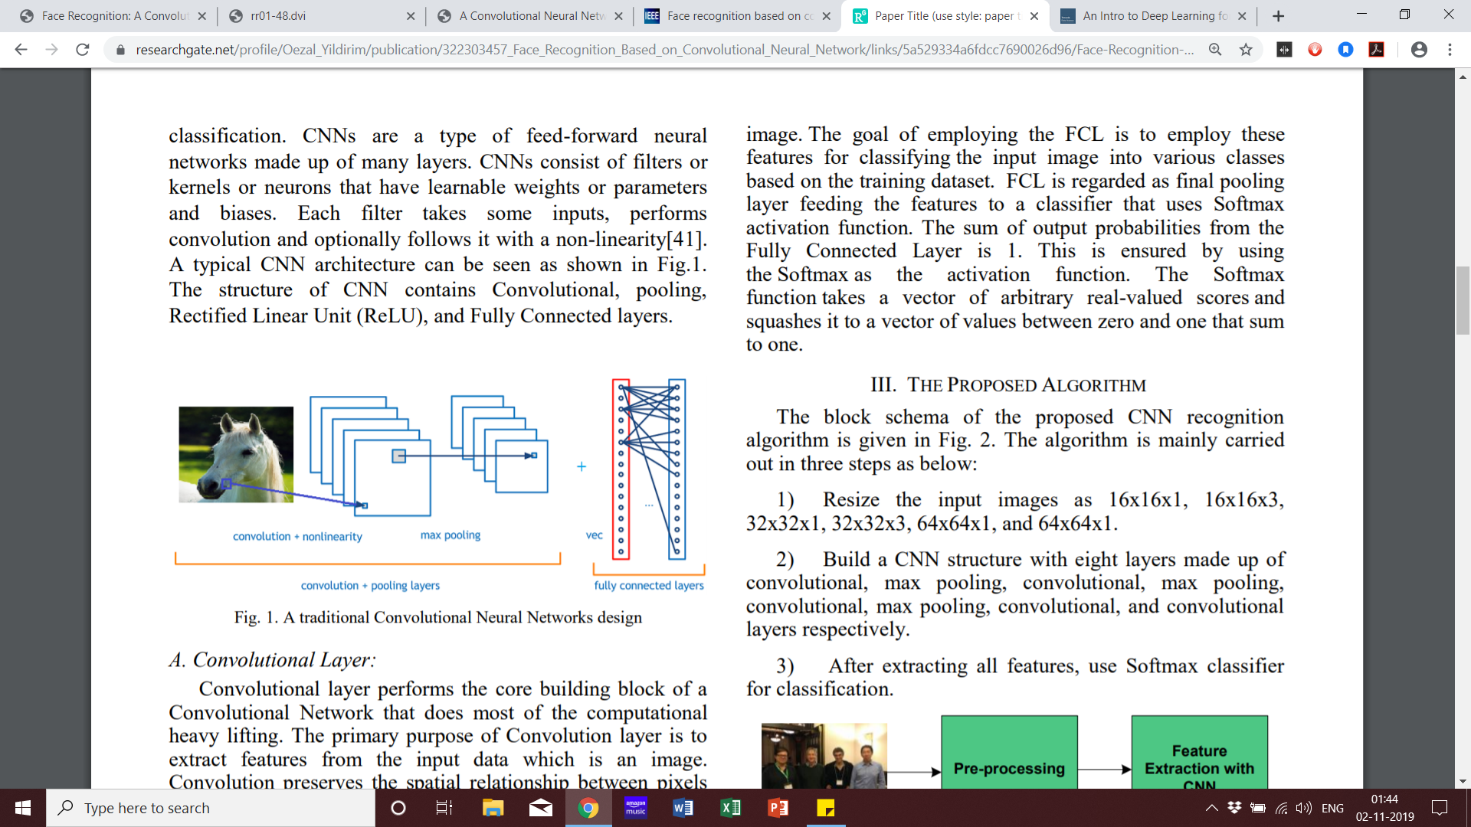
Figure-1: Design of a Traditional CNN [4]
2.1 LAYERS OF A CNN
2.1.1 THE CONVOLUTION LAYER
This layer is the most at work. Convolution is officially defined as the integral that shows the amount of overlap of one function as it is moved across another function. [5] This scenario includes a kernel being moved across an input image. A kernel is a matrix of values created to detect different features. [6]
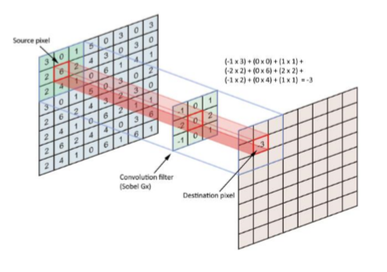
Figure-2: A kernel analysing an arbitrary picture [7]
The kernels are made to identify detailed features of the input such as edges. When the convolution encounters a local maximum that position is identified as an edge. Different kernels are required within the CNN in edge detection. Depending on their values, kernels are used to identify differently oriented edges. [6]
2.1.2 THE POOLING LAYER
The pooling layer essentially shrinks the image stack by picking a window, striding over filtered images and then taking the maximum value from each stride. The 4 steps are:
• Select the size of the window (usually 2).
• Select stride (2).
• Run the window over the filtered images.
• Retrieve the max value.
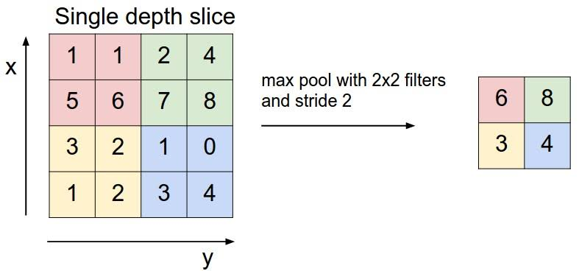
Figure-3: Max Pooling [8]
2.1.3 THE ReLU LAYER
In the ReLU (Rectified Linear Units) layer a stack of images becomes a stack of images with no negative values. [8] ReLU is a classification function in deep neural networks (DNN).This layers is used as an activation function in deep neural networks, with Softmax function used as the classification function. Mostly used only in the output layer, the Softmax function is to represent probability distributions of all the possible outcomes generated by the CNN.
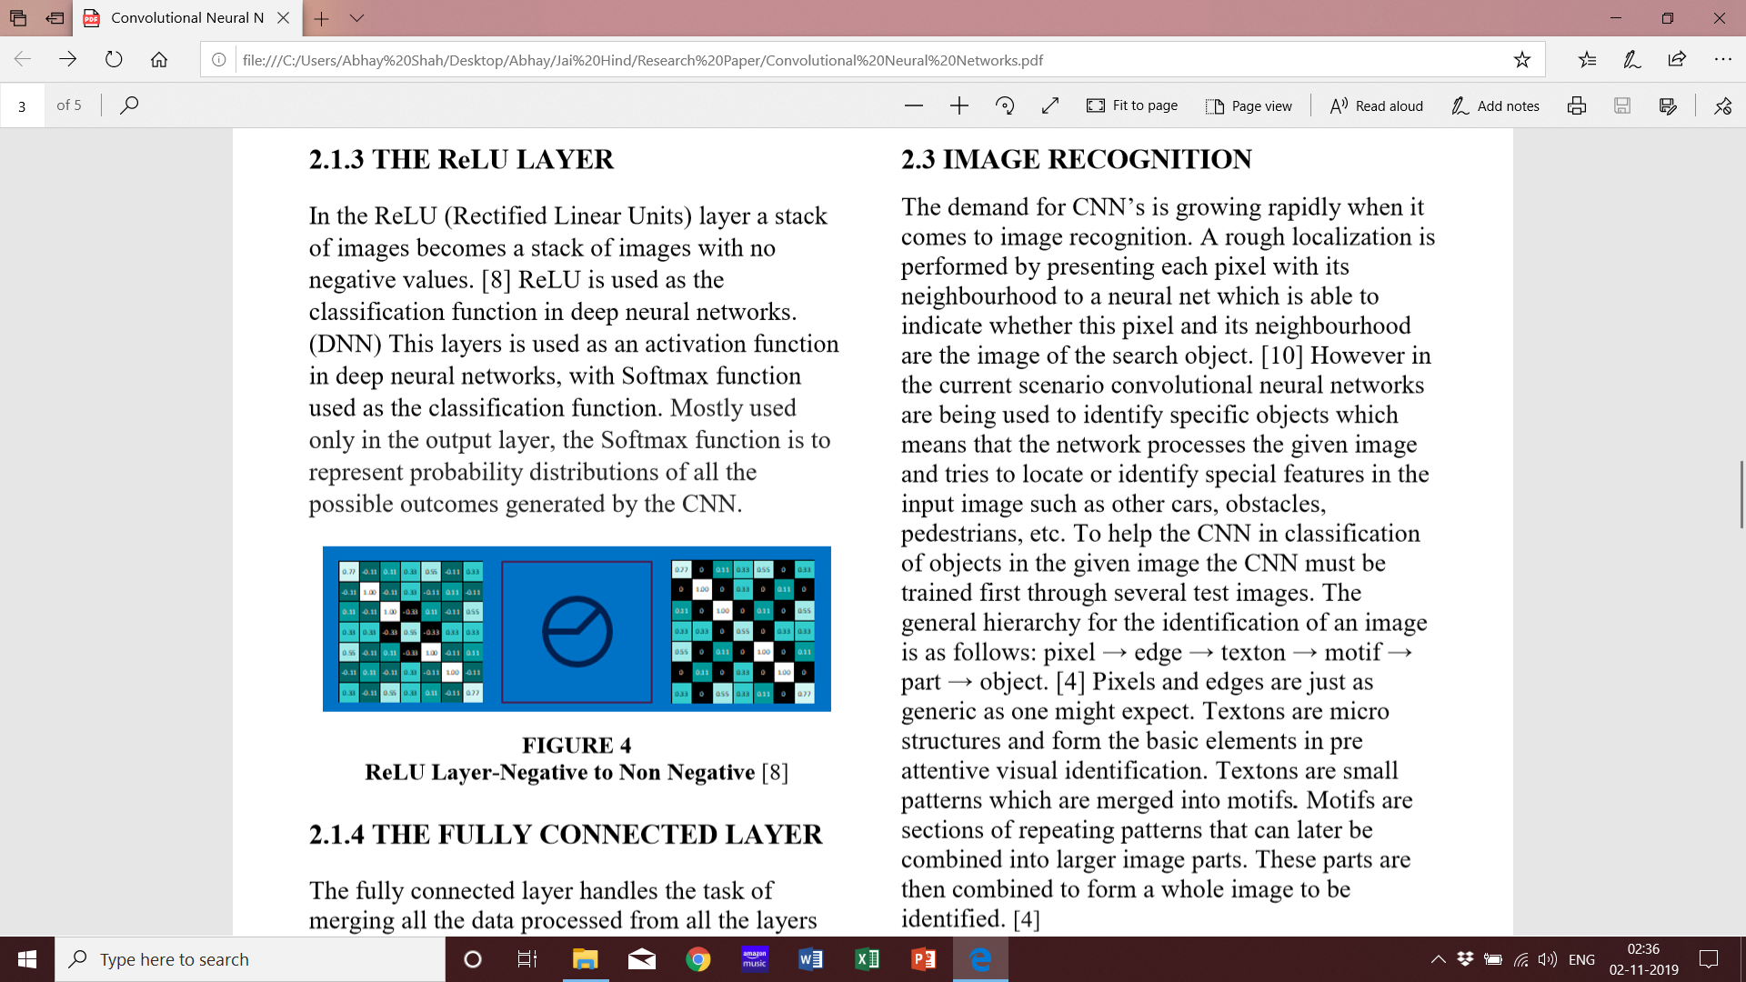
Figure-4: ReLU Layer-Negative to Non Negative [8]
2.1.4 FULLY CONNECTED LAYER
The fully connected layer handles the task of merging all the data processed from all the layers into one final output. The FCL produces inner products. All neurons in the full connected layer are connected to all the other outputs provided by the previous layers. The fully connected layer analyzes all the data provided at the same time without the need of a convolution function. The task of this layers is to use these features for the classification of input images into separate classes based on the training images. [4]
2.2 LEARNING IN A CNN
Convolutional Neural Networks learn using what is known as stochastic gradient descent and back propagation. One of the algorithms used for learning is backpropagation. The goal is to make the predictions of the CNN match the ground-truth (original input image) by minimizing a cost function. [6] The CNN must be able run in both a feedback and feed forward configuration.
During the forward run the errors are collected and processed by the loss layer. Error are reduced with the help of stochastic gradient descent. Stochastic simply means that the training images are fed through the network in small, random subsets. [9]
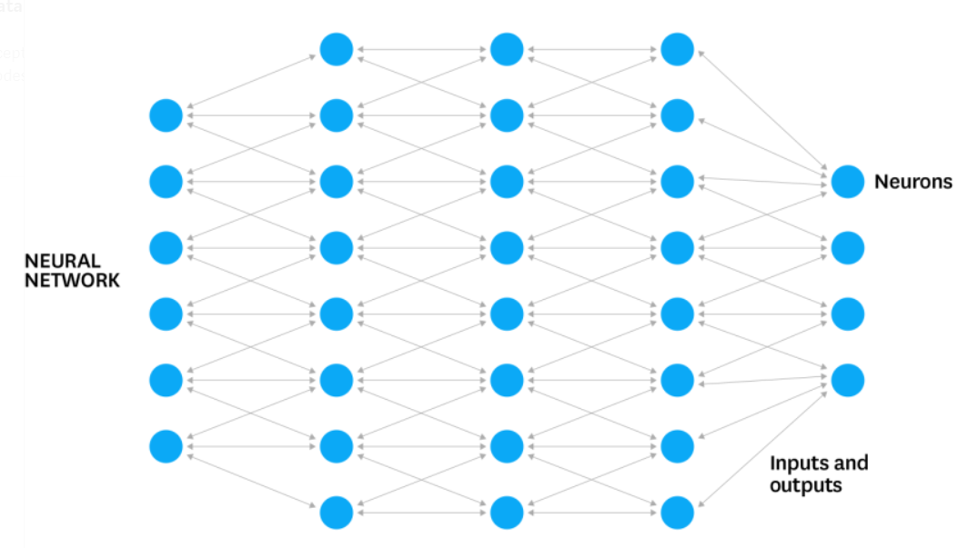
Figure-5: Neurons in Deep learning Networks [10]
2.3 FACE RECOGNITION
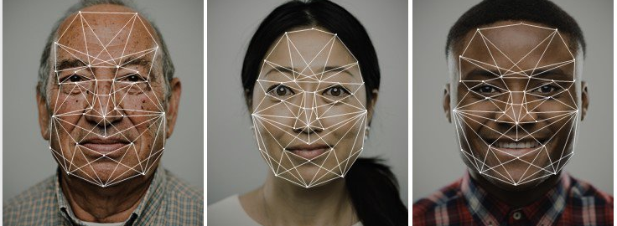
Figure-6: Mapping [10]
The very first step that takes place is the recognition of a face in the image and highlighting the following area. The software involved in this process can use various algorithms such as determining the similarity of proportions and skin colour, the selection of contours in the image and their comparison with the contours of faces, the selection of symmetries using neural networks. [10] However an effective method is the Viola-Jones method. This method can be used in applications that involve real-time computing, the system can analyse images even when rotated by a factor of 30 degrees.
The gathered data is then compared with the results. Even after the face is detected the algorithm continues to track the region to determine the optimum angle and the quality of the image. Correlation and motion vector algorithms are used for the constant detection.
Once the region is finalized by the algorithm the system will begin the process of face recognition by comparing the region with the existing database. The program will attempt to locate reference points that make up the individual features of a person’s face. For accurate detection the program will locate a minimum of 100 points.
The most important measurements for face recognition programs are the distance between the eyes, the width of the nostrils, the length of the nose, the height and shape of the cheekbones, the width of the chin, the height of the forehead and other parameters. [10]
After this if the analysed data matches the data in the database then the person is identified.
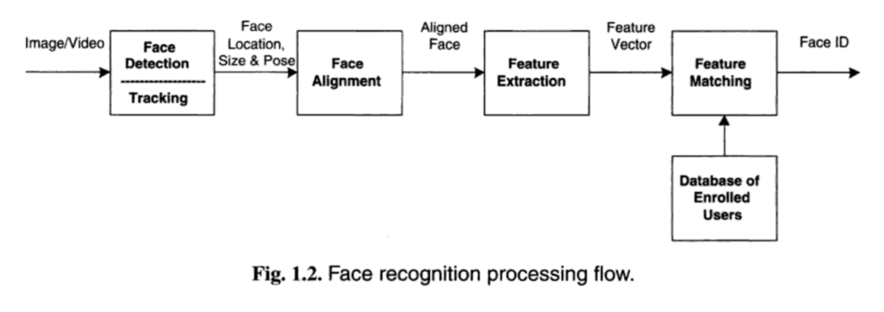
Figure-7: Face Recognition Process flow [10]
2.4 CNN BASED IMAGE RECOGNITION
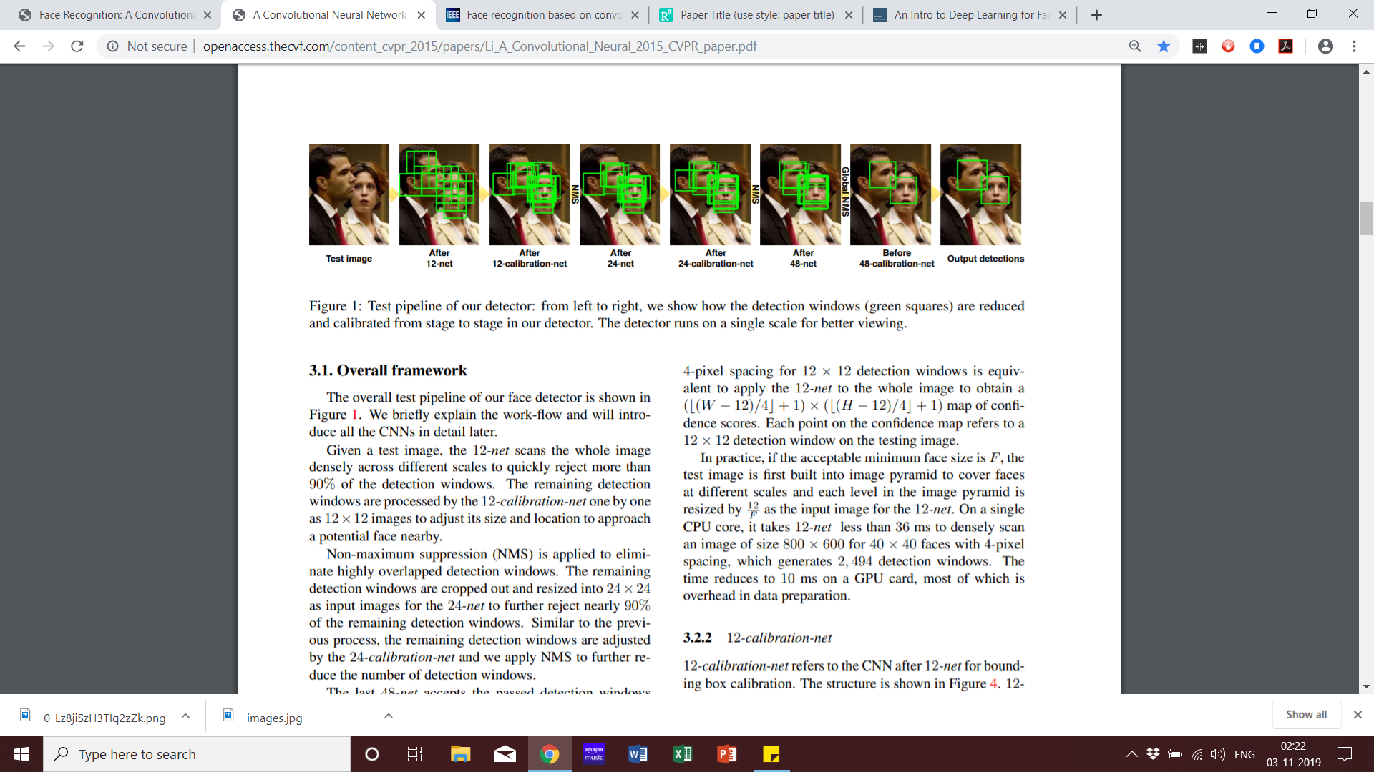
Figure-8: CNN Image Recognition [11]
The demand for CNN’s is growing rapidly when it comes to image recognition. Localization is performed by presenting each pixel with its neighborhood to a neural net which is able to indicate whether this pixel and its neighborhood are the image of the search object. [12] However in the current scenario CNN’s are being used to identify specific objects which means that the network processes the given image and tries to locate or identify special features in the input image such as other people, obstacles, etc. To help the CNN in classification of objects in the given image the CNN must be trained first through several test images. The general hierarchy for the identification of an image is as follows: pixel → edge → texton → motif → part → object. [6] Pixels and edges are just as generic as one might expect. Textons are micro structures and forms the basis of early attentive visual identification. Textons are small patterns which are merged into motifs. Motifs are sections of repeating patterns that can later be combined into larger image parts. These parts group forming a whole image to be identified. [6] Image classification begins with the division of the input image into sections/pixels. The input then passes through the CNN for analysis. The kernels in the convolutional, pooling, ReLU and full connected layers identify special features in the given image. The matrix of values becomes more detailed and accurate with the progression of the layers.
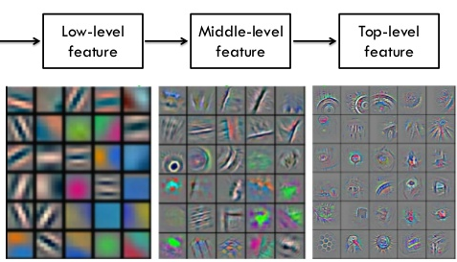
Figure-9: The Kernel Becomes more Intricate with each Layer [13]
Each grid square in figure 9 represents one kernel which is passed over each pixel of the image. The result is a representation of the original ground-truth image. [6]
In the current scenario most CNN’s are made to identify specific objects such as faces, wildlife, handwriting, etc. For the CNN classification to work well and efficiently in face detection systems the network must be able to classify various objects.
2.5 OBJECT DETECTION
Object detection is a technique through which bounding boxes are created. Bounding boxes surround the objects detected in the image. A machine overtook human level performance in the ImageNet classiﬁcation challenge for the very ﬁrst time in 2015. This is far more complex and several concepts such as super human performance through deep learning is still not clear and remains puzzling. The problem arises when identification of several objects is needed at once with the class and the number of instances. Surpassing this problem in an efficient way could be a major breakthrough in the development of face recognition systems.
3. CONCLUSION
The multi-layered trainable structure of the CNN’s puts them a class above other neural networks. They include parameters which can be varied to best fit the intended purpose. The neurons are constantly improving the accuracy of their outputs by learning from each piece of input data. [6] This is specifically very useful in the application of face detection systems to differentiate both the existence and distance of obstacles in front of the face. CNN’s are the backbone in face detection systems and will continue to become more and more advanced.
4. REFERENCES
- McNeal, M. (2015, August 07). Fei-Fei Li: If We Want Machines to Think, We Need to Teach Them to See. Retrieved August 2, 2019, from https://www.wired.com/brandlab/2015/04/fei-fei-liwant-machines-think-need-teach-see/
- Schmidhuber, J. (January 2015). Deep learning in neural networks: An overview. Elsevier, 61, 85117. Retrieved August 1, 2019, from https://www.sciencedirect.com/science/article/pii/S 0893608014002135.
- http://openaccess.thecvf.com/content_cvpr_2015/papers/Li_A_Convolutional_Neural_2015_CVPR_paper.pdf
- https://www.researchgate.net/profile/Oezal_Yildirim/publication/322303457_Face_Recognition_Based_on_Convolutional_Neural_Network/links/5a529334a6fdcc7690026d96/Face-Recognition-Based-on-Convolutional-Neural-Network.pdf
- E. Weisstein. “Convolution.” Wolfram Math World. n.d. Accessed. 2.7.2017. http://mathworld.wolfram.com/Convolution.html
- Erin Welling "CONVOLUTIONAL NEURAL NETWORKS IN AUTONOMOUS CONTROL SYSTEMS" University of Pittsburgh Swanson School of Engineering. 10.2.2017 Accessed 8.8.2019 from https://pdfs.semanticscholar.org/545b/2ce4bc5ed7b 1c1089020b3e53c1d67186370.pdf
- T. Hartley. “When Parallelism Get Tricky: Accelerating Floyd-Steinberg on the Mali CPU.” ARM Community. 11.25.2014. Accessed 2.7.2017 https://community.arm.com/graphics/b/blog/posts/ whenparallelism-gets-tricky-accelerating-floydsteinberg-on-themali-gpu
- Honglak Lee, Roger Grosse, Rajesh Ranganath, Andrew Y. Ng “Convolutional Deep Belief Networks for Scalable Unsupervised Learning of Hierarchical Representations” Retrieved August 4, 2019
- J. Wu. “Introduction to Convolutional Neural Networks.” National Key Lab for Novel Software Technology, Nanjing University. 4.27.2016. Accessed 1.25.2017. http://cs.nju.edu.cn/wujx/paper/CNN.pdf (Learning in a CNN)
- https://towardsdatascience.com/an-intro-to-deep-learning-for-face-recognition-aa8dfbbc51fb
- http://openaccess.thecvf.com/content_cvpr_2015/papers/Li_A_Convolutional_Neural_2015_CVPR_paper.pdf
- R., C., & Y. (august 1994). Original approach for the localization of objects in images. IEEE, 141(4), 245-250. Retrieved August 5, 2019, from https://ieeexplore.ieee.org/document/318027.
- A. Chernodub, G. Paschenko. “Lazy Deep Learning for Images Recognition in ZZ Photo App.” Al&Big Data Lab. 4.23.2015. Accessed 2.21.2017. https://www.slideshare.net/Geeks_Lab/9-48711
Research on Political Promises
Shiv Sagar Prajapati¹ and Prakash Patil²
Student¹ and Head², Department of Information Technology, S. K. Somaiya College of Science, Arts & Commerce, University of Mumbai, Mumbai
Abstract
This research is based on political promise. All politician promise to citizens but they do not complete it. As we know that politician is the core of any country. Any country is run by a leader. If that politician is not truthful then he can't handle situation of that country. Due to which the economy of that country will fall very fast. Therefore, we should choose a good leader for the development of the country. Everything above depends on the leader's mind. If that leader is liar makes false promises to the citizens there, and the citizens come under his influence and vote for him. Despite being a well written leader if the leader is liar, then his study has no meaning. In this research paper we will set up a criterion. This will be based on the promise of the leader’s voting time. If a leader crosses that criterion, he will be eligible to stand in next-time voting, or else.
Introduction
I want to remove corruption form my country so I have decided to publish my research Paper, because people doesn’t know their power of vote. Only when people know their rights can they choose the right leader for the development of the country. There may be a rule in it that whenever a leader submits his proposal letter at the next time of voting, then they should complete their work at 35%. If he completes that promise, then in the next voting he/she can fill the paper. The pro – people make false promises at the time of voting and people come to their enticement and vote for them. And after that, they do not do any such thing for the people of that place, so that people do not have any meaning in their valuable vote. So when this is implemented in the constitution, then people will make as much promise as they can fulfill. And in this way we can reduce corruption from our country and this will be a small beginning for the development of our country.
Introduction of Material
In this research paper, I will prepare a set of questions that the leaders would do at the time of voting. And for this a backend will be required which stores the leaders promise with safe and security. In this research paper, we can create a Google Form and we can send that link to all our friends if we want to know about the promise of a leader at Lok Sabha level. If a leader works at the regional level or has been elected as a leader, then how many promise he fulfilled that we can find out the people of that area by sending a Google Form. The people of that area will fill that Google Form and we can make a good algorithm by calculating how much promise the leader has fulfilled. If that leader has also done at least 35 % of his promises, then that leader can get his name registered for voting again if not, that leader cannot fill his form in the next 5 voting. Yes, even if he had won the Lok Sabha elections, even then he did not fulfill the 35 % promise he made so he can fill the post as a leader for voting of Rajyasabha and Vidhan Sabha But he cannot fill his name in the next 5 voting in the Lok Sabha elections. In the form of Google, we can also make a thumb impression for verification so that it will be ensured that whatever response has been received, it is received by that personal person.
Working Principle
And through this Google form, we can also find out which leader people like more. This Google form will be passed by the Tehsildar of that area because all the people who have their voting card have their registered Mobile no. And he will send this ready Google link to the registered mobile number of all the people of that area. And the registered mobile number from which no answer came, the team of some people will go to their house and will motivate them to fill that form. Because the next time the leader is going to be selected, he is also very dependent on that Google form in voting. So it is the duty of every citizen to vote, it is the duty of everyone to fill this Google form without any pressure.
When the public will give the right decision, only then the right leader will fill the ballot next time in voting, otherwise the same corrupt leader will come to handle that area again. And due to which development has not been done in many areas till date, because the same corrupt leader comes again and again. This process is different from voting because when voting time comes So the leader visit’s the homes of everyone and distributes the money and sometimes even threatens. When the vote is counted, the leader comes to know from which constituency he has not got the vote. And after winning, he hurts that lovely public because he knows that next time he will come again because he has power. Using this technique, we can save our country from harm. When voters go to vote, they have a lot of options, but some of them are corrupt. If this proposal is passed, then with the help of public, we can filter those people before voting who used to win the corrupt people through money or threatens.
The rule of this Research Paper will be something like this
Rule1. When this form is filled, there will be no change in it again and public cannot fill this form again. And this form will not sent to everyone at same time, the entire public will be sent at different times by the Tahsildar. It will be benefits by this rule that no leader can ever threaten someone’s home because that leader will not know when the form has been filled by anyone.
Rule2. When the research paper is filled by any citizen, then he cannot take a screenshot of this form. This will ensure the security of that form. No citizen can take money from a leader to fill that form in his favor.
Rule3. And when this research paper form will be sent to the public of that area by the Tahsildar office then that form will have to be filled by that citizen for the first time attempt. When we send a Whatsup message to anyone then we find a signal of double tick in blue color means that message has been read by receiver, we can make a rule of like this, when message is sent by sender then after reading this message, receiver will have to send a response within a 5 min. If they send a response within a 5 min then it will be store in database otherwise.
Rule4. The Team of Tahsildar office will inspect of this problem, why the research paper form is not filled by them. And the team of officer will give the understandable thinking and will tell them responsibility. This will be responsibility of citizenship like a voting.
Rule5. In this rule, when the officer’s team will come to people’s home So when this form will be filled by the citizen there, then a video clip will be made by the officer. So that it can be ensured that this form is filled without pressure from the officer. And until once the form is not sent by the officer, before that the officer cannot come to the home to fill the form. If they come before filling the form, then after filling the form, a link will automatically come for filling another form, which will be in the form of feedback. Those who fill the form once will get a link again after a few days, which will not be available. After clicking, citizen will give their feedback. In which only Yes or No have to ensure that the form is filled without any pressure. And this will be the final submission; we can apply this rule in this form. After a few days of the form or without the schedule time, this form will automatically be sent to number given the first time response.
Rule6. With this rule, we can reduce corruption because when these rule will be followed, there will probably be no leakage information from anywhere. Because the submission made by the public will not be visible even in the backend as there will be store in the information encrypt format. The response of the form which will be filled by the public will be direct used in algorithm for good output. So that information will not be locked from anyone. Only the output can be seen by the administrator but not the public response. If all research paper rules will be followed by our country then we can reduce at least 35 % corruption from our country so we can say by this research paper, we will have saved our country from corruption and all bad news which are not good for any country Because all country are driven by that country leader so at least that country leader must be educated and good person without any cases.
In our country, most of the leaders are corrupt and not educated but also they win in vote because they have money and power of threat. So when this rule will be passed from our Constitution then by this rule we will be saved our country by that man. We know that No leader will mind the passing of this rule because the other party can say that when you are not wrong then then why are you afraid of this rule. So there will be no problems for this rule to be passed. And we will get a qualified and good leader.
Rule7. If we follow then officer directly communicate with that person who is not able to make a voter like an old man and physically handicapped. Because we know that if anyone wants to make a vote they have to go in voting booth because voting bucket cannot bring near of them. This is rule of India so when this rule will come in focus even if public could not make a vote if they fill that google form they will support of our country knowingly or unknowingly. So the report of google form is equally important to voting because when we vote so support our country like this when we fill this form then we will support our country as well as voting. When officer send a link to public of that area where voting is going to start, but they do not find any response of some public then here can be other reason. That person can be poor they have no money to brought a smartphone, when officer will go that public home they will take response of that person. Here no fault will be that man because they have no money to bring a smartphone. So In this research paper, officer responsibility is more effective. So I have thought like this. In this research paper we can find out how many promises are done by leader and in that how many promises are completed by leader.
And whose leader is more popular in public compare to their competitor.
Observation1: How many promises have been fulfilled by our leader, it has been taken by research paper form.
So by this we can assume that our leader is liar or truth.
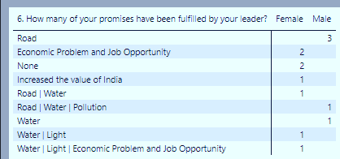
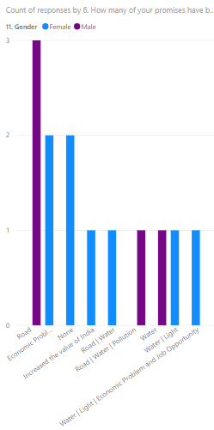
Observation2: Our leader is educated or not, how response by Male and female and our leader has ever changed the party or not also can be assumed.
If our leader is not educated, how we can say that they will handle the country or region situation?
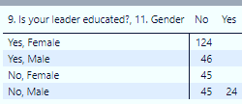
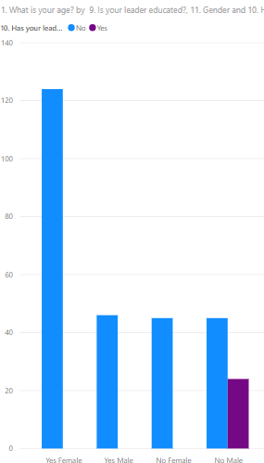
So this research is very important to select right leader in voting if a leader is good person so we can assume, there is more chance of being the truth leader.
Observation3: Here we can find out how many male and female support which party leader and we can got good leader in that region or country.
So, here numeric values are showing the how many times male and female have voted to which party. And we can assume who will be winner of next voting time.
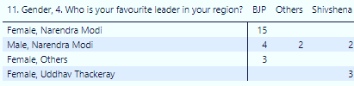
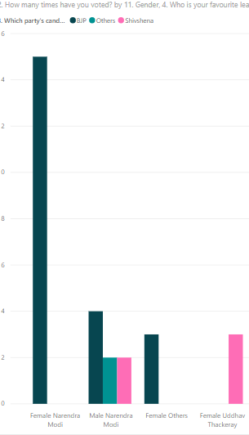
Observation4: By Help of this we can assume which party is popular in which gender.
Like this, here BJP is more popular in Female compare to Male and we can also assume which party polarity in public (Male and Female), Here BJP is more Popular to other party like- Shivshena and other.
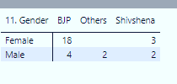
Below, numeric value represents how many male and female support which party.
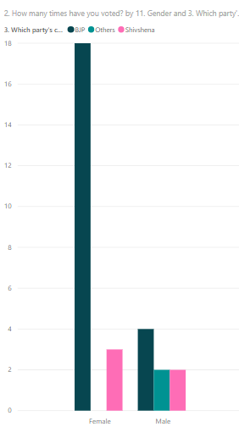
Observation5: Here we find out what is response of their citizen of country of citizen after complete the voting process. So we can assume how much popularity has been reduced by popular party.
So, we can find out how many vote balance loss of which party. So we can give this report to that party to improve their performance.
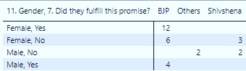
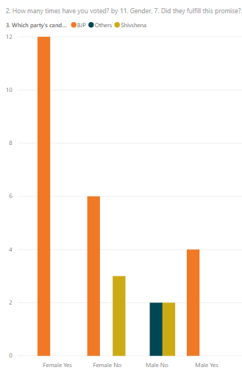
So, we should fill this type of survey because by help of this we can find out the survey reports will provide good output, because this in type of survey we should make a part.
Observation6: Here we can see the hope of public because some people accepted that BJP has not fulfilled their promise but they want to see that party in voting again.
So, we can say that how much believe of public of their leader like a P.M. Narendra Modi.
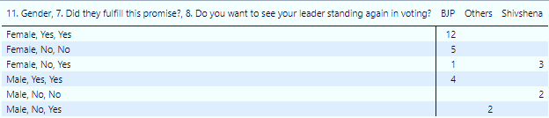
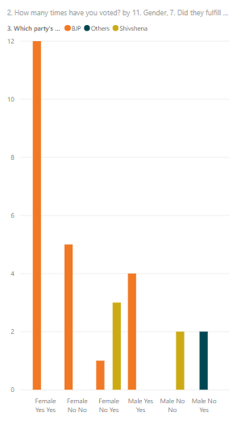
They accept Modi has not completed his promise, but also he wants to see in voting again. So all leader must fulfill their promises which have accepted at voting time.
Observation7: In this visualization, we find out Selected party has fulfilled their promise or not and which type of promise has been done by selected party in voting, which will be in the power of that country or any particular state. Here we got some people accepted that economic; water, light and value of India are increased. Compare to last few years.
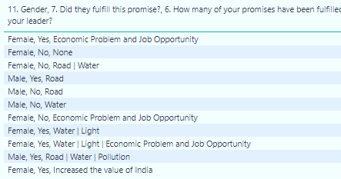
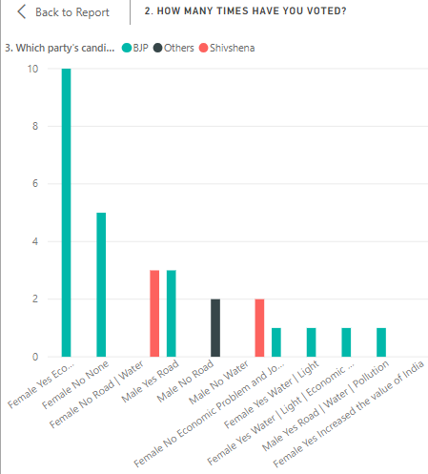
Observation8: Here we got that how much people like to Narendra Modi because they do not know Shree Narendra Modi how many times applied in voting but also in favorite leader list P.M. Modi name is more times compare to other leader.
So, using this form or improve this form we can find out, before voting which leader is more popular to their competitor. So here we can also apply these visualization techniques.
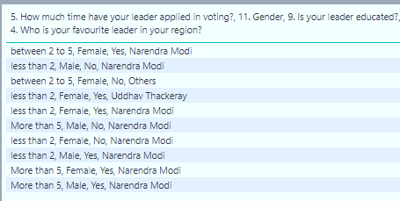
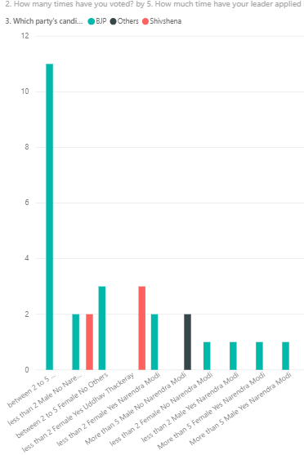
Conclusion
After all of the data wrangling and data analysis I conclude that the liar promise in India is increasing and youth of India is getting the most of it.
While I have forward my link in what sup and find that popularity of P.M. Narendra Modi is more than compare to other leader. Looking at which public have voted first and second time, who are youth, have voted to Narendra Modi or we can say that popularity of Narendra Modi is more inside in mind. Education is a great impact on the liar promises. The more the person is educated less likely the person have liar promise. Because they do not fulfill their dream so they want to earn more money doing corruption. According my research I got Females is more love BJP party. So we can say that popularity of BJP party is higher than other party. Many person (Female and Male) do not know how many times Modi has applied in voting but also they love them and vote for BJP party according Modi speech. Here I am not doing evil of the party, but I want to tell you that many people are still in the uneducated. They vote to any party without thought our future. So I want to spread awareness through this form. When people will know, what is responsibility of that person in country, and then he will vote to right person. Because a leader is chosen in any country then a lot of people behind its voting is right of all person. And filling the google form also should be a right of all people with honesty because behind this report, algorithm will make a more reports, on this basis. Then on the basis of reports we can make output, which will be decided who will be the next leader of that area or country so please fill the all types of reports form. This google form will be very different because here we will be saved all details of report receiver, So on this basis we can say that this google form is secured. Without any tension anyone can fill this google form for our better tomorrow.
Result
- We can provide the popularity of leader.
- We can provide, how many promises had been done by which leader and how many promise have been fulfilled by that leader.
- We will make algorithm that will accept all types of information and competition of some process will generate the output. Whose leader are not eligible to apply in voting for coming voting
- We have seen more leader complete their some promise at upcoming because they know if I did not complete their promise then public will not do a vote for them. So he fulfilled some promises before voting. But When this rule will be apply in our country, leader have to complete their promises from beginning because google form will be sent to all person mobile number automatically. Here it has automatic because officer can be greedy and leak the produced timing of that link.
- If any leader found that completed 35 % less work of their promises then they can no apply in that time for voting. If they want then they will have to wait next time voting.
References
- Hilali, A.Z, (2005) Confidence and security Building Measures for India and Pakistan, Alternatives: Global, Local, Political, Vol.30, No.2, Sage Publications, India.
- Riley, T.B. (2003) E-government vs. E-governance: examining the Difference in changing Public sector climate, The Common wealth Secretariat and Government telecommunication and Information Services, Public Works and Government Services, Canada.
- UN Global E-government Readiness report. Form E-governance to E-inclusion, UNPAN/2005/14, united Nation publication. United nations, 2005.
- Riley, Thomas B. “the Role of Information in e-Government Implementation”, in Egov Monitor weekly, London, Jan. 27, 2003:2
- Margolis, Michel and David Resnick, 2000. Politics as Usual: The Cyberspace Revolution’, Thousand Oaks, CA: Sage
- Rose, Nikolas. 1996 “Governing Advanced Liberal Democracies” in Foucault and Political Reason, Chicago: University of Chicago Press.
- Thompson, Dennis F. 1993. Mediated Corruption: The case of the Keating five. American Political Science Review, 87(2), 369-381
- Rose-Ackerman, Susan. 1999. Corruption and Government: Causes, Consequences and reform. Cambridge University press.
- CIOL. 2006. India ranks 87 in e-governance readiness, April, 7, http://www.ciol.com/content/news/2006/106040704.asp accessed on April 15, 2006.
- NASSCOM. 2003. E-Governance in India accelerating but roadblocks exist, says NASSCOM (National Association of Software and Services). January 16,

HEALTH INFORMATICS IN AI HEALTHCARE
Prajakta Shahare¹ and Hiren Dand²
Student¹ and Head², Department of Information Technology, S. K Somaiya College of Science, Arts & Commerce, University of Mumbai, Mumbai
Abstract
AI offers various favorable circumstances over customary analytics and furthermore in social insurance it has demonstrated the most guarantee in diagnostics. Learning algorithms can turn out to be increasingly exact and precise as they associate with training information, enabling people to gain remarkable bits of knowledge into diagnostics, care forms, treatment fluctuation, and patient results. AI will give a lot to that development by fueling prescient investigation and clinical decision bolster devices that hint suppliers into issues well before they may somehow or another perceive the need to act. This paper provides information about how health informatics can be effectively used for healthcare using AI algorithms which are being used to minimize the time it takes to diagnose genuine illnesses and describes the limitations of health informatics.
Index Terms – AI, analytics, algorithm, clinical data, diagnosis, doctor, genomic-data, healthcare, health informatics, health-record, legal ,medicines , Naïve-bayes ,neural-networks, National institutes of Health, patient, precision, TF-IDF , technical , word vectors
NOMENCLATURE
AI-Artificial Intelligence
EHR-Electronic Health Records
HL7-Health Level 7
FHIR-Fast Health Interoperability Resources
CAD-Coronary Artery Disease
1.0 INTRODUCTION
Health informatics, at times known as healthcare informatics, has grown as an advancing science with the extension of electronic health records system and health data investigation systems. It has additionally grown with the foundation of health data trade guidelines, for example, HL7 and FHIR (Fast Health Interoperability Resources) and clinical health phrasing sets like SNOMED CT.
Health care data refers to a wide information pertaining to patients, specialists and health care systems. The way toward gathering data on points, for example, understanding results, protection and specialist appraisals can serve to improve health care systems through the expert examination of huge data sets to reach inferences and advance productivity Health informatics is the practice of acquiring, studying and managing health data and applying therapeutic ideas related to health data innovation systems to assist clinicians with giving better healthcare.
AI describes the ability of a machine to become familiar with the manner in which a human learns, for instance, through picture acknowledgment and finding designs in complex circumstances. AI in is changing the manner in which data gets gathered, investigated and produced for patient care.
AI is changing the patient experience. Some of the examples of AI in health informatics use algorithms to diagnose diseases , Machine learning and radiology ,Automating Administrative tasks , Reducing Operational costs .The essential aim of wellbeing related AI applications is to break down connections between anticipation or treatment procedures and patient outcomes.AI programs have been developed and applied to practices such as treatment convention advancement, customized prescription, and patient treatment . Moreover, clinics are looking to AI solutions to help operational activities that expansion cost sparing, improve patient fulfillment, and fulfill their staffing and workforce needs. Companies are creating prescient examination solutions that help healthcare directors improve business tasks through expanding usage, diminishing patient boarding, lessening length of remain and upgrading staffing levels.
AI in healthcare is the utilization of complex algorithms and programming to copy human comprehension in the investigation of muddled medical information. In particular,. AI is changing the way information gets collected, analyzed and developed for patient care. What recognizes AI technology from conventional advancements in medicinal services is the ability to gain data, process it and give a well-characterized output to the client, for which agorithms are used .These algorithms can perceive designs in conduct and make its own rationale. So as to diminish the room for give and take, AI algorithms should be tried more than once.AI algorithms carry on uniquely in contrast to humans in two different ways: (1) algorithms are exacting: in the event that you set an objective, the calculation can't change itself and just comprehend what it has been told expressly, (2) and algorithms are secret elements; algorithms can anticipate incredibly exact, however not the reason.
Artificial intelligence (AI) is quickly entering medicinal services and serving significant roles, from computerizing tedious tasks and routine tasks in medical practice to overseeing patients and medical assets. As designers make AI systems to perform tasks, a few risks and difficulties rise, including the risk of wounds to patients from AI system mistakes, the risk to persistent security of data obtaining and AI deduction, and that's only the tip of the iceberg. Potential arrangements are perplexing however include interest in foundation for top notch, delegate data, changes to medical instruction that will get ready suppliers for moving roles in an advancing system.
2.0 REVIEW OF LITERATURE
Keith J. Dreyer, DO, PhD J. Raymond Gees, MD (2017)
Artificial intelligence (AI), machine learning are terms presently observed all time, all of which refer computer algorithm that change as they are presented to more information. Huge numbers of these algorithms are shockingly great at perceiving objects in pictures. The blend of a lot of machine-consumable computerized information, expanded and less expensive processing power, and progressively advanced factual models join to empower machines to discover designs in information in manners that are financially as well as possibly past people's capacities. Building an AI algorithms can be simple. Understanding the related information structures and insights, then again, is regularly troublesome and cloud. Changing over the algorithm into a refined item that works reliably in wide, general clinical use is mind boggling and deficiently comprehended. To show how these AI items decrease costs and improve results will require clinical interpretation and mechanical evaluation reconciliation into routine work process. Radiology gets the opportunity to use AI to turn into a focal point of wisely totaled, quantitative, demonstrative data. Centaur radiologists, shaped as a cooperative energy of human in addition to PC, will give translations utilizing information separated from pictures by people and picture investigation computer algorithms, just as the electronic record, genomics, and other different sources. These understandings will shape the establishment of exactness human services, or care tweaked to an individual patient.
In this paper author has mentioned the future scope as AI applications will eventually be used to identify patients at risk for disease in disease detection and quantification, and for medical management. For radiologists, one of the first applications will be AI for screening detection. AI will expand the exactness of CAD, possibly diminishing bogus positive outcomes essentially and expanding CAD’s power. With the progress of AI in healthcare using algorithms AI can be used efficiently in enhancing its applications in medical field for patient’s welfare using health informatics for predictive analysis of diseases and risk factors associated with it and can prove useful for further development in healthcare. Thus when AI combined with health informatics can help to diagnose predictive analysis of medicines, risk factors of diseases, treatment associated to particular diseases. This requires feed information to AI so that it can perform faster analysis based on the given data.
3.0 SHARING HEALTH INFORMATICS WITH AI TECHNOLOGY
Data is the foundation of all AI applications. During the Roundtable, participants distinguished various high-esteem health data types that can be used for AI advancement. Expanding on the master input assembled at the Roundtable and consequent research, this area gives a rundown of six significant health data types and the challenges related with their utilization.
Clinical Data is a broad term that encompasses different sorts of data produced in a clinical setting and constrained by a clinician, instead of a patient or parental figure.
Genomic Data can incorporate various characteristics, ranging from full DNA successions to singular DNA variations. Late advances have made it conceivable to investigate and store data on an individual's whole genome succession. Genomic data is considered exceptionally touchy and must be shared and utilized under deliberately controlled conditions.
Persistent Generated Data incorporates "health-related data made and recorded from patients outside of the clinical setting to answer health concern." This data type is getting progressively common through the making of versatile health applications and wearable health gadgets.
Social Determinants Health Data speak to "conditions in the situations in which individuals are conceived, live, learn, [and] work...that influence a wide scope of health, working, and personal satisfaction results and dangers." Instances of these social determinants incorporate access to transportation, training, and openings for work just as the accessibility of nourishment and lodging choices. Social determinants of health data can emerge out of numerous sources inside and outside of government, and can be utilized to all the more likely comprehend populace health.
Observation Data is a broad term that encompasses the "continuous, orderly assortment, examination, and translation of health-related data fundamental to arranging, usage, and assessment of general health practice.
3.1 USING HEALTH INFORMATICS IN AI HEALTHCARE
AI can use to diagnose serious diseases at early stage itself as AI processes information rapidly arrives at likely causes of symptoms for diagnosis and treatment for many patients ,this is achieved through deep learning; machine learning algorithms to minimize the time it takes to diagnose critical diseases. Health informatics can reduce medical errors as doctors and physicians no longer manually report and analyze diagnoses. Rather they record and evaluate patient in electronic format which eliminates collection of false data which may happen due to misdiagnoses and wrong prescription dosages or false information about their current health state. Medical records provide information to doctors about a patient’s health condition, surgeries and current prescriptions .Health informatics helps in the medical record retrieval process . EHR ( electronic health record) systems allow providers to access a patient ‘s medical history in real- time from any healthcare facility using EHRs .The accumulating data generated in clinics and stored in electronic medical records through regular tests and medical imaging takes into consideration more applications of AI and superior data-driven medication. These applications have changed and will keep on changing the manner in which the two specialists and analysts approach clinical critical thinking. AI algorithms perform tasks that require human intelligence to complete, for example discourse acknowledgment, image analysis, and decision-making. In any case, humans need to expressly tell the computer precisely what they would search for the image they provide for a calculation, for instance. So, AI algorithms are extraordinary for computerizing laborious tasks, and in some cases can beat humans in the tasks they are trained to do.
So as to generate an effective AI algorithm, computer systems are first fed data which is normally organized, implying that every data point has a name or explanation that is recognizable to the algorithm. After the algorithm is presented to enough arrangements of data points and their names, the presentation is broke down to guarantee precision, much the same as exams are given to students. There are algorithms that can learn from data. Applications of AI in medication is some kind of data, either numerical (such as heart rate or blood pressure) or picture based (such as MRI sweeps or Images of Biopsy Tissue Samples) as an information. The algorithms at that point learn from the data and produce either a likelihood or a characterization. For instance, the significant outcome could be the likelihood of having a blood vessel clump ,blood pressure data, or the naming of an imaged tissue test as harmful or non-dangerous. In medical applications an algorithm’s diagnostic performance task is compared to a physician’s performance to determine its ability and value in the clinic.
3.2 AI IN SUPPORTING DOCTORS
AI can be used to know common allergic medications for adults and children: Allergies happen when the body's resistant framework reacts to a substance it considers an invader. Substances that incite the immune system into a hypersensitive reaction are known as allergens. There is nothing of the sort as an all-inclusive allergen. What may trigger a hazardous unfavorably susceptible reaction in one individual may cause definitely no mischief in another. Health informatics represents intersection of IT and the design, health care services delivery and latest health care technologies combined, so a wealth of data becomes available to help professionals provide quality care to patients. This data can be used for diagnosing allergies Patients have from a particular medicine by analyzing their health record and treatment a patient went through, like this by analyzing patients health information common drugs stimulating allergic conditions such that when given to patient in a particular disease can lead to side- effect and endanger patients’ lives can be determined .
3.3 ALGORITHMS THAT CAN BE USED FOR PREDICTIVE ANALYSIS OF ALLERGIC MEDICATIONS
Neural networks: In neural networks, the relation between the output and the input variables are depicted through hidden layer blends of prespecified functional. The objective is to assess the loads through input and output information so that the normal mistake between the actual output and the expected output is minimized.Neural networks are effectively applied to different zones of medication, for example, diagnostic frameworks, biochemical examination, image analysis, and medication advancement, with the common case of bosom malignant growth expectation from mammographic pictures.
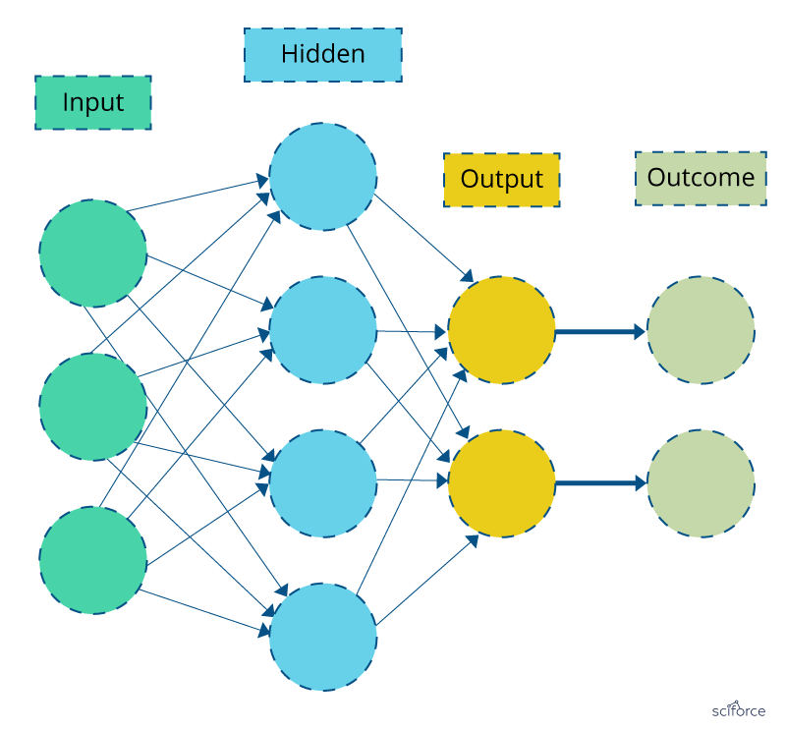
TF-IDF: Basic algorithm for taking out keywords. The TF-IDF weight is a statistical measure of a word importance to a document in an assortment or corpus. The importance builds relatively to the occasions a word shows up in the document yet is balanced by the frequency of the word in the corpus.
TF-IDF is used for finding patients’ similar behavior patterns in observational studies as well as in discovering diseases correlations from medical reports for finding sequence patterns in databases.
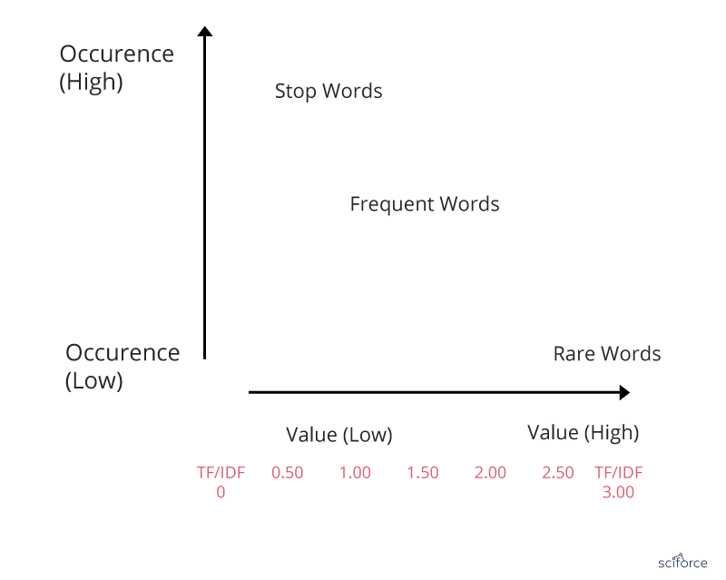
Naïve Bayes: Naive Bayes classifier is a method for content arrangement, the issue of making a decision about archives as belonging to one category or the other. Naive Bayes classifier expects that the presence of a specific feature in a class is not related to the other feature presented. Regardless of whether these features are related, these properties autonomously add to the likelihood of belonging to a specific category.
It remains one of the effective and efficient classification algorithm which has been successfully applied to many medical problems like classification of medical reports and articles of journals .
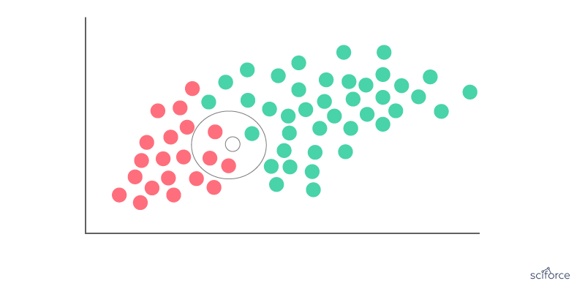
Word Vectors: Considered to be a breakthrough in NLP, word vectors, or word2vec, is a gathering of associated models that are utilized to deliver word embedding’s. In their embodiment, word2vec models are not so deep and are two-layer neural systems that reproduce etymological words. Word2vec produces a multidimensional vector space out of a book, with every remarkable word having a relating vector. Word vectors are in the vector space such that words that offer contexts are situated in closeness to each other.
Word vectors are used for “biomedical language processing”, includes similarity finding ,medical terms standardization also discovering new aspects of diseases.
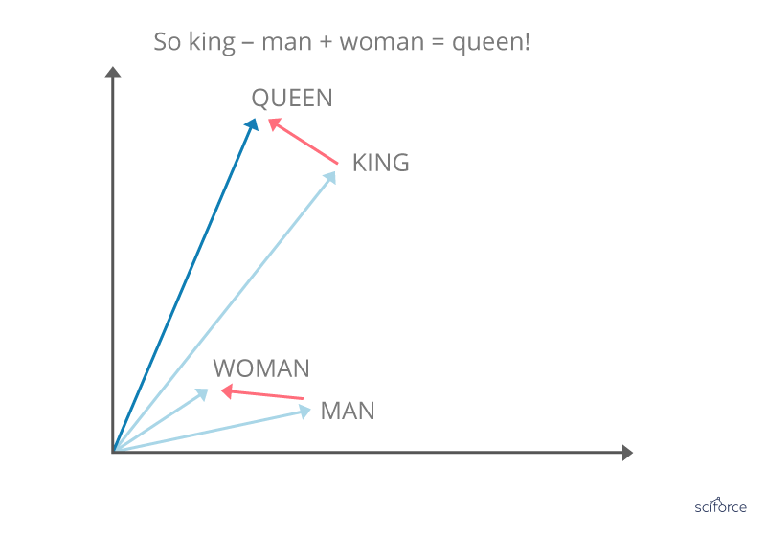
3.4 DISEASE PREDICTION BASED ON AI SOLUTION:
First AI systems were basically knowledge-based decision support systems and first machine learning strategies were utilized for deriving arrangement rules from marked datasets. These first systems had great execution. Be that as it may, they were never utilized routinely on genuine patients. One explanation was that these systems were independent systems, not associated with tolerant electronic
Health records (EHRs). Another explanation was that, because of the subjectivity of the aptitude communicated in the knowledge bases of these master systems, the systems created here were not acknowledged there, and the greater part of them ended up being more valuable for educating than for clinical practice.
As new AI methods come,one normally becomes worried about the degree of control we are getting when inspecting the speed at which new AI methods are being acquainted and the pressure to quickly adopt them. AI with new machine learning methods focusing around complex Deep Learning through the generation of “deeper” and multi-layered connectionist artificial neural networks. One of the areas where AI has shown the most progress is in diagnostics. Early diagnosis significant factor in a result of a patient's care. Deep-learning algorithms are being used to minimize the time it takes to diagnose diseases . The manner in which AI quickly processes a lot data and arrives at likely causes for symptoms can drastically decrease the diagnosis and treatment work for some patients .
Combining clinical decision support frameworks with patient self-management, population health management can likewise profit by AI. Utilizing prescient investigation with patient populations, healthcare suppliers will have the option to make preventative move, decrease health hazard, and spare pointless expenses. The probability of aggregating, breaking down and activating health information from a huge number of consumers will empower medical clinics to perceive how financial, social, hereditary and clinical elements associate and can offer more focused on, preventative healthcare outside the four dividers of the hospital.
3.5 DEVELOPING TREATMENT PLANS USING PRECISION MEDICINE:
Precision medicine is an emerging for disease treatment and prevention which considers singular fluctuation in qualities, condition, and way of life for every person. This approach will enable specialists and analysts to anticipate all the more precisely which treatment and prevention strategies for a specific disease will work in which gatherings of individuals. Precision medicine is dependent on large databases that contain genetic and clinical information can be studied to develop treatment plans that will be more effective for particular patients. Advances in genetic information for diagnosis and treatment will have implications for medical education and postgraduate training.
In the area of PHM, big data sources such as EHRs and charging claims are being utilized in the United States to recognize patients with different conditions who are in danger of high frequency health care use and who may benefit from mediations such as longer care coordination. The potential for Canada has been represented by crafted by Woodchips and partners, who have demonstrated that in Ontario in 2007 the top 1% (regarding frequency of utilization) of patients utilized 34% of freely subsidized health resources.
3.6 USING ELECTRONIC HEALTH RECORD INTO RELIABLE RISK PREDICTOR:
EHR analytics have produced numerous fruitful risk scoring and stratification tools, particularly when specialists utilize profound learning strategies to distinguish novel associations between apparently irrelevant datasets. Be that as it may, guaranteeing that those algorithms don't affirm hidden bias in the information is pivotal for sending tools that will genuinely improve clinical consideration.
Artificial intelligence will provide much for the development by driving prescient investigation and clinical choice support apparatuses that educate providers to issues some time before they may somehow or another perceive the need to act. Artificial intelligence can provide before alerts for conditions like seizures or sepsis, which regularly require serious examination of exceptionally complex datasets. Machine learning can likewise help support choices around whether to proceed with care for basically sick patients, for example, the individuals who have entered a trance like state after heart failure, says Brandon Westover, MD, PhD, Director of the MGH Clinical Data Animation Center. Normally, providers should outwardly examine EEG data from these patients, he clarified. The procedure is tedious and emotional, and the outcomes may fluctuate with the ability and experience of the individual clinician.
If you have an AI algorithm and lots of data from many patients, it’s easier to match patterns and may detect subtle improvements that would impact your decisions around healthcare. EHRs are essential part of patient information but analyzing that wealth of information in an accurate, timely manner has been a continual challenge for developers. Leveraging AI for clinical decision support, risk scoring, and early alerting is challenging area of development for this changing approach to data analysis.
3.7 LIMITATIONS
Legal challenges
Inconsistent limitations on data use: Among the legal challenges, participants noticed that health data types have distinctive legal and administrative requirements on their utilization. For instance, managerial and claims data, clinical data, and specific types of observation data, such as study data, can incorporate delicate, singular level data. The utilization of these data types is regularly confined under existing security systems such as HIPAA. Tolerant produced data, such as data gathered from portable applications and wearable gadgets, can likewise contain delicate data about people extending from fruitfulness medications to emotional wellness conditions. In any case, there are generally hardly any legal rules that shield this developing data type from abuse.
Concerns about intellectual property: Roundtable participants also discussed the challenges of using and sharing proprietary data and algorithms. Data collected in drug development trials, through private-sector health surveys, or in other ways could benefit researchers and organizations in the health sector developing AI applications, and proprietary AI models could be developed for greater accuracy if the algorithms they use were shared. But while all parties stand to benefit from sharing data and algorithms, it is difficult to balance that benefit against companies’ need to protect their intellectual property for competitive advantage.
Technical challenges
● Limited technical capacity for data the board and investigation: Roundtable participants inside and outside of government noticed the need for more staff with data science preparing. Specifically, both government and the private part need more specialists in AI and its application to wellbeing data and issues.
● Inadequate IT framework for facilitating and investigating large datasets: Artificial intelligence applications require large amounts of data, and large computational capacity, to prepare and test calculations. The expanding interest for continuous data adds to these technical prerequisites. Both HHS and the partners that work with the division may need to update their infrastructure to address these difficulties.
● Poor data interoperability: Roundtable participants hailed various challenges identified with joining what's more, joining wellbeing datasets. Over the social insurance framework, large measures of data are organized in various ways, keeping partners from effectively trading and coordinating this data. Participants ascribed these challenges to an absence of normal data benchmarks and issues with requirement where models do exist.
3.8 CONCLUSION AND FUTURE SCOPE:
AI in healthcare is changing the manner in which information gets collected, analyzed and created for persistent consideration. Advances in AI in healthcare are on the whole exciting, especially for health informatics. AI could help get scatters, chance factors quicker which PC vision algorithms can be trained to spot, regardless of how unobtrusive. AI is demonstrating to be viable in medicine, including diagnosis, arranging and even treatment with more health information availability and the ongoing advancements of effective and improved AI algorithms, there is a restored for AI in medicine.
Informatics helps in not simply supporting the needs of doctors, medical attendants and caregivers, however the needs of patients too. The fundamental reason for informatics to gather health data and make the data usable so it tends to be broke down and controlled to improve the present care process. Health care has developed from a paper-based framework and today, it has gotten only electronic/PC based. At present, health care utilizes modern PC tools like EHRs, CDSS; electronic solutions and so on to propel the nature of care gave to patients. Informatics could likewise be utilized to run NLP tools to identify examples and concentrate significant data. Slowly and consistently, health data is anticipated to possess a greater amount of the market for advancement and innovation improvement. Since data has been the key, headways in health care are tilting towards creating tools that produce data at a steady pace that stays aware of the individual (tolerant or non-persistent). Wearable advances, sensors and NLP tools to identify examples and data mining used to remove important data are a portion of the regions of fast headway. With data accessible to health suppliers, health care can make progresses in proof based care, customized made medications for patient's particular conditions, pre-ID of side effects and more .Health data science helps emergency clinics around the world to surf through all accessible health information and identify patterns that could give experiences on the health state of populaces and care forms. This information recovered utilizing PC frameworks is useful for caregivers when they select the most suitable treatment/drug customized to a person's condition. Informatics in health care can possibly propel the manner in which health care is conveyed. Someone who practices informatics have empowered the utilization of telemedicine to improve remote finding, remote checking of patients and producing health training and mindfulness among patients. Informatics has likewise begun to utilize advancements like expanded reality and computer generated reality to prepare health experts. To outline Someone who practices informatics create better information and information dependent on data which can additionally prompt better patient care.
REFERENCES
1] Y. Cao et al., “Improving tuberculosis diagnostics using deep learning and mobile health technologies among resource-poor and marginalized communities,” in IEEE Connected Health, Appl., Syst. Eng. Technol., 2016, pp. 274–281.
2] R. Caruana, Y. Lou, J. Gehrke, P. Koch, M. Sturm, and N. Elhadad, “Intelligible models for healthcare: Predicting pneumonia risk and hospital 30-day readmission,” in Proceedings of the 21th ACM SIGKDD International Conference on Knowledge Discovery and Data Mining, 2015, pp. 1721– 1730.
3] K. Fiveash, “Google AI given access to health records of 1.6 million english patients,” ArsTechnica, https://arstechnica.com/information-technology/2016/05/ google-deepmind-ai-nhs-data-sharing-controversy/, 2016.
4] G. Ateniese, L. V. Mancini, A. Spognardi, A. Villani, D. Vitali, and G. Felici, “Hacking smart machines with smarter ones: How to extract meaningful data from machine learning classifiers,” International Journal of Security and Networks, vol. 10, no. 3, pp. 137–150, 2015.
5] V. Nikolaenko, U. Weinsberg, S. Ioannidis, M. Joye, D. Boneh, and N. Taft, “Privacy-preserving ridge regression on hundreds of millions of records,” in 2013 IEEE Symposium on Security and Privacy. IEEE Computer Society Press, May 2013, pp. 334–348.
6] A. Nguyen, J. Yosinski, and J. Clune, “Deep neural networks are easily fooled: High confidence predictions for unrecognizable images,” in Proceedings of the IEEE Conference on Computer Vision and Pattern Recognition, 2015, pp. 427–436.
7] O. Oyelade, J. Soyemi, I. Isewon, and O. O. Obembe, "Bioinformatics, healthcare informatics and analytics: an imperative for improved healthcare system," International Journal of Applied Information Systems, vol. 8, pp. 1-6, 2015.
IOT FOR KIDS
Meghna Praful Chavan¹ and Hiren Dand²
Student¹ and Head², Department of Information Technology, S. K Somaiya College of Science, Arts & Commerce, University of Mumbai, Mumbai
Abstract
One of the trending technologies in the modern world is the (IOT). The transformation of the normal real world objects to the virtual world object is the main and interesting feature of the IoT. It makes them smarter, more efficient and more useful. The IoT is very useful for automating, controlling and tracking systems throughout the industry. The aim of this research paper is to study the application of IoT to benefit children. Right now, they're very trendy and they're doing a lot of research on the IoT, how they can use their application to better develop the world. The paper's main goal is to study the IoT's vital role in the child's life. For ex. We can monitor the new born babies (3-9 month). Activities such as baby’s health, diets, growth, medicines. The paper, however, will enable researchers to have a good understanding of the Internet of Things and effectively promote the development of information.
Keywords: IoT for kids, Kinsa Smart Thermometer, Self-installing car seat, Owlet Smart sock 2 Baby monitor, Wearable tracker.
1.0 INTRODUCTION
The Internet of Things is also termed as IOT devices. It is an extensive network of connected devices. Such tools collect and share data on how they are used and how they are operated in the environment. It’s all done using multiple component such as.
• Circuit board
• Sensors (heart of IOT devices)
• Other parts of the devices based on its use
• Power source
• User interface: s/w
• Connection to local n/w, cloud etc.
• Database
Let have clear understanding on the “Internet of Things”. By using sensor, which are embedded in every physical device. It can be our cell phone, electrical appliances, vehicle almost everything we come across in day to day life. Such sensors emit data on the working status of the systems continuously, which gather at the IOT platform security then IOT platform integrates the collected data, further analytics is conducted on the data to extract the valuable information as per requirement. Finally, the result is shared with other devices for better user experience Automation and improving efficiencies. IOT redefines our lifestyle, health and how we communicate with technology. The future of IOT will push forward with more accurate information. Research of business insider estimates that 24 billion IoT systems will be deployed by 2020.
2.0 IOT FOR KIDS
Every parent is working hard to ensure that their children are safe and well looked after by the babysitter for happiness and health. For any new parents, the first stages of baby life can be the most troubling. Because there's so much to keep up with, and give the baby highest level of care [2]. As the technology evolved, IoT technology offered helpful products to support families. From devices we can empower parents with the modern tracking, facilities communication or measure body temperature, or even impact force-it’s all out there. IOT device feature is not only for baby, the benefit can be given to senior’s citizens who are less able to live without assistance device is great for those senior citizen suffering from Alzheimer’s or dementia, it will be sent alert pop-up to the family member if there is any serious condition. And these IoT devices are wearable like cloth, shoes, glass, etc and all these devices contribute significantly to the optimize the life of people with special need.

3.0 Application of IoT for Kids
3.1 Kinsa Smart Thermometer
When someone in the family gets sick, we want to give them the highest level of care. With the Kinsa Thermometer device [2], We can do that alone. Through the earbud socket, this super smart heat sensor is interfaced with our phone and synchronized with the Kinsa app. With the app, we can log and keep track of our babies’ temperature, and even their symptoms. Kinsa is easy to use on baby, and even provides a bubble-popping game to keep children entertained while testing their temperature. Another useful aspect is that we can monitor the temperature and symptoms of more than one member of the household at a time and keep up with the well-being of all. The Kinsa smart thermometer may be just what we need during the flu season. This device is use to keep babies healthy during such season.
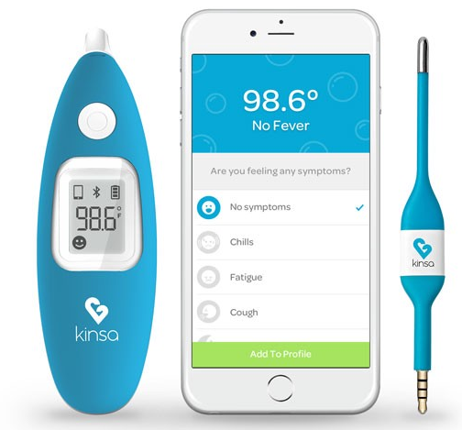
Fig-1: Kinsa Smart Thermometer
3.2 Self Installing Car Seats
According to research 80% car seats are fitted incorrectly. Unless we get someone to fit it for us. But how do we know the installation and fitting went well? The Self-Installing Car Seat checks the tension and levels by the sensor and response according to our car, before verifying it’s safe to use. After installation, its twenty sensors monitor its status and send error alerts to our phone. In fact, the car seat not only follows current safety requirements, it also meets the new side impact protection standard. We will drive safely in the awareness that our child is cocooned in a protective bubble with its steel reinforcement and aluminium crash bars. [3].

Fig-2: Self Installing Car Seats
3.3 Owlet Smart Sock 2 Baby Monitor
For new parents, the first stages of a baby's life may be the most appalling. There's so much to keep up, track, and worry about. These [2] IOT devices help to ease some of these concerns. Owlet is like a little bootie that our baby can wear, measuring her heart rate, oxygen levels, sleep quality, and sleep place, so we no longer have to worry at night. All this is accomplished with a built-in wireless (sensor) oximeter, and then all information is stored in the cloud. This helps us to access the information of our child on any device at any time. Owlet is completely harmless and comfortable for our child, and it is also waterproof and easily washable.

Fig-3: Owlet smart sock 2 Baby Monitor
3.4 Wearable tracker (Children Tracker for Parents)
Children’s tracking is the world’s most important and commonly used method. Every parent is very happy if the child is safe now. The IoT devices make child tracking devices possible and continue to evolve. The machines can be found in different shops and sizes. The child tracking devices ' weight is distinctive and easy to use.
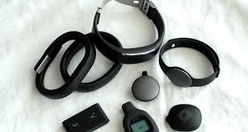
Fig.4: -Wearable device for Kids
4.0 Conclusion
In this paper, we talk about the current trending technology, IOT for the kids care. In the Introduction part we seen how Internet of things evolve and how it is impacting our daily life. And in the second part we talk about (IOT) Application for the kids care, how it is helping parent to keep their babies safe and health. As we know technology are booming every day, so the standard of the IoT are increasing and its capabilities are also evolving it mean the IoT devices will provide more precise data which will help the organization to develop and create more and more IoT devices for the kids and the senior citizen.
5.0 Reference
- AkashMoodbidri, Hamid Shahnasser (Jan 2017) ‘Child safety wearable device’, International Journal for Research in Applied Science & Engineering Technology, Vol. 6 Issue II, IEEE, pp. 438- 444.
- Muruganandham, ‖Real TimeWeb based Vehicle Tracking using GPS‖,World Academy of Science, Engineering and Techonogy, 37, 2010
- Akash Moodbidri and Hamid Shahnasser, Child Security Wearable Device, IEEE paper, 2017.
- Smart IOT Device for Child Safety and Tracking M Nandini Priyanka, S Murugan, K N H Srinivas, T D S Sarveswararao, E Kusuma Kumari.
- Chitra, jewel jose, sandeep, shirinidhishetty, A. (2018) ‘smart safety jacket for smallbaby’ yenepoya institute of technology, moodbidr.
- Kok Sun Wong, Wei Lun Ng, Jin Hui Chong, CheeKyun Ng, AduwatiSali, Nor KamariahNoordin, (15 -17) December 2009) ‘GPS Based Child Care System using RSSI Technique’, Proceedings of the Malaysia International Conference on Communications. pp. 899-904
- Bradley J. Rhodes, Nelson Minar and Josh Weaver (Aug. 4, 1999) ‘Wearable Computing Meets Ubiquitous Computing’, pp. 471-475

IoT Secured Home Door
Puja Kiran Nadgouda¹ and Abhijeet Kale²
Student¹ and Head², Department of Information Technology, B. N. Bandodkar College of Science, University of Mumbai, Thane
ABSTRACT
In this paper, I have proposed a Smart Door Lock. A Smart Door Lock accepts inputs through secret code, smart card (RFID or NFCs), retina recognition, palm recognition, iris recognition, fingerprint etc. as the method for authentication instead of manual lock and key system. In my proposed system, I have used three factor authentications i.e., RFID keys, user password and OTP and this is connected to a controller raspberry pi, which will control the locking and unlocking of the door. The purpose behind this research paper is to make fully automated and secured smart door-lock application running on raspberry pi. Raspberry pi will automate the locking and unlocking of the door. We have used bio-metrics for giving inputs to smart door-lock. We have programed whole system using python IDLE for Raspberry pi operations.
Keywords: Internet of Things [IoT], Raspberry Pi, RFID Key, Password, OTP, Home security
INTRODUCTION
Today safety and security are becoming more and more popular day by day and it is getting improved and we are using it on daily basis. We have integrated technology in our life, that’s why we can’t ignore security.
This research paper is focusing on developing fully functional automated smart door-lock system which provide mechanism for the locking and unlocking of the door in secure way for home. This system requires RFID key which will be given to every individual of the house. Whenever an individual will produce the RFID key near the reader the system will record it.
When individual gets recognized the system asks for the password that is unique for each individual and an OTP is sent for further process to the individual mobile number. This proposed work is sent to the individual’s mobile. The system decides that whether the permission should be grant to the individual or not. This project requires proper network connection between raspberry pi and other at end user.
LITERATURE REVIEW
Optimized door locking and unlocking using IoT is very secure solution for locking and unlocking the door within the network range. This system simplifies the task of unlocking the smart-doorlock with providing inputs on touch-screen display and by using rfid based tag for authentication purpose. The raspberry pi then process the inputs taken from touchscreen and rfid tags and then it will decide whether granting access to user. This system gives ability to user for locking and unlocking door withing given network range. All the data including door unlocking time and unlocker information is available on protected google spreadsheet.
For that purpose raspberry pie constantly updates the record in database,and we can export particular record to spreadsheet.
For send otp raspberry pi uses online sms notification platform. After registration of user,user phone no gets linked on sms notification platform.Then system will send otp via sms after authentication of user. We are using Raspberry Pi-3 Model B which was released in February 2016. For connectivity purpose it has built-in Wi-Fi, Bluetooth and USB. It is enabled with USb Boot capabilities.For processing it has an ARM based processor(CPU) and integrated GPU for handling graphics related tasks.
SYSTEM ARCHITECTURE
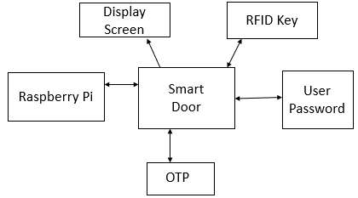
Fig-1: Proposed System
In above Fig 1, system rely on components and different technologies likely, RFID Key, User Password, OTP, Display Screen, Raspberry Pi. Essentially the system promotes security for home. Raspberry pi uses 5v DC supply which has in-build Wi-Fi module. RFID reader senses the RFID key presented by the individual and if it is correct then the display screen will display the individual’s detail and ask for is password and then an OTP will be sent to the individual but the presented RFID key is not correct then the door will be locked till the correct RFID key is presented.
This system requires following components:
• Raspberry Pi-3 Model B
• RFID Reader
• RFID Key
• LCD display
- Raspberry Pi-3 Model B: This is third generation of Raspberry Pi. This is a low-cost single board computer running modified version of Debian Linux on it, which is Optimized for the ARM architecture. This minicomputer system is the main part of home automation. It has Broadcom based BCM2837B0, Cortex-A53 cores 64- bit SoC running on frequency @ 1.4GHz in its processor. It has 1GB LPDDR2 SDRAM as its memory. It has connectivity of wireless LAN of 2.4GHz and 5GHz IEEE 802.11.b/g/n/ac, Bluetooth of 4.2, BLE gigabit Ethernet over USB 2.0. It has extended 40-pin GPIO header. For video and audio it has full size HDMI, MIPI DSI display ports, with MIPI CSI camera port, 4 pole stereo output and composite video part. This board supports H.264, MPEG-4 decode, H.264 encode, OpenGL ES 1.1, 2.0 Graphics for graphics calculations. Board has built in Micro SD reader for loading operating system and data storage in SD card. Operating Temperature, 0-50oC is the environment needed for the Raspberry Pi to work.

Fig-2: Raspberry Pi
- RFID READER: This reader falls in HX203D RFID family. It has frequency of 125KHz. It has sensing distance of about 5-15cm. It has USB model Interface. 9600 bps is the speed of the information transformed in the communication channel i.e., known as baud rate. Current required is <120mA to make the reader working. Power requirement is USB and working temperature is -10oC to +70oC.

Fig-3: RFID Reader
- RFID KEY: This key has 8kbit storage capacity. It has 13.56MHz frequency. The read and write distance for this key is 2.5-10 cm.

Fig-4: RFID Key
- LCD DISPLAY: The display is designed for Raspberry Pi, with 320x480 resolution. It is supported by any version of Raspberry Pi. It is directly pluggable. It has drivers provided that works with Raspbian/Ubuntu environment directly. It supports software keyboard (system interaction without keyboard/mouse).
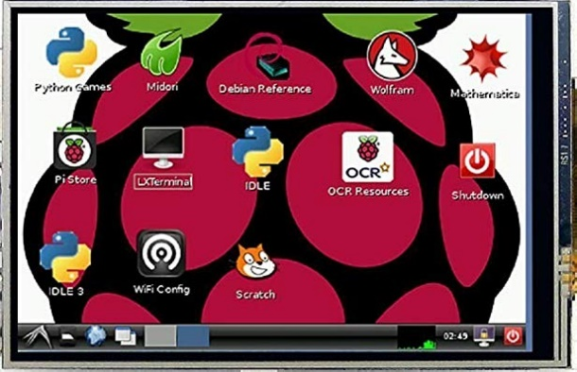
Fig-5: LCD Display
FLOWCHART AND ALGORITHM
Working of system and flow of the system is given below:
Steps include:
I. Start
II. Show RFID Key/tag.
III. If RFID Key matches then password is asked.
IV. If password matches then OTP is generated.
V. OTP is sent.
VI. If all the steps are properly executed then the door unlocks.
VII. Stop.
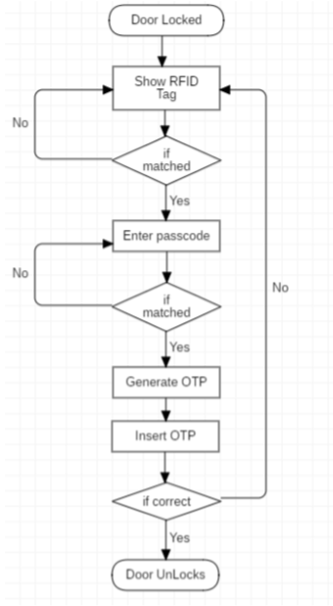
Fig-6: Flowchart
CONCLUSION
This system designed, which is based on Three factor Authentication which integrates the security to our home from unauthorized person or strangers. It implements all the features and function that are necessary for security All the planned functions were implemented in the system: RFID getting read by RFID reader, prompting for user pin, generating OTP and sending on our registered mobile number and entering OTP to get access to the door. For future we can put retina scanner, fingerprint, face recognition etc. in the system.
REFERENCES
- Home based security control system using Raspberry Pi and GSM, International Journal of Innovative Research in Computer and Communication Engineering, Akash V. Bhatkule
- Optimized Door Locking and Unlocking using IoT for physically Challenged people, Anuradha R. S, Bharathi R.
- An Intelligent Door System using Raspberry Pi and Amazon Web Services IoT, International Journal of Engineering Trends and Technology, S. Nazeem Basha, Dr. S. A. K. Jilani
- IoT Based Home Automation system using Raspberry Pi, International Research Journal of Engineering and Technology, Nisarg Shroff, Pradeep Kauthale.
- Secured Smart Home Monitoring System Using Raspberry Pi, International Journal Innovative Research and Development, Rajendra Nayak, Neema Shetty.
- Design and Implementation of Low-cost Home Security System using GSM Network, International Journal of Scientific and Engineering Research, S. R. Khan, A. Kabir, S. Jaman.
- GSM based digital door lock security system, A. Ibrahim, A. Paravath, P. Aswin.

iIOT-Based iSmart iHomes iand iTheir iExtension ito iSmart iBuildings i
Shrikant Prajapati¹ and Hiren Dand²
Student¹ and Head², Department of Information Technology, Mulund College of Commerce, University of Mumbai, Mumbai
Abstract
This iresearch iapproach iis ito idesign iand idevelop sSmart home automation, ieconomical, ireal-time iand i iwellness isensor inetworks ifor ismart ihome isystems. These technologies facilitate the building of Smart homen enviroments in which device and System can communicate with each other and can be controlled smart way and automatically.describes the Smart Home networking technologies and discusses the main issues for ensuring security in a Smart Home environment. Nowadays, the integration of current communication and information technologies within the dwelling has led to the emergence of Smart Homes.
Keyword: IOT’s iwellness ifunction, iBehavioral idetection, iautomatically iControlled, iinterference.
1. Introduction
2. Description Smartihome Monitoring System
It is very important to determine the main components of the Smart Home architectural model in order to be able to understand the factors that raise security breaches in a Smart Home environment as well as realize security technologies that can be applied to minimize the risk of security attacks. Smart Home can be considered that consists of three main components; the internal network, the external network and the residential gateway. These three components are presented in the Figure 1. The internal network is the basis of a Smart Home and can consist of wired and wireless networks. The internal network of a Smart Home incorporates a combination of different communication media and protocols in order to support a number of Smart Home systems that simplify the residents’ life and improve their quality of life. The external network of a Smart Home includes Internet and the service provider which is in charge to provide services over Internet to the household members. Finally, residential gateway (RG) is an always connected device located in a Smart Home and plays a very important role in bridging the internal network of the Smart Home and the outside world.ipredefined iirregular ibehavior. iThe wellness iforecasting imodel iwe ihave idesigned iand iproposed iis divided iinto itwo isections. iAt ithe ilower isection, iall ithe iraw isensor idata ifrom ihousehold iappliance usage iand imovement iis idelivered ito ithe icoordinator iattached ito ithe ilocal ihome igateway iand ithis local server istores ithe iunstructured idata isets ifor ifurther iprocessing iand ianalysis. iRaw isensor idata icollected at ithe ilower iinformation isection ican ionly iidentify iwhich isensor iis iactive ior iinactive iand iat iwhat time. analyzed iby ithe iupper isection isoftware ilogic. iIntelligent idata irecognition iand iclassification mechanisms are iapplied ithrough ithe isoftware iat idifferent ilevels iof idata igeneralization iin ireal itime, ibased ion ithe time iand iorder iof ithe isensor iusage. iThere iare ivarious iZigBee iRF imodules iavailable iin ithe iwireless industry. iFor iour iresearch iapplication, iwe ipick iDigi iXBee iSeries-2 iRF. iThe iXBee imodule ifacilitates various ifeatures isuch ias idifferent isampling irate, ibaud irate iand isleep irate iassociated iwith itwo itypes iof operating imodes. iThe ifirst iis ian iapplication iprogramming iinterface i(API), iand ithe iother iis iapplication transparent i(AT).
2.1. iTopology iand iDevice iConfiguration
The iZigBee idevice ican ibe iconfigured i(programmed) ias iZigBee iend idevice i(ZED) iand iZigBee iend idevice iplus irouter i(ZEDR). iZED iis iusually ilow ipower ias iwell ias ismall ibattery ipower idevices. iThey itransfer itheir idata idirectly ito ithe iparent i(ZC), iand ithe iparent imay ibe ithe icoordinator ior ianother irouter inode.
2.2 Existing Wired Networks
ZigBee ibased iDigi iXBee iSeries i2 iis iused ias iRF imodule iin iour ismart iand iintelligent ihome imonitoring isystem. iThe iZC ihas ithe iauthority ito iselect ia ichannel, iPAN iID i(16-bit ipersonal iarea inetwork iunique iidentification inumber ithat ionly ibelongs ito iparticular iZigBee iWSN), isecurity ipolicy, iand istack iprofile ifor ithe inetwork Existing wired network technology is directly applicable to new and old houses as rewiring of the buildings is not required. The major limitations of this networking technology include the networks’ structure and the interference from the original operation of the network. Based on existing wiring of a home, Powerline networks, Phoneline networks as well as Coaxial networks can be developed to satisfy the needs of the household members (Jiang et al., 2004; Teger et al., 2002; Valtchev et al., 2002; Zahariadis, 2003; HGI, 2006; Delphinanto, 2003);iavailable ichannel. iIt ican ibe iconfigured iby ithe iRF imodule ithrough iXCTU isoftware i[36].
3. iExtension ito iSmart iBuilding
After isuccessful iimplementation iof ithe iwe iaim ito idesign iand idiscover ithe iissuesd irelateded ito ithe ismart ihome imonitoring isystem ifor ibuilding iapartment iwhere imany ipeople ilive iindividually. iWith We can better understand this by the packet reliability terms of ZigBee based WSNs. Packet delivery ratio (PDR), packet success rate (PSR), packet loss rate (PLR), packet error rate (PER), received signal strength, Signal to noise ratio and received packet delay are some of the parameters that define system reliability and performance. In order to evaluate these parameters in IEEE 802.15.4 ZigBee based wireless sensor and networks, the smart building setup is developed and implemented in real-time to get control and monitoring applications without any time delay. The results show that the distance, deployment environment and positioning of sensor nodes are essential parameters that decide the reliability of wireless sensor and networks.
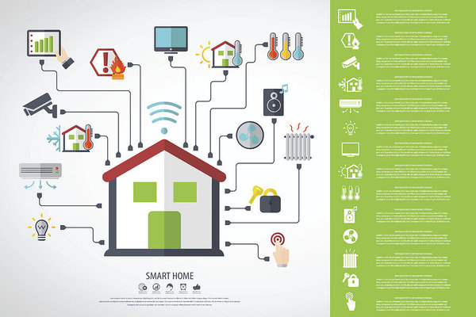
4. Conclusion
Smart Home security is of extends importance since it affects the privacy of the household members. Thus, a variety of important security issues in Smart Home environments were discussed. Especially, the security objectives of a Smart Home as well as the main factors that increase the level of difficulty to provide security in a Smart Home environment were described. Furthermore, the threats that intend to compromise the security requirements were examined. Finally, existing security mechanisms that provide security features in a Smart Home environment were presented.
In a lot of cases, most of the home users are not security-aware enough to realize the implication of the Smart Home environments system.
5. References
- Sanchez, iL.; iMuñoz, iL.; iGalache, iJ.A.; iSotres, iP., iSantana, iJ.R.; iGutierrez, iV.; iRamdhany, iR.; Gluhak, iA.; iKrco, iS.; iTheodoridis, iE. iSmartSantander: iIoT iexperimentation iover ia ismart icity testbed. iComput. iNetw. i2014, i61, i217–238.
- Gopinath, iashwin i(August i2013).” iAll iabout itransferring ipower i i iwirelessly” i(PDF). iElectronic for iyou iE-zine iretrieved ijan i16,2015
- Magana-Espinoza, iP.; iAquino-Santos, iR.; iCárdenas-Benítez, iN.; iAguilar-Velasco, iJ.; iBuenrostro-Segura, iC.; iEdwards-Block, iA.; iMedina-Cass, iA. iWiSPH: iA iWireless iSensor iNetwork-Based Home iCare iMonitoring iSystem. iSensors i2014, i14, i7096–7119.
- Hwang, iK.-I.; iChoi, iB.-J.; iKang, iS.-H. iEnhanced irobust iZigBee-based ihome iautomation. iIEEE Trans. iConsum. iElectron. i2010, i56, i583–590.
- Desai, iA.S.; iKonstam, iM.A. iHome iMonitoring iHeart iFailure iCare iDoes iNot iImprove iPatient Outcomes iLooking iBeyond iTelephone-Based iDisease iManagement.
- Suryadevara, iN.K.; iMukhopadhyay, iS.C. iSensor iActivity iPattern i(SAP) iMatching iProcess iand Outlier iDetection. iIn iSmart iHomes; iSpringer: iBerlin, iGermany, i2015.
- Valtchev, iD.&Frankov, iI., i&ProSystem iSoftware iAG. i(2002). iServices iGateway iArchitecture ifor ia Smart iHome. iIEEE icommunication iMagazine,126-132.
- Suryadevara, iN.; iGaddam, iA.; iRayudu, iR.; iMukhopadhyay, iS. iWireless isensors inetwork ibased safe ihome ito icare ielderly ipeople: iBehavior idetection. iSens. iActuators iA iPhys. i2012, i186, i277–283
- Teger, S., & Waks, D. (2002). System Dynamic Inc(pp.114-119). End-User Perspective on Home Networking.IEEE Communications Magazine.
- Casole, M. (2002). WLAN security – Status, Problems and Perspective. In Proceedings of European Wireless 2002. Florence Italy.
Managing Modern Businesses using Artificial Intelligence
Shriyans Jain¹ and Priti Palkar²
Student¹ and Head², Department of Information Technology, N. G. Acharya & D.K. Marathe College, University of Mumbai, Mumbai
Abstract
Artificial Intelligence seems to be everywhere. We experience it at home and on our phones. Before we Know it if entrepreneurs and business innovators are to be believed AI will be in just about every product and service we buy and use. But it is more than a service it is application which can help solve various business problems as business problem are becoming more big and complex it is hard for a human being to solve these problem by their own. This kind of application help them in taking the decision by themselves. AI is so powerful that once it is trained it can handle a complete business by themselves without any human interference. Some example of AI application which we face in day to day life are Alexa, Siri and Google Assistant are the common example of AI which we almost all have interacted in our life some or the other point of life. These application are not directly related to our topic but have many similarity through which we can understand our point more easily. These application help us in many of our day to day activity they keep a track of where we go at what time what is our time to reach office ect. and notify us accordingly to make thing’s go in the right direction. In Business AI help us to take complex decision to maximise profit. AI Work on Studying or taking reference from the past instances and scenario to take action on the current problem this is the very basic way through which AI works. Developers and various other individuals like scientists and engineers are working day and night to make AI more powerful. As the world is growing very fast the and limitation for AI are also increasing day by day many new problem occur everyday which do not have any past reference which causes AI many Problems to take decision. It is also disappointing when AI efforts run into real-world barriers, which can lessen the appetite for further investment or encourage a wait and see attitude while others charge ahead. We also need to understand that where we can implement AI and were it is not fissible.
Introduction
In todays world we can find AI everywhere in our surrounding. This also makes us understand that AI is becoming a huge part of our life when it comes to using any technology/products. The main of objective of AI is to reduce load over human and help make the work done more perfectly to maximise profit. AI in business can be very useful as it can help take decision over various business problems very easily. As AI getting more powerful day by day it is also harming the job of personal because it can almost do all that stuf which a human being can do. The name AI says it all in AI we make over machine work in such a way that it can think like a human being and can take decision in such a way like human does by using various mathematical algorithm and by using past similar experience and instances. Some times AI can take better decision then a human being because it take’s reference from the past experience as it has lots of memory it does not forget any instance whereas in human being their are chances that one can forget that. While taking any decision a human can become partial because he has feeling which can effect the decision he is going to take whereas in AI It does not have any feeling so it can take any decision without being partial to anyone. But in some cases AI losses against human being such as if an event or problem occurs which is completely new i.e. it does not have any previous instance in such case decision making becomes tougher and sometimes impossible for AI. In such case it increases the chance of failure and loss. Whereas in human being one can take decision based on the experience with the work and their own knowledge of how the product or the public react to the decision he takes. The power to take risk is more in human being than that of AI. As AI is becoming stronger day by day there are chances that one day they can replace human being completely in a workplace. The AI system are designed in such a way that they learn new things each and every day. There are some product which shows this quality of AI very nicely.
A AI based product give us the felling that we are interacting to human being. Some product which are available in the market which purely works on AI is cozmo. It is a pure example of how AI learns and interact with human being. If we give total control of our business to AI there are chances that it will take the business to very great extent because it can keep an eye on each and every activity happening around itself without missing any which is impossible for a human being. The most used AI service in the field of voice assistant is google assistant and Siri
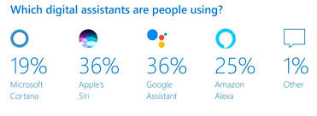
Their are various reason because of which we should use AI in our business such it can help us reduce down time utilize the resources more efficiently and reduce cost which is one of the most important factor in any business. Whenever we give any responsibility to AI the chance of failure becomes less.
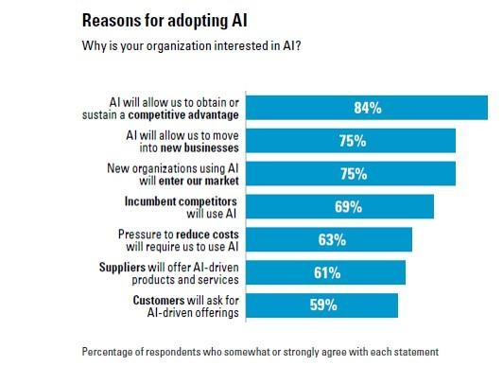
If we give the power of running a business to AI there are high chances that the company will grow over time. There are various examples of the company who have used AI for their management have score great results then by running the company depending on an manager/ human being. In the below image we can see a company who works with funds. Previously the use to do their trading depending on human being and on their experience but recently they are allowing a AI application to trade on behalf of a human being. They have allowed their human team and AI application to trade simultaneously to compare the profit between them. In the initial face the AI application was not able to compete against the human team due to lack of previous experience but as time passed it started learning the market trends and monitoring them after some time the AI application trading graph started to increase and started coming closer to human team. After some time the AI application graph surpassed the human team and the end result was the human team has made 23.87% profit whereas the AI application has made 26.56% profit i.e. approximately 3% more this shows thee capability of AI application.

Like the above company there is one more company who has incorporated AI in their working environment in that companies profit graph we can see that the company was making a profit x with their human team which was not increasing above that. But when thy incorporated AI with their working their profit started to shoot up in the initial moths the profit made by AI was very little but as tie passed the AI application learned more about the organization and their working which lead to the profit increase every year after some year they were able to make 50% more profit than the normal profit based on the human team

Despite of so many plus point not many company use AI. Only 14% of the company around the world use AI or have developed the AI application based on their need. 9% of the company are not thinking about AI they think it is waste. Whereas 23% company are about to develop their application within 12 months and 25% company are going to complete their development in 12 to 24 months. Rest 29% are going to develop in 2 to 3 years
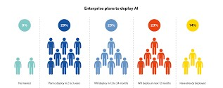
Challenges and risk of AI
One of the most important and the first problem which we face is developing a thinking AI systems are currently too difficult to achieve in practice and also one cannot give its requirement properly to the developer which can cause a problem. As AI has many plus point there are negatives as well. As AI is very new to the market and its working is very different from the normal working of the other application there are various number ethical and legal issues that are yet to be addressed. Developing of a AI Application is very costly for now it can be only done for a person who has wealthy owners to invest in his company. As the working of AI is different from the traditional way of working it creates negative impact and increases inequality in results. The people who are going to work with AI don’t understand this technology and how it works and the people who can are not much available and also they are expensive. There is high chance that the AI application developed can be immature i.e. it not trained enough to concur the day to day business problem. These AI Technology is oversold in the market i.e. due to lack of expert people and not much company using this technology the company who are using it overcharge for their service.
Area of AI implementation
As it is very flexible and able to adapt new things very easily AI can be implemented in almost every place just we have to modify the operation and function as per its work and train it accordingly. AI is mostly used in the field of IT were every thing is on system the application to manage them should also be their on the system so that work can be made easily done. After IT the AI is most used in Supply and Logistics were AI can better understand the route of destination and how much time it will be required to do that job and also AI can also arrange the job in such a way that all the resources are completely utilized to maximize the profit. Beside supply chain AI can also be used in Production Innovation and R&D hear AI can help us determine new techniques of production. It can evaluate the current market demand and give us the approximation of how much product we have to prepare/produce to avoid wastage. In R&D AI can show us which is the trending topic in market on which we can perform our research. AI can also be used for Customer Support
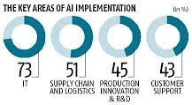
Solution for the problem related to AI
As we all have come across in the above phrase about the problem related to AI we can use some simple way to rectify these problems. One of the main and the biggest problem with AI because of which many organization do not use AI is cost. Cost of AI related product are always touch the skies to resolve this problem we can train individuals from our organization to make or work with AI related product this will reduce the cost of labour on the organization if the organization is outsourcing the product we should ensure that the other organization who is making the product should not over charge for the product. We should ensure the organization about the capabilities of AI so that they can trust it and use it in their organization without taking any stress. For ensuring them we can show them the profit graph of various other companies who are using AI in the current time and making profit we should show them companies which have similar working like them before AI implementation after AI implementation the working has become so good for them this will also help us to gather their trust. Making people aware about AI is on of the most important prospect to popularize AI.
Conclusion
As we know in todays world AI is catching its phase to reach the top. AI is been started to become one of most important aspect for many of the organization. But still there are various people who do not know about AI. AI has many plus point when used in business management it can help us grow our business by helping us in increasing the profit by using the resources efficiently and by helping us take complex decision on time. AI also helps us to know when and were to take which action that can help us increase the profit. As there are various plus point there are many negative also about AI some of them are the cost. If we go in a market to buy a AI application it will come with a huge price tag which cannot be affordable to every organization. The second most biggest problem of AI is he lack of specialist individual who can work with AI which make AI less preferable for any organization. If we overcome these problem we can use AI for business management it can help us achieve great results.
References
[1] Reshaping Business with Artificial Intelligence by By Sam Ransbotham, Philipp Gerbert, David Kiron and Martin Reeves.
[2] Impact of Artificial Intelligence on Business by Neha Soni, Enakshi Khular Sharma, Narotam Singh and Amita Kapoor.
[3] Artificial Intelligence and Human Thinking by Robert Kowalski
[4] Artificial Intelligence and its Application in Different Areas by Avneet Pannu
[5] Application of Artificial Intelligence & Associated Technologies by Jatin Borana
[6] Artificial Intelligence, Income, Employment, and Meaning by Betsey Stevenson
[7] Public Policy in an AI Economy by Austan Goolsbee
[8] What AI can do what Can’t for business by Michael chui james manyika and mehdi miremadi
[9] Using AI to enhance business operation by MITSloan

A COMPARITIVE STUDY ON DRONES WITH SIGNIFICANCE OF HYDROGEN FUELED CELLS
Megha Kandpal¹ and Pournima Bhangale²
Student¹ and Head², Department of Information Technology, V. G. Vaze College of Arts, Science and Commerce, University of Mumbai, Mumbai
ABSTRACT
Controller as well as autonomously running vehicles sent to the skies to capture high definition videos and photographs. It is considered to be the most emerging technology today. This paper focuses on SKAI(Hydrogen Powered drone technology) which has been recently launched for the betterment of future transportation. SKAI is a smart technology which typically uses hydrogen as its fuel to create electricity which does not affect the sensitivity of nature and also helps reducing the pollution as it leaves nothing behind but just water or water vapour. This drone is been designed to make it easier to travel from one place to another as it does not require launch pad etc. It uses simple constructs as it will be easier to detect the failure. It also has the advantages of hydrogen fueled cells in comparison to others. In this research paper there has been a discussion related to characterization of SKAI drones and hydrogen fueled cells and also its benefits and limitations in compared to other drones. As this drone is been designed to reduce the human efforts for transportation and travelling it also helps to recognize how it can be the future of transportation in upcoming years.
Keywords: SKAI, Hydrogen fueled cells, DJI Phantom 3, Quadcopter, FAA certification.
1.0 INTRODUCTION
According to Axel Smits (Chairperson and Senior partner, PWC Belgium). Drones are the most emerging technologies used. He raised a question on how drones can be used to make client’s operations more impactful? Drones can also be defined as an unmanned vehicle that acquire assistance to fly without any human pilot onboard. It uses different0systems of communication. Drones were initially operated in two different ways:-
1.Human operator with a remote control. These human operators operates drones from the particular place continuously giving signals to the flyingdrones. 2.On-board computers that are already attached to the drones that manages the drones according to air pressure. The first drone was 1918 Kettering Bug which was developed during the world war 1 phase for defense purposes and could move only to a certain amount of area. But today as the technology evolved the drones have the capability to move anywhere around the world. Here we can get an idea of how fast the technology is developing. According to some surveys it has been proven that these evolving technologies have helped changing the world. At present there are 1 million people registered as drone owners around the world. Using SKAI drones frameworks that are designed by (Designworks- A BMW company). They made each component so light it does not have any impact onto its airframe. The major task that they accomplished was designing hydrogen fuel tanks. FAA certified SKAI to be the most safest vehicle to run on air without affecting tropospheric conditions as it uses fibre-optic cables instead of metallic wires. Finally, this ended up creating a vehicle much powerful land less destructive for nature.
2.0 REVIEW OF LITERATURE
JACOBSON stated
“Hydrogen fuel cells vehicles are more effective in order to preserve nature. There are many ways to produce hydrogen but then too it in every possible way it emits less pollution as compared to other vehicles exhaust. And also hydrogen is the only energy that can be available as soon as possible with less amount of efforts.”
Goldin stated
“ Developing different techniques to make low cost and pocket-friendly manufactures can make each ssand every lives more interesting. There is a need to have safe planes and to conquer this there is a requirement of simple constructs as it can easily detect failure without any damage as complex constructs makes it hard to detect failures. If things are going to be affordable and cheaper it can affect the livelihood of many individuals.”
Tollefson stated-
“The first car that a child born today could drive, can be powered by hydrogen” this was said a long back by George Bush in 2003 as the usage of hydrogen is more good than biofuels and batteries as hydrogen fueled cells are more cheaper than them. As these cells can be used for a longer period of time as compared to other fuels and batteries.

3.0 RESEARCH IN USAGE OF HYDROGEN FUELED CELLS:
3.1 USAGE RATE OF HYDROGEN FUELED CELLS IN DRONES:
As compared to different drones such as DJI Phantom 3, Spark, Mavic, Owl drones and many more work only on batteries and these batteries are reusable but the only limitation to them are they can carry only a limited amount of weight and can fly upto certain possible area only. But hydrogen fueled drone(SKAI) can move from A to Anywhere without any problem as it does not work on batteries and can carry about 5 passengers onboard. More usage of hydrogen fueled cells can create a great difference in the pollution graph as it does not emit harmful exhausts.
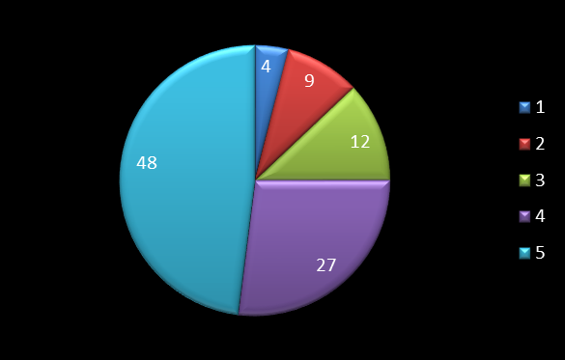
Fig-1: Hydrogen fuel cells usage rate
As shown in the diagram early 1800s hydrogen fuel cells usage was 4% and now have increased up to 48%. It has taken a very long time to adapt the usage of hydrogen fueled cells. Some of the researchers have predicted till the year 2030 there will be immense growth of hydrogen fueled cells in the vehicles as well as drones. There will be more air vehicles used which are normally known as air taxi run on hydrogen fueled cells rather than road vehicles to improve traffic conditions and pollution statistics can also be decreased.
4.0 RESULTS AND DISCUSSIONS
A comparative study is carried out using DJI Phantom 3, Quadcopter and (SKAI) showing their capabilities:
DRONES | DJI PHANTOM 3 | SKAI DRONES | Quadcop-Ter
Carriage Capacity | 1.124 kgs | 453.592 kgs | 10 kgs
Battery | 4480 mah | Runs on fuel having 200 or 400 liter tank | Runs on solar energy with the help of solar panels
Flight Duration | Approximately 23 minutes | Approximately 4 hours and more | Approxi-  Mately 3 hours 20 mins
Speed | 35 mph | 118 mph | Works as per the presence and amount of sunlight consumeD
Control System | Cannot have onboard pilot | Can be controlled by both onboard pilot and remote controller | Can run autono-  mously
This clearly shows that hydrogen fueled cells are more effective and useful than the rechargeable batteries as well as solar panels.
5.0 Limitations
As it is easily available and useful it also have few limitations that stops people to use it:
- Hydrogen is highly dangerous as it can create fire when mixed up with the air.
- Hydrogen is readily available without huge money loss but to create the hydrogen fueled tanks it requires a lot of stainless steel and big investment.
- As hydrogen is gravity resistant it can make a machine imbalance at any difficult point.
These limitations should be overcome so as to increase the production and usage of hydrogen fueled cells in vehicles and drones.
6.0 Conclusions
The enhancement of hydrogen fueled cells is supported by very few population as it has advantages along with dangerous disadvantages. This technique must be used but by overcoming all the disadvantages as it is time consuming but also a dangerous mixture to deal with. The limitations provided in this research paper must be read wisely and research is required for the safe use of hydrogen fueled cells in drones as well as vehicles to increase its productivity and usage.
7.0 APPENDIX
The above mentioned graph is been desined as per the survey of many automobiles organizations as well as Designworks(a BMW company) showing the usage rate from 1800 to 2017. When we analyze the graph we can clearly identify that the rate has increased but the process is very slow as compared to other developments. The highest rate shown is just 48% after a decade has been passed. The limitations must be decreased and usage should be increased.
REFERENCES
- Tollefson, Jeff. "Hydrogen vehicles: fuel of the future?." Nature News 464.7293 (2010): 1262-1264.
- Jacobson, Mark Z., W. G. Colella, and D. M. Golden. "Cleaning the air and improving health with hydrogen fuel-cell vehicles." Science 308.5730 (2005): 1901-1905.
- Trujano, Fernando, et al. "Security analysis of dji phantom 3 standard." Massachusetts Institute of Technology (2016).
- Kumar, Gaurav, Shubham Sepat, and Shubham Bansal. "Review paper of solar-powered UAV." International Journal of Scientific & Engineering Research 6.2 (2015): 41-44.
- Santhi, S., et al. "HIGH RANGE SOLAR AERIAL VEHICLE." International Journal of Computer Science and Information Security 14.11 (2016): 43.
- Appleby, A. J. "Fuel cells and hydrogen fuel." International Journal of Hydrogen Energy 19.2 (1994): 175-180.

SECURING THE VULNERABILITIES IN CLOUD COMPUTING
Payal Debnath¹ and Sunita Joshi²
Student¹ and Head², Department of Information Technology, JVM’s Mehta Degree College, University of Mumbai, Mumbai
Abstract
Cloud provides the most powerful platform for organizations and individuals to carry out their business. It provides services like online servers, storage space, customized software and hardware, creation of a virtual network that would seamlessly work as an actual physical network, etc. A recent study has found that usage of the cloud environment has dramatically enhanced over the years and most of the data is now being stored in the cloud network. This has grabbed the focus of hackers, which has led to the exploitation of data securities, data leakage, data breaches, etc. in the network. This paper contains comparison of the 3 cloud models, threats in clouds and its security measures in detail. Real-world attacks are included later, to illustrate the various ways that hackers try to infiltrate the network. Countermeasures that would help avoid such breaches are also presented.
NOMENCLATURE
DoS: Denial of Service
Amazon EC2: Amazon Elastic Compute Cloud
Amazon S3: Amazon Simple-Storage-Service
IaaS: Infrastructure-as-a-service
PaaS: Platform-as-a-service
SaaS: Software-as-a-service
1.0 INTRODUCTION
Cloud computing has been around for a very long time and most of the businesses are migrating their data slowly over the cloud. It provides a vast range of services like online storage, servers, network, software/hardware, building & deploying product platform, etc. with a low-cost structure. Cloud believes in Pay-as-you-go (i.e. only pay for services until you are using them); this has made cloud services trending, as small business sectors can also avail them.
The commonly used cloud services are Google Docs, which allows users to store, edit and share documents, emailing systems like Gmail, Yahoo and Hotmail, that allows users to send/receive emails which are stored on provider’s servers, Flickr and Picasa provide servers to store online photo albums, Dropbox, Strongspace, Xdrive, Google Drive, Zumo Drive, etc. provide online storage for various digital media, Hotstar, Sony App and Amazon Prime allows users to watch TV shows, Carbonite, Mozy and Jungle Disk provides users automatic backup of data on cloud servers. Some of these services are free while others need registration and payment.
MNCs are switching to Cloud services for storing data, Scaling up of resources, Software building tools, Servers, Customized software, etc. This helps them to reduce setup, operational and implementation costs as Cloud believes in pay only for what you are using, only till when you are using it. For example, a photo-sharing site, SmugMug uses Amazon’s S3(Simple-Storage-Service) for photo hosting. Mazda USA, an automobile company, rents RackSpace for its marketing and advertisement. Infosys uses EC2 provided by Amazon, to generate reports.
Cloud computing is undoubtedly convenient and low cost service that has change business conduct over the past few years. This has led to increasing risks like Cybercrimes, security threats, data breaches, unauthorized access, eavesdropping, etc. due to vulnerabilities in cloud computing. Hackers use a variety of methods to gain access to private & confidential data, illegally and disrupt the cloud system. If hackers get access to the exact location of the data they can steal private and confidential data for criminal activities. For Example, in 2016, the ‘National Electoral Institute of Mexico’, suffered a huge data breach, where 93 million voter registration records were compromised due to a poor configuration of server & confidential information became publicly available. Investigation showed that the server was an insecure & illegal Amazon server hosted outside Mexico. This shows the level of loss one can suffer if the cloud network is not secured. Countermeasures & remedy for such breaches are discussed later in this paper.
2.0 CLOUD SERVICE MODELS
Before buying cloud service, business needs to determine the level of control and flexibility they need.
2.1 IaaS: The most bottom layer is the system layer, it includes resources that consists network devices, storage disks and servers. It is commonly known as Infrastructure-as-a-service. These resources are available for usage as per requirement. Virtualization has helps to deliver a complex network infrastructure. This approach reduces operational cost of clients to build and maintain physical network. It also reduces the requirement of network admins to constantly monitor and support to the actual network. Amazon EC2 is an example of IaaS infrastructures. It provides a virtual computing environment with web service interfaces, using these users can perform deployment on Linux/Windows/Solaris based virtual systems.
2.2 PaaS: The next layer is the platform layer, also known as platform-as-a-service. It provides a platform to perform build, compile and deployment user’s specific applications. The service provided by this model consists of libraries and tools for building user’s applications. It allows users to control application development and configuration settings. Using PaaS users do not have to worry about setting up different environments for building their software, thereafter reducing the operational cost. Gmail, Google Groups, Google Calendar, Google Docs and Google Drive are suites of PaaS infrastructure. They allow customization of tools as per customer’s demand. Windows Azure is an example of PaaS provider. It supports various languages, tools and frameworks for building and deploying applications. Integration of applications into already existing IT environments can be achieved easily with the help of PaaS.
2.3 SaaS: The final layer is application layer, commonly known as Software-as-a-service. This allows users to rent application instead of purchasing licensed software, which requires monthly/yearly payments to continue using it. Cloud computing is undoubtedly convenient and low cost service that is now easily available. Example of SaaS services are DocuSign BigCommerce, ZenDesk, etc.
3.0 TYPES OF ATTACKS ON CLOUD
Since cloud has the ability to provide individuals with huge computing power; hackers avail such resources, analyze its configurations and settings to find out their vulnerabilities that helps them to understand the entire system. This gives them an insight about other networks on the same cloud. The most important security risk faced by cloud models is data loss. Data Breach can be done by internal(employees) as well as external(hackers) sources. Internal employees can have access to restricted data intentionally or accidentally. External hackers gain access to the data in cloud network using a range of hacking techniques, e.g. session hijacking and network eavesdropping. It is extremely important to recognize the possible attacks in the cloud in order to implement various security mechanisms to protect the cloud environments. Following are the possible types of attacks on the cloud environment that hackers perform to exploit the systems:
3.1 Denial of service attacks: Denial of Service attack attempts to distress a server/network that makes legitimate users unable to reach the service. Flooding, a common way used to crumble the targeted system by the hacker, where they send a large number of overwhelming bogus requests to the server and actual users cannot reach the service because of this false traffic in the network. For example, Bryan and Anderson, two security consultants, launched DoS attacks in a cloud network to one of their customers in order to test its connectivity using the Amazon’s EC2 cloud framework. By renting virtual servers on EC2, at the cost of $6, they used a homemade “Thunder Clap” program to successfully flood their customer’s server and made the company unreachable on the Internet. The following figure illustrates the DoS attack.
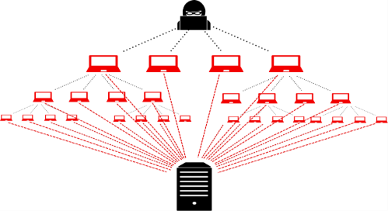
Figure-2: Denial of service
3.2 Abuse of cloud services: Earlier, attackers used multiple devices or botnets to generate a large amount of computing power, to conduct cyber-attacks on the network. However, this was a complicated process back then. Nowadays, cloud services have made it easy to get powerful cloud infrastructure, with both hardware and software components, after a simple and easy registration process
A brute force attack is a method, which violate and break passwords. This attack require large computing and processing capability as thousands of passwords are needed to be processed to a targeted user until it finds the correct password. Cloud computing provides a perfect platform for hackers to launch this type of attacks across the internet. A German researcher, Thomas Roth, demonstrated brute force attack in the ‘Black Hat’ Technical Security Conference. He was able to crack a WPA-PSK protected network by using a server from Amazon’s EC2. In approximately 20 minutes, Roth launched 4,00,000 passwords per second into the system & the cost of using EC2 service was only 28 cents per minute.
3.3 Malware injection attacks: This lets attacker gain access into user private data on the network. To perform this, they add infected module into the cloud systems. If the module implementation is successful then the legitimate user’s request will be directed to the infected module that will then take control of the execution flow thereafter. A common way to such attack is by injecting infiltrated JavaScript code inside web sites. Sony’s PlayStation become a victim of SQL injection attack in 2008, which is another example of such attacks.
3.4 Insider attacks: An insider, who purposely initiates any violation to the security policies of the company, causes an insider attack. The attacker could be an employee (of Client Company) or a service provider administration. To protect cloud from such attacks, a secured architecture should be implemented that would give employees/admins only necessary privileges & any offence to such privileges should be punishable.
3.5 Account or service hijacking: This attack requires user’s credentials. Phishing, spyware & cookie poisoning techniques are used for obtaining user’s ID & password. Once done user’s personal information or corporate data, which are kept confidential, will be compromised. For example, in 2007, Salesforce suffered a data loss of its client’s accounts because of a phishing fraud.
3.6 Spectre and Meltdown: These are another 2 types of attacks on cloud, where JavaScript embedded with malicious code can read encrypted data from the memory by exploiting a design’s loopholes of the modern processors. Both Spectre and Meltdown break the isolation between applications and the operating system; it lets attackers get information from the kernel. Users who are not updated with the latest security patches can face this.
4.0 COUNTERMEASURES
The cloud-computing framework consists of a cloud service provider, who provides computing resources to the end-users. To assure & provide the best quality of service, the service providers are responsible for ensuring the cloud environment has the capability to detect and stop any kind of attack. This can be achieved by applying advanced security technologies & making stringent security policies.
4.1 Security Policy Enhancement: Nowadays anyone can avail cloud services offered by the various Cloud Service Providers available in the market after a simple registration & online payments. This gives hackers a platform to take advantage to misuse such high computational power on the cloud system. Using this they practice malicious activities, like attacking other computing systems & spamming. As soon as an account on cloud is observed to be involved in any kind of suspicious activities then the account should be blacklisted immediately. Implementation & execution of security policies/SLAs can minimize the risk of abuse use of cloud computational power. Structured rules and regulations can help admins manage & control the clouds more efficiently & effectively. For example, AWS has defined a clear user’s policy, which states that whenever a complaint is received against an offending instance that is causing spam or malware, that particular account is terminated and further investigated.
4.2 Access Management: Cloud stores the customer’s data that are sensitive & confidential in nature. An access control mechanism is needed to ensure that only people with authorized access can have access to that data. Not only the storage systems need to be continuously monitored & secured, but also the access flow of the data (i.e. who can access the data & how much) also needs to be controlled. Malicious activities and suspicious instances are restricted using Firewalls and various Intrusion detection systems.
4.3 Data Protection: Data breaches can be either an insider employee or an external source (hackers/attackers). Insider employee can access illegal date either accidentally or intentionally with a hidden motive. Insider attacks are difficult to monitor, hence proper monitoring tools are necessary to be installed in the system. The tools like abnormal behavior pattern detection tools, data loss prevention systems, encryption and decryption tools, format prevention, user behavior profiling, and authentication/authorization technologies should be installed. With the help of these tools, admins can track real-time traffic monitoring, support the cloud system & trap suspicious activities as soon as they are encountered.

5.0 REAL-WORLD ATTACKS
5.1 Case 1: In 2011, Sony’s PlayStation Network was hacked, which caused them to shut down the PlayStation network from April to May. The attackers stole data of 100 million users. Investigation revealed that it was carried-out through Amazon EC2. The hackers pretended as a legitimate company and registered for EC2 service provided by Amazon. All they had to do was go through online registration and Credit card details, which apparently were fake. This is the reason a thorough KYC process by service providers is necessary before registering a new customer.
5.2 Case 2: In 2019, the Indian government’s Aadhaar card database suffered multiple data breaches, compromising up to 1.1 million citizen’s personal data, including name, address, retina scan, thumb impression, etc. Criminals were selling access to the database at the cost of 500 INR/10 minutes. Such leakage of citizen’s information can be dangerous as it can cause criminal activity in the nation & it will be difficult to get hold of the culprit, as they will be disguised as other innocent citizens.
5.3 Case 3: In 2019, in London, at 11 am EST, most of the Facebook users suffered ‘Denial of service’, while others were able to access only limited functionality. This was due to hackers were successful in flooding the Facebook server for several hours. A Facebook spokesperson said that this was due to configuration changes scheduled in a production environment. But this seems very unlikely as firstly, production changes are carried out on a 24/7 service only when fewer users are expected to use the service not during peak hours like 11 am and secondly if the changes would cascade an outage for several hours, customers are notified beforehand. Point to be noted here is Facebook has experienced various such attacks over the years but has always shown a shady & nontransparent behavior when it comes to facing such controversial questions.
6.0 OBSERVATION
All the cases discussed above are examples of outside attacks that were carefully planned and executed. Like we know with power comes responsibility, cloud providers provide a huge amount of computing power if misused can cause damage beyond expectation. Hence, service providers should verify their users before registering them i.e. a through KYC process is necessary.
Since scaling up of resources is easy with cloud, various fake instances are used to cause Denial of services by attackers. A monitoring device or Admin who should monitor sudden scaling up of resources is necessary. This will verify if the instances are flooding any particular website or participating in a brute-force attack. When any such account is detected, they should be immediately reported and blocked.
7.0 CONCLUSION
In order to make the latest technologies service available, cloud computing needs to make continuous development, with these vulnerabilities appears. Security is the key challenge when it comes to keeping the customer’s data safe and secure from attackers. Even though several security measures & techniques have already been developed for the cloud system, loopholes are still present and hackers try to crack the network wherever they see an opportunity. In order to provide a better and more secure cloud network such flaws and loopholes should be identified and rectified. In this paper, we studied the types of security threats, security measures, real-world attacks and countermeasures to those security attacks.
ACKNOWLEDGEMENT
Hearty thanks to Mrs. Sunita Joshi, Professor at JVM College, Airoli, for proof reading the content & all other Professors for providing their guidance & encouragement throughout my research.
REFERENCES
- Himanshu Agarwal, Anju Sharma, “A Comprehensive Survey of Fault Tolerance Techniques in Cloud Computing”, International Conference on Computing and Network Communications(CoCoNet),IEEE,2016
- E. M. Mohamed, H. S. Abdelkader, and S. ElEtriby, “Enhanced data security model for cloud computing,” in Informatics and Systems (INFOS), 2012 8th International Conference on. IEEE, 2012, pp. CC–12.
- X. Wang, B. Wang, and J. Huang, “Cloud computing and its key techniques,” in Computer Science and Automation Engineering (CSAE), 2011 IEEE International Conference on, vol. 2. IEEE, 2011, pp. 404–41
- F. Sabahi, “Cloud computing security threats and responses,” in Communication Software and Networks (ICCSN), 2011 IEEE 3rd International Conference on. IEEE, 2011, pp. 245–249.
- Feng, Q., Han, J., Gao, Y., Meng, D. “Magi‐cube: High Reliability and Low Redundancy Storage Architecture for Cloud Computing” 2012 IEEE Seventh International Conference on Networking, Architecture, and Storage. 2012, PP. 89 - 93.
- Wenbing Zhao, P.M. Melliar and L.E. Mose” Fault Tolerance Middleware for Cloud computing” 2010 IEEE 3rd International Conference on Cloud Computing.
- I. Gul, M. Islam et al., “Cloud computing security auditing,” in Next Generation Information Technology (ICNIT), 2011 The 2nd International Conference on. IEEE, 2011, pp. 143–148

PDF Invoice Data Extraction
Labhesh Mehta¹ and Dr. Hiren Dand²
Student¹, Department of Information Technology, K. J Somaiya College of Arts, Scence and Commerce, University of Mumbai, Mumbai
Head², Department of Information Techonology, Mulund College of Commerce, University of Mumbai, Mumbai

Abstract
Nowadays there is used of soft invoices everywhere with the help of an online system. However, Manually entering invoices is tedious and time consuming work there are no such systems that can accurately fetch useful data out of the invoice and process it. All the invoices have basic data like the name of shopkeeper and customer, billing date, due date, billing amount, etc. We can extract the same data and use it in other systems like Tally or we can add them in an excel sheet which will reduce the human effort in manually entering the data thus reduce typo, also will be fast, accurate and reliable.

Introduction
Nowadays there is used of soft invoices everywhere with the help of an online system. However, Manually entering invoices is tedious and time consuming work there are no such systems that can accurately fetch useful data out of the invoice and process it. All the invoices have basic data like the name of shopkeeper and customer, billing date, due date, billing amount, etc. We can extract the same data and use it in other systems like Tally or we can add them in an excel sheet which will reduce the human effort in manually entering the data thus reduce typo, also will be fast, accurate and reliable.

Problem Statement
Extracting data from soft invoices which can be used for a better way of book-keeping and reducing human efforts. Let's understand the base of the system and the use of data generated by the system.

1. Ease of Use

Daily Use of System
The use of PDF invoices is increasing day by day and has become an integral part of corporate business with the help of the internet and ease of technology. But for book-keeping, we are still manually entering data into the system. There is almost no such system or processing engine which can extract data from PDF and that data can be used further in a various system like automatic payment or tally software etc.

Maintaining the integrity of data
Data is something that can be found in any form and can be used in multiple ways which may or may not be safe. Giving away any form of information related to corporate business and its expenses can increase the risk. So to avoid the data theft approach system made in such a way that it won't save any of the output data.

Abbreviations and acronyms
We are going to look at some of the basic words that we have heard but don’t exactly know about it.
NLP - Natural Language Processing: Technique by which computer understands the human-readable language.
OCR - Optical Character Recognition: Technique by which the computer understands characters present in the image and gives it as output.
Regex/RE - Regular Expression: Technology using which we will search for patterns from the string.

Forms of data
Quantitative Data: This kind of data that can be measured in terms of quantity is called quantitative data, basically this kind of data is in number format. In this system, quantitative data is usually amount, quantity, etc.
Descriptive Data: This kind of data that can define/ describe any entity is called descriptive data, basically this kind of data is in string format. In this system, descriptive data is usually name, address, particulars, etc.

Methodology
To extract data from PDF invoices, we will allow the user to upload the PDF, then that PDF will be saved to server in the original format as well as Image and HTML format using python package pdf2image and pdf2tree respectively once the files are saved we will display user HTML file where he has to do one time activity of selecting and saving the tag of that template with its respective RE/Regex. We will save the HTML DIV styling .i.e. Location from top and Location from left.
Now, whenever the user uploads another PDF (maybe next month invoice) first will convert the PDF into an image to compare it with the original template (For example: If the Template is MTNL Bill, then our system should accept only MTNL Bill for that template). Then if it matches our template we will convert the PDF into HTML and we will find the div with respective to location saved into our database. Once the div is located we will check it, if it matches our RE/Regex once the match is found we will highlight that section and display it to the user or we can use the data of the highlighted region as per our needs.
In the way, we can extract useful data from PDF invoices. Also for same API can be constructed where other program can request this system to give the data.
For the new PDF we will run Spacy NLP package from python to show user/Suggest user the entities. If the PDF isn’t convertible to HTML will we display Image to the user where now he/she has to select the region now we will store the coordinates of the selected region and the text of that region will we extracted using OCR tool. now the same process will be carried out as of HTML file.

Process flow
- First user will have select the text which he wants to capture for the upcoming invoices then the user has to label it. On the backend, we will capture the HTML div location then save the location with respect to the label given and the RE/ Regex given by the user. The step can be called as Learning Stage where we will teach the machine about a location that we want to capture. The capturing process is done on the frontend using javascript and jquery. Onclick listener.
- Now on new PDF upload, we will convert it to image and compare it with our original image using the OpenCV python package if it matches around 85-90% we are good to go. As few invoices have an advertisement on it which changes from time to time also details changes so the changes are count as an error which is around 10-15% of our file. If it is matching now we will convert it into HTML and find the div with location which is saved into our database if div found then will we check it with the regular expression save into our database. If regular expression pattern matches we will highlight the div with its tag name which is the data we wanted to extract from a database.

Inputs and Outcomes
Input to this system will be a PDF of invoices. Where the user will have to upload the invoices monthly. whereas the expected output is useful data like due-date, amount whatever use have tagged during the one time process in form of high light or if using API particular data with respective data type.

Application
Anybody can use this system who wants to get important data from PDF invoices that are extracted and processed by the computer itself and further the data can use by any system.

Conclusion
A System or processing engine is possible which can accurately extract the data from the PDF Invoices. With almost no or little human interaction.

Acknowledgement
I sincerely thank my guide, Hiren Dand for the guidance and encouragement in carrying out this research and rectify the mistakes in the same for the betterment of this work

References
- UPPSALA , “Uppsala Portal : Automatic reading and interpretation of paper invoices” May 2016, accessed November 2019 . [Online]. Available: https://uu.diva-portal.org/smash/get/diva2:967971/FULLTEXT01. pdf
- "OpenCV" accessed November 2019 . [Online]. Available: https://opencv.org/
- "Tesseract for Open Source" accessed November 2019 . [Online]. Available: https://code.google.com/p/ tesseract-ocr
- Python invoice2data accessed November 2019 . [Online]. Available: https://pypi.org/project/invoice2data/
- Python pdf2tree accessed November 2019 . [Online]. Available: https://pypi.org/project/pdftotree/
- Python pdf2image accessed November 2019 . [Online]. Available: https://pypi.org/project/pdf2image/
- Image Processing with Scilab accessed November 2019 . [Online]. Available: https://atoms.scilab.org/toolboxes/IPD/8.3.3/files/Tutorial.pdf
Electronic Payments – Comparing Google Pay with Paytm
Vatsal Shah
Department of M.Sc.I.T., Kishinchand Chelaram College, University of Mumbai, Mumbai
Abstract
Presently electronic payments have become routine, everybody buys items over the web and pays the bill, which is turning into a simple and regular need. Secure strategies for the transaction portal for such online purchases have been extremely significant. Along these lines, security for such exchange is vital on the grounds that this data is private, for example, Mastercard / credit card numbers. This paper surveys security in electronic exchange utilizing debit cards and other payment applications over mobile applications.
Keywords: Credit Card, Debit Card, Electronic Transaction, Password, Paytm, Security.
I. INTRODUCTION
The rise of electronic exchange utilizing mobiles that began in the year 2000 has increased exponentially and is popular among individuals. It is helpful and the individuals can utilize electronic exchange while making payments whenever the timing is ideal.
Essentially banking has moved to web-based banking and Commerce has turned into an E-Commerce and it is imperative to verify the online information from being hacked by any unapproved or unauthorized clients. The advent of electronic exchange has decreased the opportunity of cash transactions. Payment of bills electronically saves time and can be overseen from home, office or from any place by the user with a smartphone.
Electronic payment framework alludes to an electronic gadget that enables a person to make electronic trade exchanges, and furthermore to buy online items. It likewise encourages e-wallet where it is connected to a person's bank a/c. Clients utilize computerized wallets to store payment information, have no need to repetitively feed data every time they make a purchase. To add security to these applications and transactions is a significant errand.
I.I OBJECTIVE
1) To consider the procedure of electronic exchange is done utilizing a mobile application.
2) To examine the advantages of electronic exchange.
3) To underline the motivation behind Security in an electronic exchange.
II. LITERATURE REVIEW
There are various research papers that were created for security in electronic exchanges. Writing study [1] which gives the data about the various conventions which defeat the issue of security and [2] various issues, dangers which happen during the exchange and furthermore gives the answers for that issue.
These are the accompanying security dangers that are looked into in this study. Security issues in electronic exchange application are as follows:
1) Malicious code:
• Viruses: The infection has the capacity to reproduce and spread itself to different documents in the system.
• Worms: They are like infection however it is intended to spread from one system to another.
• Trojan horse: They give malicious users control over legitimate users.
2) Hacking: It is an endeavor to get into other systems without knowing to that individual.
3) Credit card fraud: In this client utilizes the other Credit card pins for personal use.
4) Spoofing: In this programmer endeavors to increase unapproved access to the system by professing to be the approved client.
5) DOS: It happens when authentic clients are kept from getting to assets by the programmer.
There are certain RBI Guidelines for an online transaction which are as follows which have to be followed:
1) Confidentiality: The private data of the user should be confidential and not accessible to unauthorized users or third-party vendors.
2) Non-repudiation: A person to communicate with one another must accept the authenticity of the message.
3) Authentication: During a transaction, it should ensure that it is the authenticated account holder who is making the transaction.
4) Data Integrity: The transactions and wallet amounts are shown to the customer within the application.
5) Access and availability: Some apps and USSD systems work through SMS or voice calls from the mobile phone, thus being available to customers who do not have internet or data connections on their mobile devices
6) Privacy: The payment app or service should not ask for customer data that violates the privacy or increases the risk of identity theft.
III. METHODOLOGY
Various papers have been surveyed, various reports have been investigated to comprehend the electronic payments security threat and the requirement for a secure method.
IV. PROCESS OF ELECTRONIC TRANSACTIONS
IV.I PAYTM
The online-payment mobile application Paytm is the biggest applications used in India. Paytm is a payment and web-based business organization in India. The application was launched in August 2010.
The Paytm Wallet application gives highlights to you like booking of air tickets and cabs, paying the power and DTH bills among others, money transfer using mobile phones. Users can likewise give the option of web-based shopping and purchase movie tickets through the wallet.
Following charts indicates how the Paytm application works when we buy an item:
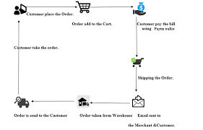
FIG-1: PAYTM SHOPPING STEPS [5]
Steps are followed in online shopping.
1) Customer place the order.
2) The order is added to the cart.
3) Pay the bill using the Paytm wallet.
4) Shipping the order.
5) Email is sent to customers and merchants.
6) The order is received by the customer.
These are the steps that need to be followed while doing the electronic exchange. The security procedure is coming in stage 3 when you purchasing an item.
IV.II GOOGLE PAY
Google Pay is a digital wallet and online payment system developed by Google. This wallet was launched in September 2015 globally. Initially, Google Pay was known as Tez in India which was launched in August 2017.
Through Google Pay we can pay for online booking of tickets, ordering online food and much more.
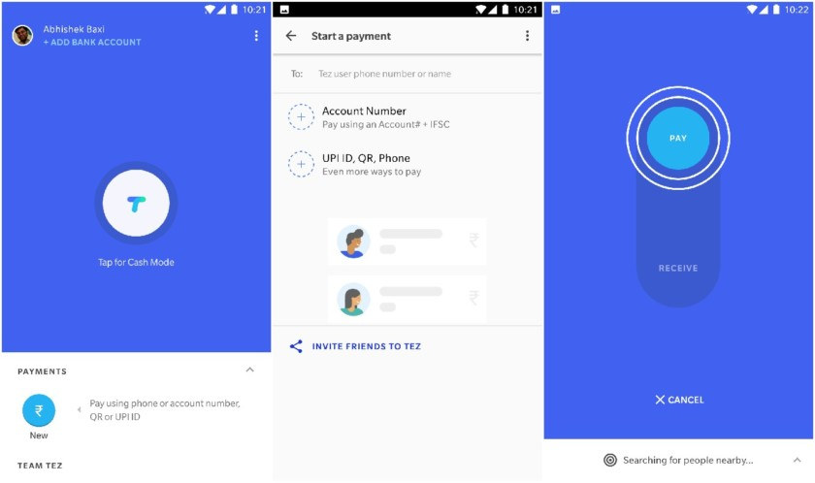
FIG-2: LOOK OF GOOGLE PAY(TEZ) [8]
V. SECURITY DETAILS OF PAYTM
During the research we found that there are various security violations which are as follows:
1) SMS and emails sent from the bank for verification are visible to anyone who has access to the user's phone.
2) Third-party applications like Uber, Bigbasket directly deduct the amount without a confirmation of the bank of the user.
3) The user is always logged in and never automatically logged out. Session timeout is not available on PAYTM.
4) Details of the transaction are difficult to find on the application.
5) During the installation of the application, they ask for access to media, camera, files that are not required for a small transaction that is to be fulfilled by a user.
There are various advantages besides the violations mentioned
1) Each transaction has a unique ID which makes it easy to track.
2) Money transfer is available easily with a secure Paytm pin.
3) Easy to read the monthly statement, which is shared over the mail.
4) Transaction confirmation Email and SMS is immediately sent over by the bank as well as Paytm.
VI. SECURITY DETAILS OF GOOGLE PAY
During the research we found that there are various security violations which are as follows:
1) SMS and emails sent from the bank for verification are visible to anyone who has access to the user's phone.
2) Error messages are not very clear.
3) Deducts SMS cost for adding bank details on Google pay.
There are various advantages besides the violations mentioned:
1) A UPI Pin is required to check the bank balance. Anyone with access to the phone cannot check or transfer the amount without the pin.
2) A statement is available to check the monthly transactions for a user.
3) During registration, it confirms the user's bank account details before adding it to the application.
4) It does not ask for access to media, images, and camera which is not required for the application.
VII. ADVANTAGES OF ELECTRONIC TRANSACTIONS
• You can send and get payments anywhere anytime.
• It is easy to use and understand.
• It saves time.
• Your account can be managed from a mobile phone.
• It gives the option of email or SMS notifications.
• Complete control of transactions.
• You can send or receive funds into your e-wallet application directly.
• Unlimited amount of transaction you are able to do.
VIII. PURPOSE OF SECURITY
These days everybody goes online shopping since it saves your time and you can get the items at home. While purchasing an item on the web, security is one of the significant parts to be taken into consideration. The motivation behind security is to conceal the data of clients and information to be moved online safely without and third-party interference.
For security reasons, you have to follow rules so that your information won't get hacked by any third-party individual who must not get your private and confidential data.
IX. TIPS FOR SECURITY
These are the following tips which you need to be followed for secure transaction [6].
• Install security software: For security purposes, you should install the security software on the mobile phone so that the data can protect.
• Use encryption signs for the password: When you do a login, make sure that the password gets encrypted. When it is transmitted over the network it will not be used by anyone.
• Used different password: Always used a different password, so it can’t be used by anyone if the password is known to the other person then change the current password.
• Avoid public computers: For financial transactions always use a personal computer. Never use any public computers.
• Avoid public WI-FI: Do not connect to an open Wi-Fi, always connect to a private and known network.
• Buy the product from the reputed site: Always buy a product from the reputed site make sure that your security is not compromised. Also, check the confirmation email once you complete the transaction.
X. CONCLUSION
A brief about an electronic exchange is clarified over this research paper. The benefits of electronic transactions on mobile phones have been talked about and furthermore gives a few hints for security.
After analyzing data from both Paytm and Google Pay we found that Google Pay is much secure than Paytm.
REFERENCES
- SECURITY OF ONLINE ELECTRONIC TRANSACTIONS by Nikhil Khandare, Volume 1, Issue
- E-Commerce Security Issues and Solutions. Niranjanamurthy vol. 2, Issue 7, July 2013.
- Online References. https://scroll.in/article/809228/three-chartsshow-how-mobile-wallets-are-exploding-inindia-but-plastic-cards-are-still-ahead.
- Online Payment and Security of E-Commerce. International symposium on web Information system and application.
- https://www.irjet.net/archives/V4/i4/IRJET-V4I4708.pdf
- Online Reference http://profit.ndtv.com/news/yourmoney/article-top-10-tips-for-safe-onlinecard-transactions-381728
- https://www.iimb.ac.in/sites/default/files/inline-files/iimb-csitm-security-issues-in-mobile-payment.pdf
- https://www.androidauthority.com/google-launches-tez-new-digital-payment-app-india-heres-everything-need-know-801059/
Cyber Threats in Online Digital Platform (SNS) Review & Solution
Aditya S Kadam¹ and Priti Palkar²
Student¹ and Head², Department of Information Technology, N. G. Acharya & D. K. Marathe College, University of Mumbai, Mumbai
Abstract
In today’s world, the internet has out pouring data. The use of social or digital networking sites is very high compared to another usage of internet. While focusing on the internet, social or digital networking is very popular and major thing that gains attention of millions of people. The main objective of the people is desire to exchange idea and communication across the globe. With updated and advancement in technology social or digital networking emerged as the crucial part of human life. It is not just use for communication purpose, but also used to promote business promotion all over the globe. As millions of peoples are nowadays connected to social or digital networking platform it has also promoted the cyber criminals or hackers for cyber crimes. A threat on the digital platforms can be intentional and unintentional, targeting an organizational or individual. Facebook, Instagram, Twitter and LinkedIn, WhatsApp etc are famous social networking sites used. People are unware of the security issues while sharing and exchanging their day to day activity on these platform. Cyber attackers or hackers or criminals exploit personal as well as business information and other confidential information of the user for hacking their accounts. Thus privacy and security is an utmost concern in social or digital networking platform. Even though we have updated antivirus system or other software it is not as effective against these security threats. These papers aim to review and identify various security threats in social or digital networking platform. Also, it review on some of the examples of cyber threats occurred and propose some solution to help people how to overcome and what are the precautions to be taken against cyber threats associated with the social or digital networking platform.
Keywords: Social Networking Website, Social Networking Sites, Digital Platform, Security, Privacy and Cyber threats.
Introduction
Social Networking sites or digital platforms focus on connecting and building social relations among people who share same interest and activities. Also, they are online applications that allow people to communicate with each other by sharing or exchanging text, profile, images, files etc. These social platforms can also be defined as a structure made up of nodes that are tied by more or specific type of relations [1]. Social networking or digital platform allows user to share views, images, videos, innovative ideas, and personal ideas with the other people whom they are connected using various social applications generally known as digital platform. With advance updation in this the overall popularity in social network website or digital platform has increased remarkably globally.
Some of the key takeaways from their Global Digital Report 2019 include [2]:
➢ The number of internet users worldwide in 2019 is 4.388 billion, up 9.1% year-on-year.
➢ The number of social media users worldwide in 2019 is 3.484 billion, up 9% year-on-year.
➢ The number of mobile phone users in 2019 is 5.112 billion, up 2% year-on-year.
Due to the advancement in the automation or use of internet, almost all the people have started using social network sites or digital platform to communicate with their nearest one such as friends, partners and any other member. These digital platform allows one to interact with other at remote location very quickly from any part of the globe at very nominal cost. The registration is free for all user as these digital or social network website enable user to register before use. Some of the popular social networking sites especially in India are [3]
1. Facebook. 2. WhatsApp 3.Instagram 4. YouTube 5. Snapchat 6. Twitter 7. LinkedIn 8. Gmail etc…
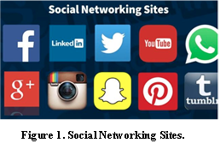
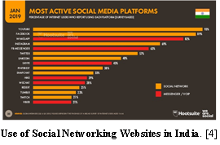
The above image is showcasing the presence of users using each digital platform in India. Since the spurting access of the internet in the late '90s, India has also become a part of the digital world with over 460 million users online in 2018 alone..
The social networking website or digital platforms have had their share of positive and negative impact.
Many people spend most of time using these digital platform which results in losing their jobs or personal lives. Most digital platform have members create and manage their personal profiles, post different types of files, provide facilities for member to automatically discover connections candidates with existing members and providing more interesting and convenient features so user can spend long time on these sites. As result of this many digital platform companies are developing new advance applications for such social networking site.
Due to the number of users towards these (social or digital platform) is increasing day by day. In India, in the past few decade the popularity and users connectivity is increased huge. As a result users make many risks and mistakes while using unauthorized sites, downloads, and network access, misuse of corporate computers, misuse of password and transfer sensitive data between work and personal computers while working at home. However, the more the trust the users have on the social networks the more vulnerable they are to a variety of attacks and data leakage which leads to cyber threat.
Cyber Threats in Social Network Website or Digital Platform
The risks can be divided into two kinds of threats that are Traditional network related threats and Privacy related threats.
(i) Traditional network related threats: Its deal with the security of people or with safety of data that is saved in the systems. Since the social networks have enormous numbers of user and amount of data, they are natural targets spammers, phishing and malicious attacks. Moreover, online social attacks include stalking, cyber bulling and defamation. Attackers or hackers create fake profiles to damage induvial within a network.
(ii) Privacy related threats: These threats can be faced due to the publishing of information on the social networking site. A lot of information on personal home pages may contain very sensitive data such as birth place, personal mobile number, and address so on. The hackers used this information by using social technique to steal money.
Cyber Security Issues
(i) Cyber Crime – This crime is conducted by induvials either alone or groups. The main function of such crime is to getting money, causing damage or obtaining private or valuable data. These crimes are used to generate credit / debit card information, disturbing the website operation and intellectual property.[5]
(ii) Cyber War - Cyber warfare involves the actions by a nation-state or international organization to attack and attempt to damage another nation's computers or information networks through, for example, computer viruses or denial-of-service attacks. [5]
(iii) Cyber Terror – Such kind of terror is caused by an organization that works independently for performing terrorist activities through cyberspace. [5]
Documented Cases
(i) ‘KBC officer and Indian government’ con woman of Rs 83k.. In this the attacker first gather the information through social network and steel the money which leads to privacy related threats.
(ii) Actor Ruchita Jadhav - victim of cybercrime and harassment. The actor’s Instagram account was hacked by an unknown user with a Turkish mobile number, who sent her threatening messages to destroy her career if she doesn’t oblige to pay $500 USD to get her account back.
(iii) A content moderation scheme for Facebook and other social media. Cyber content moderation is another solution to serious types of crimes - like objectionable videos.
(iv) Mumbai man held for posting nude pics of friend . The attacker without victims’ knowledge access her phone and shared privacy over social network site.
The way these crimes happen it’s very tough to trace the culprit even if the source is traced —more the technology progresses more the complications just like we have in case of modern medicine so our focus should be empowering and giving more knowledge to the users to overcome such kind of social network threats.
There are many more such type of cyber threats and found the most threats happen due some factors which are listed below.
(i) People are less concern with the importance of the personal information disclosure thus they are at the risk of disclosure and privacy invasion.
(ii) Many user have knowledge of threats but unfortunately not have right direction towards privacy setting.
(iii) The policy and regulatory board are not enough to handle these type of social networks threats which is day by day increasing with more challenges and modern technologies.
(iv) Lack of involvement of Government Authorities.
(v) Lack of tools and appropriate mechanisms to handle and deal with different security and privacy issues.
(Vi) Social network need more improvement and updation so user can manage their accounts more securely.
Frequency of successful attacks by year in social networking sites
Years | Cyber Threat Report (%)
2015 | 70.5%
2016 | 75.6%
2017 | 79.2%
2018 | 77.2 %
2019 | 78.0%
Solution and Recommendation
For accessing and securing information on digital platform or social networking site, following are few solutions and recommendation can be followed.
      - Try to reduce the amount disclosure of information about your personal or organizational on social networking site.
      - Always keep a track of your private account. Make sure you have set a strong password for the various account which you are using.
      - Changing of password monthly or weekly so information can’t be hacked by hackers or any unauthorized person.
- Don’t get attracted towards any promotional activity posted on social network as it can be malware or misleading information.
- Customize your security as per your need.
- Never visited the links which you feel suspicious and be aware of unknown links send by unknown person.
- Use of good antivirus to deal with a virus that may come from internet due to use of unauthorized site which may lead to damage or stolen your data from the computer.
- If you are victim of any such threats, informed it to cyber security cell or IT cell so any further damaged will be prevented or restricted.
- For Mobile Phone - Do not buy second hand mobile handsets without having any knowledge about the pre downloaded applications. Do not give your mobile phone numbers while chatting over the internet to avoid stalking.
Literature Review
Cyber threats and related privacy concerns are amongst the high rated topic nowadays as linking of multiple user to such sites increasing dramatically. Various articles and blogs come up with these issues that how the increase use of such sites and software lead to various online crimes and involvement of attackers to lead such activities are increasing day by day.
EC-Council a blog in website mentioned that “What are the primary threats visible on social networking or digital platform”. It talks about various threats associated with social networking sites and their precautions to be taken.
Roman Tobe examined “how cybercriminal execute social media threats?” and the scheme and scams associated in this. Also reviewed the basics steps required to protect against social media threats. [6]
Medha Raj, Sharmistha Bhattacherjee, and Abhijit Mukherjee reviewed the usage of social networking websites among school students. They overall research was based on the impact of use of social network sites by students and influence on their academic result. [7]
Sergiu Gatlan discuss & reveals that most social networks also come with an "over the counter" marketplace where various crimeware services and tools are being offered for sale, from a wide range of hacking tools and services, to botnets for hire and facilitated digital currency scams.
Conclusion
Social networking websites or digital platform offers advance way to communicate and get attached to people from any part of the globe by use of advance technology. Although it also raise new challenges towards security and privacy issues. In this paper, I reviewed the impact and risk of breach of privacy on digital platforms in today’s world. Also the increase in usage of social networking site. Also brief about security threats and issues in this. Also, highlighted the few documented cases associated with cyber security threats. Also suggested various recommendation and solutions to the users for improving the security while using social network sites.
I feel we should concentrate on prevention than cure, spread awareness about safety of social network and steps one must follow. Here also we can draw an analogy from medicine - we treat diseases, infections as we need to save the patients but our work does not end there. We spread awareness on prophylactic measures so that no one contracts the infection. So our focus should also be on reduction of rate of these crimes so that people do not fall prey to these things. Reduction in cyber Crimes by proper usage of digital platform makes a big difference to society. We must give examples of people who got into trouble - that’s why we need to bring out maximum cases. We tell them the dos and don’ts involved in the different social media sites like twitter, Facebook, what’s app etc. as they may have different applications - these will be more specific. No one should get troubled or get fooled. For eg , we tell people to keep changing passwords frequently , not keep same password across sites , not open web pages which are not secure , always see that Laptop or PC has active antivirus and anti-spyware , not storing credit cards in e-commerce sites like amazon etc. - such simple things also people don’t follow.
My study is to emphasis on creating awareness and to alert the users with application guide to avoid the security threats and crime taking place online in digital platform
References (Research Papers)
- Michael Fire ; Roy Goldschmidt ; Yuval Elovici : Online Social Networks: Threats and Solutions.
- Global Socail Media Research: By Dave Chaffey.
- Abdulla Al Hasib – Threats of Online SNS.
- Michael Fire, Roy Goldschmidt, and Yuval Elovici :Online S Networks: Threats and Key Solution.
- M. Prasanthi "Cyber Crime: Prevention and detection. The International Journal of Advanced Research in Computer and Communication Engineering, Vol. 4, Issue 3[10], pp. 45-48, 2015
- Arpita Banarjee, C Banarjee & Dr Ajeet Ponia - Security Threats of Social Networking Sites: An Analytical Approach .
- Medha Raj, Sharmistha Bhattacherjee, and Abhijit Mukherjee - "Usage of Online Social Networking Sites among School Students of Siliguri,WestBengal,India"
- Sergiu Gatlan - "Social Media Attacks Generate $3.25 Billion for Crooks Each Year"
- Balachander Krishnamurthy : Privacy leakage in mobile online social networks

How can AI used in Smartphones?
Akshay Hanumant Thite¹ and Dr. Hiren Dand²
Student¹, Department of Information Technology, Vikas College of Arts, Science and Commerce, University of Mumbai, Mumbai
Head², Department of Information Technology, Mulund College of Commerce, University of Mumbai, Mumbai

Abstract
Nowadays Smartphone becoming necessary thing for human being and there are number of smart phones which offers number of features which makes human life easy. Currently, there are two new technology coming to the mobile market which may be change the mobile era, the first one is 5G (5th generation of mobile network technology) and the second is AI (Artificial Intelligence).
In this research we are going to see in which area of smart phones AI is used efficiently and what are the areas where AI need to be improved in smart phones.

Introduction
In most advanced economies, artificial intelligence entering the workplace in a big way. In fact, not only is AI becoming common in workplace, but also indoors and outdoors. But one question arrives what is AI? And the simple answer is “AI which collects data from user, computing it and allow a system to think like human or to make a decision like human which makes human life easier”.
When we heard the term “Artificial Intelligence” (AI), we imagine robots doing our job. Since AI based computers are programmed to make decision with little human efforts and there will be no wonder if machines will soon make the difficult decision which are difficult for human to take.

Review of Literature
In most advanced economies, artificial intelligence entering the workplace in a big way. In fact, not only is AI becoming common in workplace, but also in the home outdoors places. But one question arrives what is AI? And the simple answer is “AI which collects data from user, computing it and allow a system to think like human or to make a decision like human which makes human life easier”. Artificial intelligence is one of the most advance and important development in mobile phones and following are the areas where AI is used in current generation of mobile phones:
Smart phones camera
Where AI can transform the picture like real human being sees those picture just like how you got the pictures and it’s going to suggest you settings automatically for a low light or a greenery or a portrait.
Mobile phones battery capacity
In this AI constantly learning how you’re using it or how your charging your device and its tweaking how the phone is being charged.
Navigation Maps
Company like Google and apple maps navigation services use by artificial intelligence to interpret thousands of data points that they can receive to provide you with real-time traffic data.
Music and Media Streaming Service
Whether you are using Netflix, Spotify, YouTube or any other music streaming application, AI us making the decision for you. You feel that you are in total control but you are not and this is a very bad because if you are using YouTube app where you are wasting your countless hours just watching the recommended videos which is suggested on YouTube.
Online Ads Network
One of the niggest users of AI is the online ads industry which currently uses Artificial Intelligence to not only track user data but also serve us ads based on those data.
Methodology
As we know there is always a room for improvement.
So, what will smartphones of the future look like after 10 years?
Following are the areas where AI can improve in future:

Mind Controlling
Earlier we are interacting with smartphones with using physical keypad but this was eventually replaced by the touch screen display that we use today. With services like Apple Siri and Google Assistant, we can now interact with our devices just by using our voices as command.
The next step huge in the evolution of smartphones is mind control where mobile phones can understand what human is thinking without saying and typing anything or mobile can control with using human thinking power. The technology would allow you to perform each and every task you can do with using touch or voice command with your mind. Where you can open an app of choice, play a specific video on YouTube, and even you can edit images with your thoughts. Even you can also send a text without touching your phone and can control the screen brightness.
Controlling the smartphones will be more faster. You can open any app without touching the screen and without stretching your fingers. Facebook is currently working on developing a technology where people can type using their minds without interacting with keypad. The typing speed about five times faster when compared to typing on our smartphones.
Over the air charging
The battery life of the smartphone is average. Even if you have a high-end phone with its massive 4,000+ mAh battery, you’re still only looking at around two days of average use. Once the device charging is totally drain, you either have to plug it in for a few hours or place it on a wireless charging pad, if that mobile phones support the wireless charging.
Things might be a going to change in the future. ‘Energous’ is company which is currently developing technology to charge your devices over the air. Wih using this technology you can place your phone three feet away from the ‘WattUp Mid Field’ transmitter and it will start charging your smartphone.
In future, this transmitters can charge your devices from long distances. This transmitters can used like a phone tower and would continuously charge your smartphone, making sure that your smartphones battery never die. These charging transmitters are so much powerful that, they keep your smartphone’s battery at 100 percent all the time and you never have to worry about battery life again.
Replacement for Smartphones in future
In future smartphones may be replace by other device. These devices form a new factor, which allow user to perform the tasks that smartphones can do.
In future may be the smartphones get replaced by regular glasses, which are based on AR technology. With using this glasses would let you make and receive calls. When someone is calling you, you’d see their name/image in front of your eyes. When you answer a call, you’d immediately hear the caller voice without to using an earphone. You also be able to play the music, navigate the song, and read the emails and texts you’ve received with using glasses. All the things that you want to see it will be display on your eyes with using AR technology. Even if you want to take pictures on camera, a frame would show up in front of your eyes, showing exactly what the camera will capture. By saying the word "Snap" in your head and the image will be taken.
Thanks to a new AR (Augmented Reality) and VR (Virtual Reality) technology, where screen/image will be projected in front of your screen glasses and you can play the music, watch the videos and see the images that you captured from your camera phone.

Conclusion
Consider a smart phones like a human being. As human has eyes and sensitivity to observe the surrounded things like wise smart phones has camera and mobile sensors to take the input for processing. A normal human brain can take thousands of decision every day but respondent could only recollect few of them. Lots of things are happening at the background and that helps you to run your life but working of human brains is different from one person to other person. Likewise every mobile phones is different and processor is the thing which make difference between every other phone. Several new upcoming smartphones are coming with integrated AI chips and AI required hardware. These chips are mostly called a neural engine or neural processing unit. They are designed for the fast processing of rapidly changing image data, which would consume more processor bandwidth and network connection bandwidth.

To take the decisions mobile phones required intelligence software and high capacity chipset which can act as a human brain and that can process more amount of data in less amount of time to take actions according to inputs and Huwai is the first mobile brand which include dedicated AI hardware in Kirin 980 chipset which is used in Huwai Mate Pro 20.

Acknowledgement

My sincere thanks to all teaching professors of the information technology of the Msc.IT Part 1 for their encouragement and whole hearted support for this project.

Also thanks for valuable feedback and knowledge from the reference book and journal.

References
- Gaurav Jindal, Mridul Anand, Android application with artificial intelligence in mobile phones, Vol:03, Dec 2012, pp 46 – 49.
- Kaustubh Kale, Artificial Intelligence in Mobiles, Vol:05, June 2018, pp 1592-1594.
- Anand Rao, Sandeep Ladda, The smarter phone: How AI-enabled devices will reshape the technology, media and telecoms industry, pp 4 – 7.
- Qiang Yang, Feng Zhao, Artificial Intelligence on Mobile Devices, Vol: 02, ISSN 0738-4602, 2016, Pp 9 -10.
- Francisco Jeronimo, Mobile AI and the Future of Intelligence Devices, Nov 2017, Vol: 01, pp 5- 8.
- Aithority, AI: Increasing the intelligence on Smartphones, Vol:04, May 2019.
- Andrew Williams, What does AI in a phone really Mean?, Vol: 01, Oct 2018.

Blockchain in Internet of Things: Conquering security and privacy concerns
Kulsum Izhar Siddiqui¹ and Prakash Patil²
Student¹ and Head², Department of Information Technology, K. J. Somaiya College of Science and Commerce, University of Mumbai, Mumbai
Abstract
In this high era of advancing technology, Internet of thing is prevailing as revolutionizing area that is evolving in every possible field. Apart from the exponential flourishment in exploration and production, it sustains vulnerability in terms of privacy and security. The standard security and privacy measures are inapplicable in IoT due to its fragmented topology and resource limitations. On the same ambience Blockchain is emerging technology that has revolutionized digital currency. Blockchain can be interpreted as a rigid time-stamped series collection of data. This data is distributed well and managed appropriately. The Blockchain can be considered as a missing link to map the gaps prevailing in IoT. This paper throws light upon various aspects needed to overcome IoT issues using Blockchain Technology. As IoT is omnipresent it is essential to curb the privacy and security problems to make it safe and trusted to wide range of consumers.
Keywords: Internet of Things, Blockchain, privacy, security, decentralization, data security, network security.
Introduction
IoT gained a wide reorganization at moment as it has impacts on everything right from the way we travel across to modernising education, personal healthcare to the way we shop; extending the ways for manufacturers in production. Each department big or small, every application simple or complex, IoT finds its deployment in every case.
Concisely, IoT is an idea of dealing with connecting any device as long as it is powered on/off to the Internet or any other devices present within the network. IoT is a massive web consisting of connected objects (where objects are smart devices/machines entitled as things) and individuals (who use/operate those things)- all of these ‘things’ collect and transfer data from the surrounding.
OVERVIEW IOT WORKING
IoT devices and objects consists of sensors and actuators which are connected to Internet of Thing platform or a dedicated software, which collect and merge data from the different devices and applies certain operations to generate and share valuable information with applications built to satisfy specific needs.
These powerful IoT platforms completely reason what data is helpful and what will safely be unheeded.
This data may be accustomed sight patterns, build recommendations, and sight attainable issues before they occur.
Existing System
IoT Architecture
Layers: | Functions:
Business | Operates the business models and entire IoT.
Application | This part of architecture functions for providing application specific services.
Processing | Stores and process data on cloud or other databases
Transport | Transfers data via networks
Physical | The sensors and actuators that percept the environment and gather information.
Problem Definition
Challenges faced by Internet of things
Generally, IoT devices are limited in computation feasibilities, storage capacity and network operability, hence they are prone to attacks.
Security Risks
The following are the prominent concerns associated to security in IoT devices:
- IoT’s tends to connected to smartphones, laptops, pcs, etc wherein compromise level of security leads to increase risks of confidential information leaking during collection and transmission of data.
- IoT objects are connected over a consumer network, if any device consists of any threat it will cause to entire network and harm them.
- Occasionally unauthorize access can exploit security features and create risks for physical security.
Privacy Risks
The following are the prominent concerns associated to Privacy in IoT devices:
- IoT machines/smart objects are interconnected with various hardware and software, there are high chances of information exposure to unauthorize users.
- All devices transmit user’s personal information through internet sometimes without any encryption leading to distorting privacy.
Few of the attacks IoT devices are prone to:
Software attacks | Including malware such different kinds of viruses.
Physical device attacks | It involves unauthorized device control.
Network attacks- | Consists of wireless vulnerability exploits and DoS attacks
Encryption attacks- | Password cracking, data theft.
Purposed Technology
Blockchain Technology:
Blockchain is emerging technology gained momentum in last few years owing its application in cryptocurrencies.
Blockchains are collection of records stated as blocks which are linked with each other. The link is preserved from attacks using cryptography. These chains are invulnerable to changes in data.
Blockchain is associate degree wide spread, distributed ledger which is capable to record transactions between couple of machines. These transactions are verifiable, economical and permanent means.
Three pillars of Blockchain
1. Transperancy.
2. Immutability
3. Decentralization.
Applications of Blockchain
Blockchain, in the beginning was used in Bitcoin along with some other cryptocurrencies.
Over the period of time it has gained huge momentum in several industries including health, real estate, etc.
Also, it has prominent and wide application in finance sector.
Structure
Blockchain structurally decentralised, distributed, and frequently public, digital ledger whose work is to take a note on transactions among several computers, hence any concerned record cannot be altered retroactively, while note the changes occurring in all succeeding blocks.
This henceforth enable the users to cross check and audit transactions severally and comparatively inexpensively.
A blockchain info is managed autonomously employing a P2P network and a distributed timestamping server.
This genuine approach can be implemented by mass collaboration among users of similar interests. This
facilitates sturdy progress wherever participants' uncertainty relating to information security is marginal. The use of a blockchain removes the feature of infinite dependability from a digital plus.
Decentralization Architecture and security benefits
The data is stored across a p2p network, this architecture eliminated a wide range of threats caused due to centralized storage of data.
Decentralized architecture of Blockchain tends to utilized ad-hoc message transferring and distributed networking.

P2P blockchain networks limits central points of threats that computer/device crackers can exploit; On the same context there is no central point of failure.
Blockchain security prevention techniques consists of public-key cryptography.
A public key (a long, random-looking string of numbers) is an address on the blockchain.
Value tokens sent over the network, further recorded as belonging to that address. A private key is similar as a password which enables its creator to access to their digital assets or the means to otherwise interact with the various capabilities that blockchains now support.
The information stored by blockchain is observed to be imperishable without alterations.
Every unit node/block present in decentralized system consist of a replica blockchain. Th quality of data is preserved by huge database replication and computational trust.
There exists no “formal” transcript and none of the end user is “reliable” more than some random user.
The activities are newscast to the network with the help of software applications. The conversation is carried on the basis best-effort given. The nodes dedicated to mining are once that will validate the transactions/conversations.
Advantages of Decentralized Consensus in IoT
- Decentralized security
The decentralized architecture backed by blockchain will initiate a huge attributed utilization of consensus mechanism, this empowers P2P trading in a fragmented format eliminating the presence of any third party.
Hence preventing the privacy and security of personal data, also restricts invades to confidential information.
- Smart Contract
Trending blockchain technology provide the feature of smart contract. Using these contact users can assure that they won’t suffer any loss. It enables users generate certain agreements which could be fulfilled if any loss occurs in future.
- Data Encryption
Data is a valuable asset, using blockchain the data is kept safe, only trusted parties across the supply chain are authorized for data access reducing chances of privacy invading.
- Prevention of physical theft
These technologies coming together can reduce the risk of physical theft of smart devices. Blockchain will assist to recognize ad block unauthorize or alien devices within networks. Also, if any smart ‘thing, (i.e. Device) is lost or reported as stolen it can be tracked from the network.
IOT and Blockchain integration
Incorporating the blockchain in Internet of Thing’s smart gadgets will minimize the costs of installing and managing servers for an IoT network.
Advantage of IoT encompassing Blockchain is prevention from network attacks such as the man-in-middle attack, by reason that it doesn’t contain only single thread of communication.
P2P conversation introduces their own collection of hurdles, major among them is the concern of security. Security in IoT is not just about preserving and assuring sensitive data and personal records.
The offered results will have to maintain privacy and security in huge IoT networks, along with it provide some form of validation and consensus for agreements to avoid attacks like spoofing and theft.
To ensure that the functionalities of an IoT system is equipped without a centralized system, the proposed decentralized point should support three important features including:
- Peer-to-peer messaging
- Distributed file sharing
- Autonomous device coordination
Active Future project
The integration of blockchain and the IoT has emerged as top most sensational use cases for this high-tech stage of development. In recent trends two business giants, Volkswagen and Bosch firmly invest on the idea comprising thought of decentralizing data and IoT’s must co-exist.
Conclusion
It can be concluded that Internet of things, is prevailing as a gigantic technology wherein there lies concerns of trust and ethics due to its inability to provide security and privacy of data. Blockchain emerges as the connecting link which directly assures data privacy and security for IoT devices.
The decentralization of data along with cryptography attempts to conquer over all types attacks and assuring against all loss. Blockchain along with Internet of Things will drastically revolutionize the technical era.
There is need of future thought and rework on the idea, wherein it can produce more reliable solutions.
References
Website Links
- https://www.netburner.com/learn/architectural-frameworks-in-the-iot-civilization/
- https://en.m.wikipedia.org/wiki/Blockchain
- https://www.datasciencecentral.com/profiles/blogs/using-blockchain-technology-to-secure-the-internet-of-things-iot
- https://medium.com/@arindey/internet-of-things-iot-security-privacy-applications-trends-3708953c6200
- https://www.computerworld.com/article/3027522/beyond-bitcoin-can-the-blockchain-power-industrial-iot.html
Reference Papers
- Applications of Blockchains in the Internet of Things: A Comprehensive Survey

( Volume: 21 , Issue: 2 , Second quarter 2019 )

ISSN: 1553-877X
- “Blockchain Based Data Integrity Verification for large scale IoT Data”
Published in: IEEE Access ( Volume: 7 )
Date: 11 Nov,2019.
ISSN:2169-3536
- Blockchain in IoT security: A survey.
Published in: 2018 28th International Telecommunication Networks and Applications Conference (ITNAC)
ISSN: 2474-1531
- “Privacy Preserving Solutions for Blockchain: Review and Challenges”
Published in: IEEE Access ( Volume: 7 )
Date: 31 Oct,2019.
ISSN: 2169-3536
- When Internet of Things Meets Blockchain:
Challenges in Distributed Consensus (Article in IEEE Network, March 2019)
DOI:10.1109
- “Blockchain technology innovation”
Published in: 2017 IEEE Technology & Engineering Management Conference
ISBN: 978-1-5090-1114-8
- Blockchain Challenges and Application.
Published in: 2018 International Conference on Information Networking (ICOIN) ISBN: 978-1-5386-2290-2
DOI: 10.1109/ICOIN.2018.8343163
- “Blockchain Meets IoT: An Architecture for Scalable Access Management in IoT”
Published in: JOURNAL OF INTERNET OF THINGS CLASS FILES, VOL. 14, NO. 8, MARCH 2018
- “Blockchain As A service for IoT”
Conference: 2016 IEEE International Conference on Internet of Things (things) and IEEE Green Computing and Communications (GreenCom) and IEEE Cyber, Physical and Social Computing (CPSCom) and IEEE Smart Data (SmartData)
DOI: 10.1109/iThings-GreenCom-CPSCom-SmartData.2016.102
A Mechanism for Prevention of Flooding based DDoS Attack
Shivani Jayavant Chavan¹ and Dr. Hiren Dand²
Student¹ and Head², Department of Information Technology, Mulund College of Commerce, University of Mumbai, Mumbai

ABSTRACT
The flood attack threatens all tastes of DDoS (denied service distribution) causing the most serious impact on a network / Internet. As a DDoS feature, there is no need for much computational effort to target the target servers and networks. The development of a mechanism against attacks not identified in the application and in the transport layer is a desired target for intrusion detection and / or investigation of the intrusion prevention system. This document presents various vulnerabilities that explicitly attempt to stop legitimate users from accessing services at the TCP / IP application level and at the transport layer. The aim of this work is to propose a technique of existing taxonomies for the detection and analysis of the flow of synchronous and non-synchronous traffic with the observation of the network in the time interval. In addition, this approach uses authentication of the traffic source of legitimate and harmful traffic using CAPTCHA in several ways.

INTRODUCTION
Today Internet services acquire crucial importance, therefore the degradation of the quality of the service or the total negation of the service can be fundamental. Denial of Service (DoS) attacks targets to prevent legitimate users from accessing network or system resources. Attacks driven by more than one node / origins in an internet traffic are recognized as Distributed Denial of service (DDoS).
There are two main methods of taking off a DDoS attack. The first method is to take advantage of network design flaws. Attackers send some camouflage packets to the target server to confuse an application running on the target. The second method adopts flood traffic that runs out of bandwidth or server resources. The main targets of the attack launcher are routers, connections, firewalls, the victim's computer and network infrastructure, the victim's operating system, current communications and the victim's application.
There are two main challenging features of DDoS. One is that the DDoS package manages to appear as original packages that cannot be clarified without any influence is staggering. Secondly, it is almost impossible to find the origin path of an intruder due to the forged IP address. Because of these two main weaknesses, network systems have often become the target of numerous attacks that have been illegally transmitted to obtain useful resources. DDoS can arise due to the extreme need for reliable users of specific resources such as flash crowds and making the server overloaded. DDoS are a major concern for companies that have integrated their technology into the public network, allowing multiple parties or users to access data. As indicated by the educational and research communities, there is a significant increase in the frequency and size of the target network by 2015: 20 percent of the service provider repeatedly reports attacks on over 50 Gpbs.
The percentage of suspects seen in application-level attacks increases, to 93 percent this year, from 90 percent last year and to 86 percent in 2013. The observed DDoS attacks are still relatively small with 84 percent of observed events smaller than 1 Gbps. There is an attack rate of 760 Mbps this year. In the world of the Internet, it is not considered a large amount, but it will surely seriously degrade the business and other related companies in their functions. In the statistics of the ATLAS data on the duration of the attack, there has been an increase of about 1% in the previous two years which lasted less than an hour. The average duration of the attack in 2015 was 58 minutes, which is relatively consistent with previous results.
The DDoS attack criteria vary considerably and the attackers are constantly increasing the procedures they use to escape defense and make the attack successful. Attacks are broadly classified into three categories:
- Volumetric Attacks: These attacks are based on creating bottlenecks on a target network or server. It severely affects the bandwidth of a network causing delays in responding to authentic user requests. These attacks simply serve to unleash the crowd.
- TCP State Drain Attacks: In TCP State Drain Attacks, attempts are made to exhaust the connection state tables found in many infrastructure components, such as load balancing, firewalls, IPS, and the servers themselves. applications. They can even register high-capacity devices that can maintain the state in millions of connections.
- Application level attacks: the deadliest and most difficult to prevent are located in the application level or are also called level 7 attacks. They are the most elegant and sophisticated because their machine generates robots and injects their worms at low speed. Therefore, this renders the traditional prevention schemes for monitoring based on the flow of incoming traffic inactive. An approach to detecting real traffic requires the installation of an online component or another package-based component for its DDoS defense.
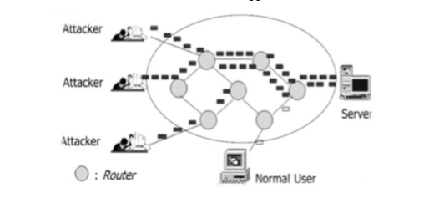

Fig-1: Structure of typical DDoS attack

2.0 RELATED WORKS
Numerous defense and prevention mechanisms have already been established to combat DDoS attacks. The goal of the prevention system is to eliminate the maximum possibility of attack or to make the victim aware of the possibility of an attack in order to resist an attack without obstructing real traffic. As indicated for the integral modules classified in modules as detection, characterization, tracing, mitigation is necessary. In general, when a DDoS attack is detected and to get information about the target server or network congestion, all you can do is disconnect the victim or manually resolve the problem.
The goal of the DDoS detection methodology is to monitor traffic on the originating node and in the network and for the same purpose requires a refined behavior analysis. Low-rate denial of service (LDoS) detection mechanisms are lacking. The proposed multiple sampling average based on lost sampling takes network traffic as a signal based on a small signal model for 10 ms in 30 seconds. The results generated against the threshold to identify the LDoS attack. Another approach to maintaining the QoS of the actual traffic flow has proposed a defense based on tracking against the DDoS flood attack which detects the attack at the end of the source. TF, DFM, IP tracking algorithm in the victim's final modules are established in a competent network.
Discarding attack packets at the end of the origin. To overcome the lack of early diagnosis and high precision, a mechanism based on the victim's extremity with a low percentage of false positives is built in a short interval. Better results than KullbackLeibler divergence when the order of information divergence measures has increased in the detection of low and high speed DDoS attacks.
The signature-based approach, the anomaly-based approach and the entropy-based approach are three methodologies for detecting DDoS attacks. These methods are used in a network based on their various conditions, such as normal traffic or in a situation with high network traffic or low incoming traffic. In the signature-based approach, the threshold is limited, so when a DDoS attack occurs, millions of packets will be counted. To overcome this, install a threshold for the number of detected signatures that will be adopted. Whenever the entropy value of the router increases unexpectedly, it is difficult to distinguish between flash events and the multitude of DDoS attacks. To this end, the concept of mean entropy is calculated at the edge of the ISP domain. Sends an alert to the downstream router to estimate the entropy value. This approach by combining entropy, mean entropy and standard deviation of the flow system can identify suspected DDoS flow. In real Internet traffic, packets can be in long synchronous flow or low level non-synchronous flow. Normal traffic flows are assumed to be short-lived and not synchronized. The suggested algorithm records the address pair of the source and destination address in time intervals and performs several intersection operations in consecutive time intervals and records it for sufficient times. If it exceeds the threshold, it is labelled as an alarm and is also detected using HCF (hop count filter) to map the number of jumps from a source to the destination.
Another approach is the rapid entropy-based method of maintaining the accuracy of detecting DDoS attacks by flow-based analysis. Attack packets are generally generated by tools installed in a bot to flood the link or a network. This shows that the flow link between DDoS flood attacks is much greater than that between random flash crowds. To identify suspicious flows, target superpoints are used to measure flood behavior and observation of flow similarity using a sliding window mechanism that allows for differentiation of random flash events and very efficient flood traffic. To defend against DDoS attacks At the application level, the technique here proposed a traffic authentication method for the origin of the traffic. The mitigation approach uses a random tree automatic learning algorithm in the training, cross validation and testing phase. The bait and bait servers are used to regulate the legality of habitual and unpleasant traffic. To determine the malicious IP address that the Command & Control (C&C) server should be, blacklist malicious IPs based on several intelligence sources simultaneously. Flow counting is a distinctive way in which the severity of the flood attack cabin is known. It is calculated at each entry point in a network at fixed time intervals. DDoS attack is characterized when the difference between rapid flow entropy counts at all times and the average value of entropy in that time interval is greater than threshold value Shows the effectiveness in terms of calculation time compared to conventional entropy.
For DDoS flood attacks, bandwidth or resource consumption are the primary methods of making the service unavailable. The greater the number of synchronous flow over a time interval, the greater the synchronized traffic. Such traffic behaviour can treat a host or network with DDoS attacks from direct attacks or reflective attacks by bots. There are several metrics based on information theory in the detection of distributed DoS attacks. The supervised learning model technique takes into account network traffic, http header filtering and the normalization process used by Support Vector Machines (SVM).

DDoS PREVENTION: SCOPE AND CLASSIFICATION
All attacks try to influence the victim. But the DDoS attack differs from where the victim demonstrated his weakness. The figure shows our extensive study and categorization of some familiar DDoS attacks at the network and transport level. Degree of automation: to train the attacking agent of the army, it is necessary to find a way to install errors in machines or zombies. Exploited vulnerabilities: attackers exploit the problems of protocol design problems such as TCP, UDP, ICMP, HTTP, FTP TELNET etc
. These errors can cause floods, amplifications or attacks of malformed packets to overwhelm a victim's service. Attack network: In general, some attackers use proxy servers and other ways to hide their existence by tracing after identifying attack agents. Some of the types of malicious network, such as bots or the IRC network where the centralized mechanism fails. Attack Speed: A dynamic network layer or a transport layer attack is also important for detecting ongoing attacks in the early stages. It can be at a constant or variable rate. With an increasing attack rate, the attack traffic gradually increases at the end of the victim. Victim type: Depending on the host type of the server, such as a single host or a connection or an application server, the attacker uses several methods to launch a DDoS attack. Impact: The severity of the attack on the network or transport layer depends on the amount of incoming traffic infected by the bot controller. It can be destructive to fail completely without leaving any recovery option. Secondly, it can be harmful and recover later. Scan strategy: in the scan strategy, the number of possible sensitive machines will follow while creating a reduced volume of traffic. Among them, the compromised random scan hosts random addresses in the IP address space, using a different seed. Scan Hitlist scans the externally listed IP address. In permutation scanning, pseudorandom permutation of the IP address space with indexing, semi-coordinated and complete scanning with the advantages of random polling. The backward chain propagation attack code is downloaded from the machine that exploited the system. Package content: part of the incoming package may be filtering through dynamically distributed firewalls, while other types of non-filterable packets that change continuously, making machine detection difficult.

4.0 CONCLUSION
It is precisely a necessity to eliminate the burden of illegal packets due to DDoS attacks on a network / Internet. This document comments on several vulnerabilities that explicitly attempt to terminate legitimate user access to services at the TCP / IP application level and at the transport layer. Therefore, it is necessary to reduce the DDoS attack of the synchronous and non-synchronous traffic flow. The proposed work is able to observe some suspicious or fake IP addresses using the information recorded for the flow of synchronous and non-synchronous traffic during the time interval. In addition, it marked address pairs authenticated by a challenge response mechanism, namely CAPTCHA while other packets are discarded. In addition to this document, the proposed work will simulate results with datasets and tools in the future.
REFERENCES
1. “D.K. Bhattacharyya, J. K. Kalita (2016) DDoS Attacks: Evolution, Detection, Prevention, Reaction, and Tolerance.”
2. “Sven Dietrich , David Dittrich , Peter Reiher, (2013) Internet Denial of Service: Attack and Defense Mechanisms.”
3. “David Dittrich, ‎Peter Reiher, ‎Sven Dietrich,(2004) Internet Denial of Service: Attack and Defense Mechanisms.”
4. “Shui Yu, (2013) Distributed Denial of Service Attack and Defense.”
5. “Mark Rhodes-Ousley, (2013)Information Security: The Complete Reference, Second Edition.”
6. “David C. Wyld, ‎Michal Wozniak, ‎Nabendu Chaki (2011) Advances in Network Security.”
7. “Daphne Tuncer, ‎Robert Koch, ‎Rémi Badonnel ,(2017) Seven Deadliest Social Network Attacks.”

IoT: FUTURE AND CHALLENGES
Manisha Talreja
Student, Information Technology Department, Kishinchand Chellaram College, Mumbai
Abstract
Every single object can be transformed to a smart device with the help of IOT. It has four important components: Sensors, Cloud connectivity, data processors and User Interface. IOT has a large impact on our society due to its possibility of connectivity at anytime, anywhere and to anything. If devices get connected to each other through internet, they can easily communicate with each other also. But the story doesn’t end here, a man and a device also needs to communicate with each other which ought to be a biggest challenge. In future we should consider IOT as the core part of internet as well as of our lives. This paper highlights the IOT’s Future and what challenges we will face to accomplish our future goals. How IOT will help in various aspects like :Business, technical , Societal and legal challenges is being discussed in this paper.
1. INTRODUCTION
IOT is simply adding internet to things which originally haven’t been using it. Because of IOT, systems or objects are able to communicate, create and exchange data with each other. IOT is reaching new heights with the numerous factors in this era and also creating a wider scope for future enhancements. IOT will set a great impact in our lives, when the data gathered by it, is analyzed correctly. The security standards are always a threat and challenges to the scope of IOT, which will have a negative impact on IOT. We definitely need to extend IOT in a dynamic way to connect Objects, devices, services and persons in a secure way. IOT generates, collects the data through sensors, actuators, control panels, human interfaces, etc and that data is first analyzed to produce more information or to perform further actions. For objects to exchange information with each other, it is necessary that each object should be connected with internet with their unique IP address. But due to limited number of IP addresses, researchers are finding another naming system for objects to communicate.
2. Problem Definition
Now because of IOT, objects can share information with each other via communicating and what if in Future IOT connects Human brain and allows us Brain to Brain communication. There are no restrictions of what can come tomorrow and How IOT will help us to achieve. Future IOT will soon be able to gather parameters from our body by a smart system like smart toilet and will help us examine fluids.
However there are only 0.6 objects that are currently connected to IOT. There should be more than 40 billion devices as a part of IOT by 2020.
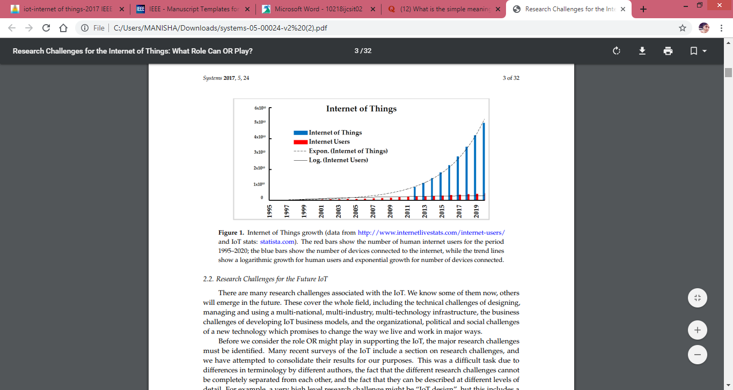
Fig-1: Usage of IoT
The bars in red show the number of human internet users for the period 1995– 2019; the blue bars show the number of devices connected to the internet, while the trend lines show how it has increased by time.
Many challenges are associated with IOT especially in research..Some challenges will also emerge in future while some are already known. The known include Technical, Social, Business and Political changes of a better technology which will positively change the way we vital and work.
3. Proposed Methodology
For any application requirements, communication protocols, identification of objects, security, applications, data, information processing, and the service platforms, standards are required. Yet IoT doesn’t have a standard definition.
The following are few standards available: DDS( Data Distribution Services) which is an IoT standard for real-time, scalable and high-performance machine-to-machine communication. AMQP (Advanced Message Queuing Protocol) is an International standard for message-oriented middleware environments. MQTT (Message Queue Telemetry Transport) is a lightweight protocol that allows sending simple data flows from sensors to applications and middleware.
Standard specifies “HOW TO DO” the activities. It provides guidelines of doing all the work with standards which should be at all the levels, starting from designing, managing and using the IoT.
For IoT to succeed, many international standards development organizations(SDOs) including IEEE, ISO, IETF are analysing the IOT’s Standards. They are main focusing on the technical level such as RFID, Bluetooth, NFC, Address protocols, Network protocols, IPv6, Routing Protocols and HTTP protocols.
4. CHALLENGES TO IoT
When we think about connecting more than 20 billion devices to IoT in the future, there ought to be many challenges coming in the way. Some of the important challenges are discussed in this Session:
- Security Concerns: Attackers always find a way to breach into anyone’s privacy. As all the IoT enabled devices are associated to the internet, it will provide a gateway for malware. Other devices in the network can also be harmed if the IoT devices are weakly secured. It will give entry points to the attackers to harm the devices. It will be easy for attackers to collect the data, analyse and use the data for wrong purposes. So it is very crucial to ensure the safety and sureness of the IoT devices.
- Privacy Issues: The people using IoT devices trust them a lot with the collection of their personal data, without realising the future implications to their data. As the devices are continuously attached to the internet, the private companies and government are taking an opportunity to track and survey people’s private data.
- Standard issues: Ideally all the interconnected IoT devices should be able to exchange the information but actually there is more complexity as it depends on variety of communication protocols. So there is need to apply for same standards in creating market for new technologies. If the same standards are not used by manufacturers, interoperability will be more difficult between the devices.
- Development issues and emerging economy: In the various sections of developing countries, low cost of micro processors and sensors will make IoT devices accessible low income households. But there comes a lot of problems when it comes to High speed internet, basic infrastructure, technology architecture utilization in developing countries. IoT devices would be useless, if basic infrastructure is not in the place. IoT brings new opportunities as well as many layers of complications.
- Business: Any investor definitely needs to invest a huge amount of money in any IoT project, but he certainly wants a full proof plan of action for IoT. There is a lack of inspiration for beginning, putting resources and managing any IoT venture. All kind of consumer markets, ecommerce should be fulfilled by IoT and also with a promise of higher returns.
- Societal: Understanding point of view of customers is not simple. The customer’s requirements tend to change very fast. The market has to be in a rush to meet these changes. The market needs to invent new features and capabilities to satisfy the changing needs. There also needs to be strong and reliable technology to secure the IoT data so that the sensitive data collected by IoT shouldn’t get leaked.
5. Future of IoT
IoT has not grown fully, it is in developing stage. While Developed countries are already availing the benefits , However, we have to overcome the challenges for the better future of IoT. We need to think in a way where IoT becomes reality. Smart Grids, Smart cities, Smart homes, Healthcare, Earthquake detection, Radiation detection/hazardous, gas detection
Smartphone detection, Water flow monitoring, etc are all the IoT examples. But the IoT’s Future should have many more things in it.

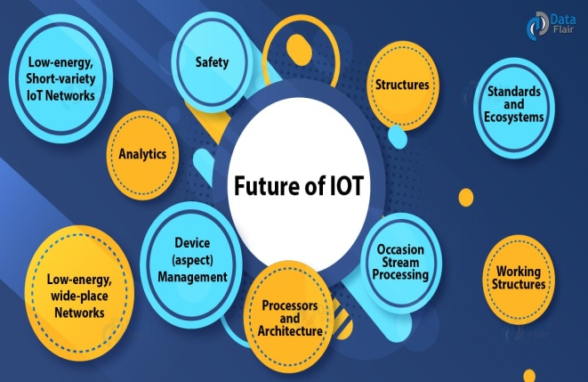
Fig-2: Dimensions of future of IoT
- 21 Billion estimated IoT devices: It is estimated that by 2025 more than 21 billion devices will be connected to the internet. According to the IoT analytics more than 5 billion things were connected to internet in 2016.
- More Cities will become smart: Not only individuals will use IoT but Cities also will become smart by connecting to IoT. They will be totally automated, will collect data, control traffic, remotely manage through sensors, video camera systems and visitors kiosk.
- Artificial intelligence will continue to become a bigger thing: From lightning systems to even coffee makers, every device is collecting data which analyses your daily habits and pattern of usage. That data is used to felicitate the storage in cloud and for further processing. Artificial intelligence helps computers to learn without something having to program them. So the devices can make their own decisions with the help of data collected. The collected data will help machine learn on what your choices are and accordingly adjust.
- Routers will become secure: Mostly all the IoT devices you use are inside your home and connected to the internet. The devices are not made secure by the manufacturers as they will be used inside the home but as Internet is connected to them, the routers are the entry points for the hackers. Today’s routers are not totally secure but in future router will provide more security, such as password protection, firewalls. It will also provide the ability to configure only certain devices in your network.
- 5G network will continue to promote growth of IoT: 5G is already on the launching stage of 2019. It assures to give faster speed and to connect more and more smart devices. Smart devices will gather, analyse and market the data at a higher speed. This will motivate companies to make more IoT devices and satisfy customer requirements for new products.
- Security and Privacy concerns: As more devices will connect to the IoT, there is a more threat of privacy concern. Especially in household because they will not be monitoring all the IoT devices. It will give new targets to attackers to break into the system.
- Personalised marketing platforms: There definitely will be a rise in internet users. Rise will eventually mean more demands and requirements. Everyone would have their unique concept of how they would want to use the IoT technology which will create a big market platform for personalization.
- Safety: The recent IoT has a lot of danger and demanding situations in their programme and working systems. A secure technology is required to defend the IoT models to match with new ultimating situations.
6. Result
Our research believes that to tackle major challenges of IoT, OR (Operations Research) should be applied. OR is a study method of decision making and problem solving which is useful in management organizations. In OR, complex problems are simplified into simple parts and then solved in fixed steps. There are very few case studies which have tried to examine the efficiency of the IoT, because of its complexity and lack of real world data.
The important section of any IoT project is choosing appropriate type of connectivity. The concept of virtual world of Internet Technology connected to the real world get real because of IoT
7. Conclusion
This paper gives a brief review of the IoT, its research challenges, its future use and its wide spread adoption. It also tells about the world wide efforts to develop interoperability standards. The goal of this research is to tackle the coming challenges in the future as well as in the current IoT technology, which mainly addresses technical, business, societal challenges to the IoT. The technologies such as Sensors and RFID would make our lives better and comfortable.
The IoT is improving the way we work and entertain ourselves plus it has become the basis of digital transformation and automation, developing new business offerings. The IoT ecosystem guarantees the accessibility of the services by providing the main objective privacy, confidentiality, ensure the security of the users, infrastructures, data, and devices of the IoT
8. References
- JORDAN SCHUETZ, Developer Advocate, MuleSoft, “The Future of IoT”, Apr 11, 2018.
- Daiwat A. Vyas , Dvijesh Bhatt, Dhaval Jha , “IoT: Trends, Challenges and Future Scope”, Volume 7, Number 1, pp.186-197 Sept 2015 – March 2016.
- Nikhila C, “Operation Research: Definition, Scope and Techniques”,
- Falguni Jindal, Rishabh Jamar , Prathamesh Churi, “FUTURE AND CHALLENGES OF INTERNET OF THINGS”, Vol 10, No 2, April 2018
- Scott Jenson,” The Future IoT: Building Better Legos”, 50(2):68-71 · February 2017
- Regenesys Institute of Management, “Present and Future of the Internet of Things (IoT)”
- Kayla Matthews, “5 big challenges still facing the Internet of Things (IoT)”, Apr 20, 2018
- Peerbits, Contributors' Post, “10 biggest security challenges for IOT”

Trends, Challenges and opportunities in big data analytics
Shruti S. Wani¹ and Mokshita shetty²
Student¹ and Lecturer², Department of Information Technology, Patkar Varde College, Mumbai
Abstract
Now-a-days the data generated and communicated is increasing tremendously. This data emerging in such a huge amount is called as big data. Thus big data is a large, diverse set of information that grows at ever increasing rates. This paper contains the trends, the upcoming opportunities in this field of data analytics. The paper also contains the challenges that arise due to such a huge data being generated. This data can be the data in various forms such as text, audio, video, pictures etc.
Keywords: Big data, Hadoop, spark, Knowledge, cost, challenges, storage, analysis, etc.

I. INTRODUCTION
Big data is the data that emerges from searches; this can be data from social networking sites, bank data, school and organizations’ data etc. Data can be any confidential information or any general information. Now-a-days people search data using google, this data is uploaded by someone and accessed by someone else. The major providers of Big data services are the big companies such as IBM, SAP, Oracle, AWS etc. This big data coming from various sources can help analyse a person’s choice of interest in say shopping, travel areas, social sites’ responses etc.
Now-a-days even researchers use data to make analysis. Shopkeepers use customers’ data to judge the trend in the market. Also this data can be used to find the product that is of most interest to the people. Big Data is most often used in the areas of marketing, sales, IT, Healthcare and finance and many more.Also data analysis is useful in WoT (Web of Things) to analyse the data and use it for further processing.

A. Collecting data [1]
Sensors, smartphones, social media are used for producing and collecting physical world data that can be integrated, communicated and accessed on the web. This data can be represented in numerical, symbolical form.
B. Sending the data [1]
The data gathered is sent across or communicated using various devices such as mobile phones, laptops etc.
C. Combining data
Once the data is coming in; it needs to be integrated so that it can be helpful in forming meaningful data called as the information.
D. Aggregation and abstraction [1]
Creating abstraction form data or pattern of data can provide and aggregated view that can be considered useful. This requires domain specific background knowledge to extract information from web of things. The quality and form of data obtained must be maintained in order to have pure data.
E. Big data market analysis[2]:
Data is useful for market analysis as it provides a view of market trend. Shopkeepers can collect data related to shopping trends in order to increase their sale for a particular product. Also companies conduct surveys where data gathering becomes easier to analyse the market condition. Also these surveys help the companies to bring up their products more efficiently in the market make the highest sale of their product. This is also helpful in bringing up the business. Also now-a-days companies have come up with various models which require only to feed the survey data and the models come out with the best plans to increase the market condition for a product of a specific company.
F. Big data analytics [2]
Big data analytics checks for analysing different pattern within the data to generate conclusions or make decisions based on the data. Big data can help organizations better understand the data and also help identify the data that is important to business and in taking future business decisions.

II. CHALLENGES
Following are some of the challenges that arise in big data analytics:
A. Data Challenges
This is concerned with the characteristics of data. Some of them are as mentioned below:
1)Volume [4]
Deals with size of data say petabytes, exabytes, zettabytes and much more.
2)Variety [4]
Deals with different forms of data say structured and unstructured forms of data such as data in the form of images, videos, audio, text, multimedia, sensor data etc.
3)Veracity [4]
Deals with complex data structures, anonymities, inconsistencies as well as quality of data obtained.
4)Velocity [4]
Deals with the management of inflow of data; meaning that the amount of data coming in at a particular time period.
5)Variability [4]
This is the issue where the stored data when utilized at different instances gives different meaning each time.
6)Visualization [4]
This is the method of representing the data in a format that is easily understood. This can be of the form such as pictorial form, graphical form etc.
7)Value [4]
This is a way of extraction useful data from a large set of data without affecting the rest of the data in any form.
B. Process challenges [2,4]
These are related to how the data is captured, integrated and transformed as well as how the proper analysis model is selected and results are provided. Some of them are as below:
1)Data acquisition and warehousing [4]:
Deals with acquiring data from various sources and storing them in proper places(warehouses) for further use.
2)Data mining and cleansing [4]:
Deals with cleaning and extracting useful data from a huge data generated.
3)Data aggregation and integration [4]:
Deals with integration of data that is extracted from large pools of data which is later on cleaned and combined for actual use.
4)Data analysis and modelling [4]:
This is a stage where analysing the selected data and choosing a perfect model for the representation of data is done.
5)Data interpretation [4]:
Interpretation means representing the data in a form which is understandable. Models for data representation should be selected such that they help in the proper representation of the available data.
C. Management challenges
Concerned with the managing data such as:
1)Privacy [4]
Privacy must be maintained as the data may be confidential. In today’s era of digital world, this is an issue of concern.
2)Security [4]
This is another issue of big data in digital era. Data that is being generated is in massive amount and can be harmed by intruders. Thus securing data is a challenge.
3)Data [4]
Data governance is perceived by organisations to maintain quality of data, improving the information and maintaining its value as an asset of governance.
4)Data and information sharing [4]
Sharing data and information should be balanced as this may help organizations to maintain close connections with their business partners.

5)Cost/operational expenditure [4]
Since the size of data has increased, so has the number of data centres that have spread over a wide geographical range. As a result cost of acquiring, storing, cleaning modelling and interpreting of data is tremendously increasing.
D. Data Storage and Analysis [ 3,5]
- This is a major challenge in big data. As the size of data is increasing, there is a shortage of storage to store data. Previously analysts used Hard Disk Drives as a storage medium but this lowered the input/output process speed as a result of which they came up with SSD(Solid State Drive) and PCM(Phrase Change Memory) to store data. Thus it is necessary to pay attention to the designing a proper storage system that can store large amount of data.
- DAS(Direct-Attached Storage), NAS(Network-Attached Storage), SAN(Storage Area Network) are the storage architectures that are used by the enterprises now-a-days.
E. Discovering knowledge and other issues [3,6]
It contains some sub fields such as authentication, archiving, management, preservation, information retrieval, and representation. Analysing large data set needs more complexities. Also, handling inconsistency and uncertainty in the data set is a major issue.
F. Scalability and Visualization of Data [ 3,6]
- As the size of data is increasing day-by-day, there is change in number of processors being used and also number of cores used by these processors is increasing. This is due to increase in amount of data which needs faster processing speed. Thus processors with multiple cores to speed up the data processing is required.
- Parallel processing is the term used when multiple processors are processing the data simultaneously. Visualization of data helps the analyst to represent the data in a better way .
G. Information Security[3,6]
- Information security is a major issue in today’s world. There are different policies set by different organizations to keep their sensitive information safe. Techniques such as authentication, md5 etc. can be used to maintain the security of data in big data.
- Lack of intrusion system, scalability of network, real time security monitoring etc. are some of the issues in security of big data.
H. Data transmission[5]
This is another problem faced in big data. As the size of data is large, Transmission of such large data becomes difficult. Security issues arise when the transmission of data is done though network. At times transmission of huge data is not possible because of the size limit of transmission.
I. Data curation[5]
This deals with the discovery, retrieval and assurance of quality of data. Currently working with data set with the size of petabytes, teraabytes is possible. Also data warehouses and data marts are used to manage structured data sets. Both these are SQL based database systems. For unstructured data, NoSQL database is used.

III. TRENDS/OPPORTUNITIES [8]
Following are some of the trends of big data analytics:
A. Rapidly Growing IoT Networks
- The trend of IoT is currently increasing. Now-a-days everyone uses smartphones which are used to control home appliances. Google assistance, cortona etc. are used to automate a task. Thus due to increased interest in the field of IoT, more and more of companies have started investing in this technological field.
- As a result many organizations are providing better solutions for IoT. This is leading to the collection of more and more of data, analysing and processing this data.
B. Accessible Artificial Intelligence
- This is another technology associated with big data that is trending currently. This is a technology where robots/machines are made to behave similar to humans. This technology helps in executing the tasks faster. As a result, humans can focus more on critical tasks. This is reducing the workload of humans.
- Organizations also use these AI based machines to speed up their work and make their work much error free and efficient.
C. The Rise of Predictive Analytics
- This is the type of analysis that is mostly used by the organizations to predict the future and take decisions based on the predictions. Also this technology is used by researchers of the organizations to do research in order to increase their market by predicting human behaviour towards certain product.
- This is helping the organizations to predict the trend among their customers.
D. Transferring untransformed data on Cloud
Information that is not transformed into digital form is known as the dark data. This is a huge source of data. These databases are to be digitized and sent to the cloud so that they can be used for prediction in business.
E. Chief Data Officers
Since the amount of data is increasing, Chief data officers are being given more critical jobs in the organizations. It is these officers that are responsible for taking their companies in the right direction. As a result there are many jobs available for data marketers that has helped in the growth of career of many individuals.
F. Quantum Computing
- Since there is much data being generated, it is becoming difficult to analyse and interpret this data currently with these current technologies. If this time of analysis and interpretation is reduced, it will help companies to take better decisions in proper amount of time.
- This is only possible with the use of quantum computing. Companies are currently experimenting on this quantum computing in order to include it in their business in near future.
G. Smarter and Tighter Cybersecurity
Security is a major issue currently. This is due to massive amount of data being generated that is leading to hacking of data. Big data is helping to overcome this problem as it can be integrated into a cybersecurity strategy through security log data where it is used to provide information about past threats [8].
H. Open Source Solutions
There are many such open source softwares that are helping to speed up the data processing. They are also allowing to access the data in real-time. Thus they are currently in demand; also they are cheaper in cost which is a big advantage.
I. Edge Computing
Due to increasing trend in IoT, many companies are using connected devices to gather data about customers. This is helping to reduce the time required to gather, analyse and process the data. This gives a better performance as there is less amount of input and output of data. Also, if amountof data is less, storage cost incurred on companies is reduced, as companies delete unwanted data collected by IoT devices.These methods help reduce the cost .
J. Smarter Chatbots
This is a way where systems interact with the customers in case of queries. No human intervention is required. As a result, the load on the employees in organizations is reduced. Also, chatbots help in processing data by providing relevant answers to the customers. Also, this is an easy method to analyse customer data from the conversations with the customers.

IV. METHODS/TECHNIQUES USED
A. Predictive Analytics [2,4]
Concerned with forecasting and statistical modelling to determine the future possibilities. Discovery, evaluation, Optimization and deployment of predictive models is done by analysing big data sources in order to mitigate risks.
B. Data Acquisition [2]
This is of two types i.e. identifying and collecting the data. Acquisition as the name suggests is acquiring or collecting of data. Identification can be done by two methods:
1.Born digital: This is the type of data that is gathered with the help of digital medium such as computers. This data is traceable. Also this data has ever increasing range
2.Born analogue: This is the data is in pictures, videos and other forms of analogue data. This data has to be converted to digital data using sensors, cameras, digital assistants etc.
C. Prescriptive Analytics [ 2,4]
These analytics is about optimization and randomization testing to see how different business organizations enhance their business keeping their expenses low. This is all about determining the cause-effect relationship between analytic results and business process. These analytics help in determining business analysts in their decision making process.
D. Descriptive Analytics [2,4]
As the name suggests, this analytics method makes use of figures and diagrams to describe the data. The analysts need to have the skill of reading facts from available figures or describe the figure in detail.
E. In-Memory Data Fabric [2]
This is a way where the processing of data is done by distributing the data DRAM, Flash, SSD memories of distributed computers. This leads to faster processing of data and information as well as the load on the servers is reduced as data gets distributed over computers.
F. Text Analytics [2]
A method where data is extracted from textual information. This can be the data coming from news feed, emails, blogs, social sites, messages etc. Large data coming in this way is processed to generate meaningful data and to make decisions out of these data. Natural Language Processing(NLP) is also used to analyse text data
G. Audio Analytics [2]
This technique extracts data from unstructured audio data. Now-a-days this technique is used in health care industry. It is used to judge the health condition of a baby from its cries’. It is also known as speech analytics.
H. Non-Relational Databases[2]
Now-a-days non-relational databases are used to store massive amount of data being generated. One of them is JSON (JavaScript Object Notion). Also, companies have started using these non-relational databases instead of normal databases as they store a huge data in today’s world.
I. Data Virtualization [2]
No technical restrictions may arise while accessing data that is virtualized. Physical data is virtualized i.e. stored on cloud storage and other storage methods. This is done now-a-days to safeguard the data and also to reduce the storage space.
J. Data Integration [2]
This is all about collecting data from various sources and combining them to form a meaningful information. This can be any audio, video, text data. This combined data is then used for further processing.
K. Optimization [5]
Used to solve problems in fields such as physics, engineering etc. Real-time optimization is at times required in big data. Data reduction and parallelization are some of the other methods used for optimization.
L. Statistics [ 5]
This is a way of collecting, organizing and interpreting data. Statistics is basically the numerical representation of data. This can be done through the use of graphs, pie diagrams etc.; where numerical values are used to represent data.
M. Data mining [5]
It is a technique where valuable information is extracted from the available data. Use of different techniques such as clustering, classification, regression etc. is done to mine the available data. Big data mining is more challenging as compared to traditional data mining. Some types of clustering algorithms are CLARA(Clustering LARge Applications),BIRCH(Balanced Iterative Reducing using Cluster Hierarchies) [5].
N. Machine learning[ 5]
A technique where computers learn based on the empirical data provided to them. Computers on their own, make decisions as per the data provided to them. This is a branch of artificial intelligence. Deep Learning/ Deep machine learning is a part of machine learning which is a topic of recent interest. These computer systems that learn using supervised/ unsupervised learning methods, are also used to make neural networks which works similar to a human brain.

O. Visualization approach [ 5]
Visualization is a technique where the data is represented in the form of tables, charts, diagrams, graphs etc. This helps the analysts to understand what the data actually says. Feature extraction is a technique that is used by researchers to reduce the size of data before actual rendering of data.
V. TOOLS
Following are some of the tools that are used for data analysis:
Table-I: Big Data tools based on batch processing.[5]
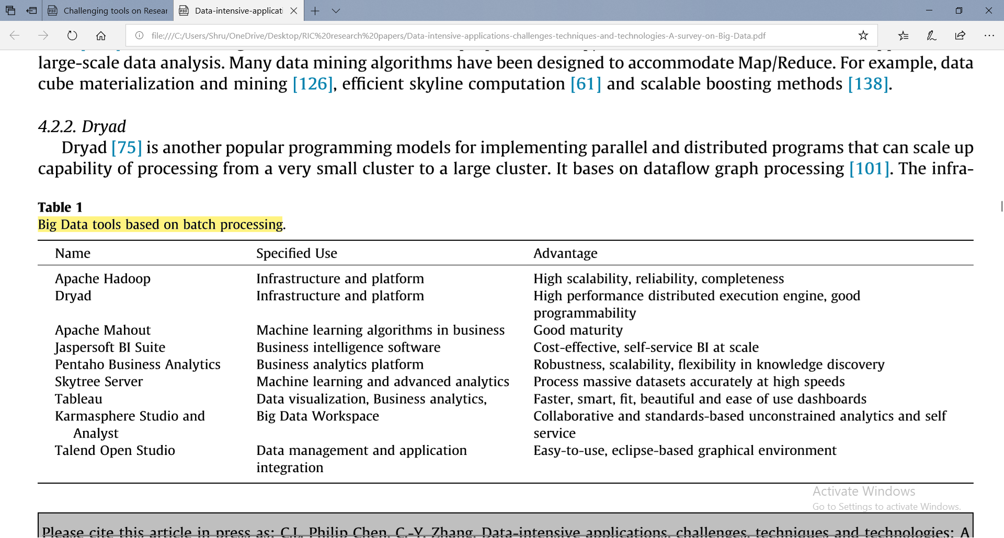
A. Apache Hadoop and map reduce [ 2,3,5,6]:
It is a framework written in java that stores and process Big Data. It uses an algorithm known as map reduce. Map reduce divides the work in smaller parts and processes it in parallel fashion. Hadoop has four core component namely Hadoop common, HDFS(Hadoop Distributed File System), Hadoop Yarn, Hadoop Map Reduce.
B. Dryad [3,5,6]
Users need not know anything about programming which is a big advantage of this tool. This tool runs directed graph. Thus this tool supports generating job graphs, making machines available for processes, failure handling, collection performance metrics etc.
C. Apache mahout [ 3,5,6]
Aim is to provide scalable and commercial machine learning techniques for large scale data. Core algorithms include the techniques such as clustering, Classification, pattern recognition, regression, collaborative filtering etc.
D. Jasper soft BI suite [ 5,6]
Open source software used to produce reports from database. This is used in many companies for their business. It is a fast operating software that does no need to perform ETL process which makes it faster to process. It can work with this fast speed on storage platforms such as Cassandra, CouchDB, MongoDB etc.
E. Panteho business analytics [5]
A software used for business purpose that generates reports from structured and unstructured databases. Helps in decision making in a positive way. It has a good security, scalability and accessibility and is associated with storage platforms such as NoSQL, MongoDB, Cassandra etc.
F. Skytree server [ 5]
First Machine learning and analytical system to accurately process data at a high speed. This server has five use cases such as recommendation system, anomaly/outlier identification, predictive analytics, clustering and market segmentation and similarity search.
G. Tableau [ 2,5]
This software is used to visualize data from the database and represent it in an effective way. This tool is used for business purpose by organizations having huge set of data. It also embeds Hadoop infrastructure. Hive is used to structure queries.
H. Apache drill [ 3,5,6]
It is flexible enough for various query language. Specially designed for exploiting nested data. It uses HDFS(Hadoop Distributed File System)for storing data and Map Reduce for processing this data. Can process petabytes of data and records in a second.
I. Storm [ 2,5,6]
Distributed and fault tolerant system to process limitless streaming data. It is an open source software. Specially designed for real-time streaming of data whereas Hadoop is used for batch processing. Users can run different topologies for different storm tasks. There are two daemons namely Nimbus and supervisor. Another one is zookeeper that records all states of the previous two daemons on the local disk.
J. Apache spark [ 2,6]
It is an open source framework developed at the AMP lab of California, Berkeley. Spark provides interface to program distributed clusters for data parallelism and fault-tolerance. It uses RDD(Resilient Distributed Database).
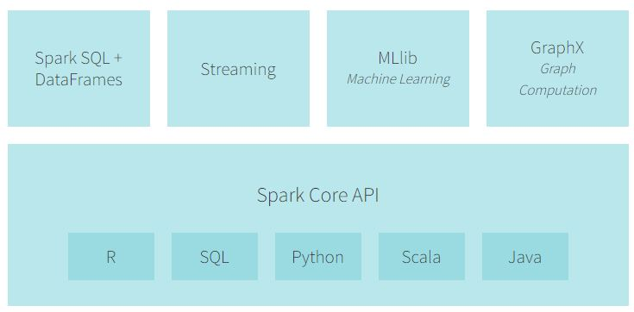
Fig-1: Components of Apache Spark[9]
K. Splunk [5,6]
Combines cloud technologies to help users to search, monitor and analyse their machine-generated data. Splunk differs from other tools as it includes indexing structured, unstructured data, real-time searching, reporting analytical results.
L. Apache Cassandra [2]
Open source, distributed, decentralized storage system that tolerates high volume of structured data across commodity servers. It was first developed by Facebook. It is a NoSQL database. Applications of Cassandra are- Messaging, IoT applications, Product catalogue and retail apps etc.
M. Apache kafka [5]
- It is used for streaming real-time data.It streams data from one system to other using pipelines. The streaming application uses the data that is streamed online.
- It has four core APIs i.e. Producers(publish streams of records), Consumers(subscribes the topics of interest), Streams, Connectors.
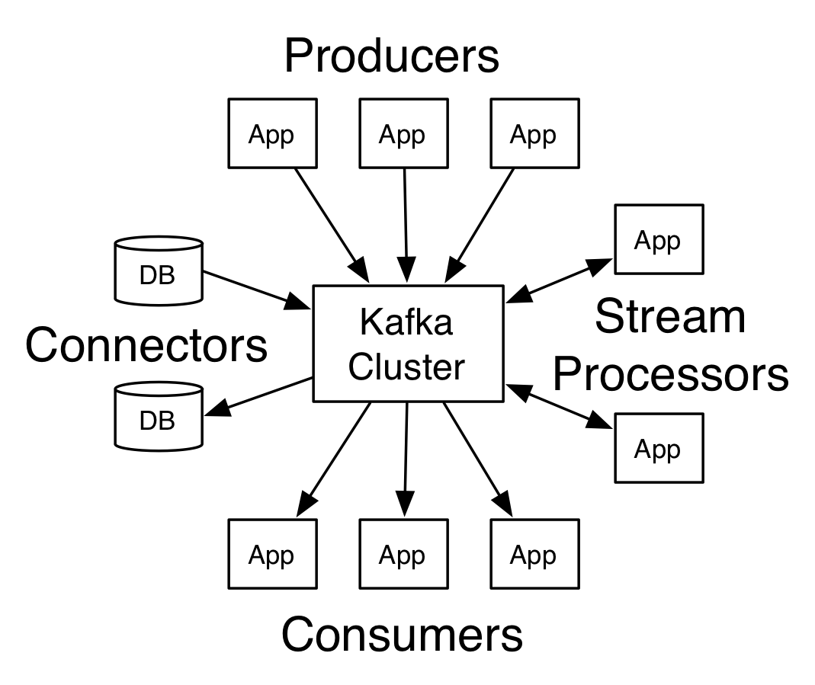
Fig-2: Components of Apache Kafka[10]

VI. CONCLUSION
As the size of data is increasing constantly, so are the complexities with the data. As the technologies will increase in near future, the data that will be generate by its users will increase. This will lead to an increase in the challenges faced with the various processes carried out on the data available. Also security issues are a major concern with the challenges of data. Thus systems need to be made scalable to overcome the issues and challenges that are being faced as well as the ones that may arise in near future.
VII. REFERENCES
- Payam Barnaghi, Amit Sheth and Cory Henson, “From Data to Actionable Knowledge: Big Data Challenges in the Web of Things”, pp 7-9, November/December 2013
- Dr. Venkatesh Naganathan, “Comparative Analysis of Big Data, Big Data Analytics: Challenges and Trends”, International Research Journal of Engineering and Technology (IRJET),Vol. 5, pp 1948-1951, 1953-1955, 1958, May 2018
- Althaf Rahaman.Sk, Sai Rajesh.K, Girija Rani K, “Challenging tools on Research Issues in Big Data Analytics”, vol.6, International Journal of Engineering Development and Research, pp 638-639, 642-643, 2016
- Uthayansankar Sivarajah, Muhammad Mustafa Kamal, Zahir Irani, Vishanth Weerakkody, “Critical Analysis of Big Data Challenges and Anakytical Methods”, pp 269,273-275, 2017
- C.L.Philip Chen, Chun-Yang Zhang, “Data Intensive Applications, Challenges, Techniques, Technologies:A Survey On Big Data”, pp 6-14 January 2014
- Kauser Ahmed P, D.P. Acharjya, “A Survey on Big Data Analytics: Challenges, Open Research Issues and Tools”, Vol.7, No.2, 2016, International Journal of Advanced Computer Science and Applications, pp 511-513
- Xiaolong Jin, Benjamin W. Wah , Xueqi Cheng, Yuanzhuo Wang, “Signiﬁcance and Challenges of Big Data Research”, February 2015, pp 4-5
- Big Data Trends Available at: https://www.kdnuggets.com/2018/09/10-big-data-trends.html
- Components of apache spark-diagram Available at: https://www.kdnuggets.com/2016/03/top-spark-ecosystem-projects.html
- Components of apache kafka-diagram Available at: https://kafka.apache.org/documentation/# gettingStarted

Data Visualization techniques concept and issues
Pratima Keni¹ and Namarata Kawale²
Student¹ and Lecturer², S.S &L.S, Patkar Varde College, Goregaon (West), Mumbai
Abstract
In today’s world Data is a main asset in life. The information is acquired from different sources. There are million or trillions of data where it is difficult to animalising on that. In recent few years there is new technology which comes into the market; this technology is nothing but data visualization technique. This technology is used in different areas like marketing, medical, networking. Due to invention of computer human is get closer to the modern digital era through the Data visualization technique. Data visualization is very important concept user analysed the data according to that it helps to user for taking decision on specific problem. There are many tools freely available in market so that Data is easily analysed. There are so many factors consider while annualized the data size of the data, complexity, scope of the data. Section I tell about what is data visualization, where it is to be used, basic steps for data visualization technique. This all points are covered in that. In Section II Data visualization Basic steps with its explanation. In Section III which techniques are used while performing data visualizing and which one is better for understanding. The purpose of this Research paper what are methods which are used for data visualization. While using DVT (Data Visualization Technique) what are issues may be occurred this is written in Section IV. Section IV is dealing with issues while using any data visualization technique in different areas. Especially issues occurred while working with big data.
Keywords: Data Visualization, techniques, Acquisition, Filtering, Mapping, Rendering, multidimensional, heterogeneous data
I. INTRODUCTION
The information is essential part of human life. Data stored it any format like email, chat, word document, excel format. Because of the different format of the data there is a big challenge how to represent that data.
Visualization in that there is lots of data which is comes from different sources and that data represent in bar graph, tree diagram and more than other format. In that data is textual or numerical format which is converted into meaningful image format, because human brain is very effective catch up large amount of data easily.
II. DATA VISUALIZATION BASIC STEPS
For visualization of the data which is converted into specific model so there are some important steps are listed below [1]:
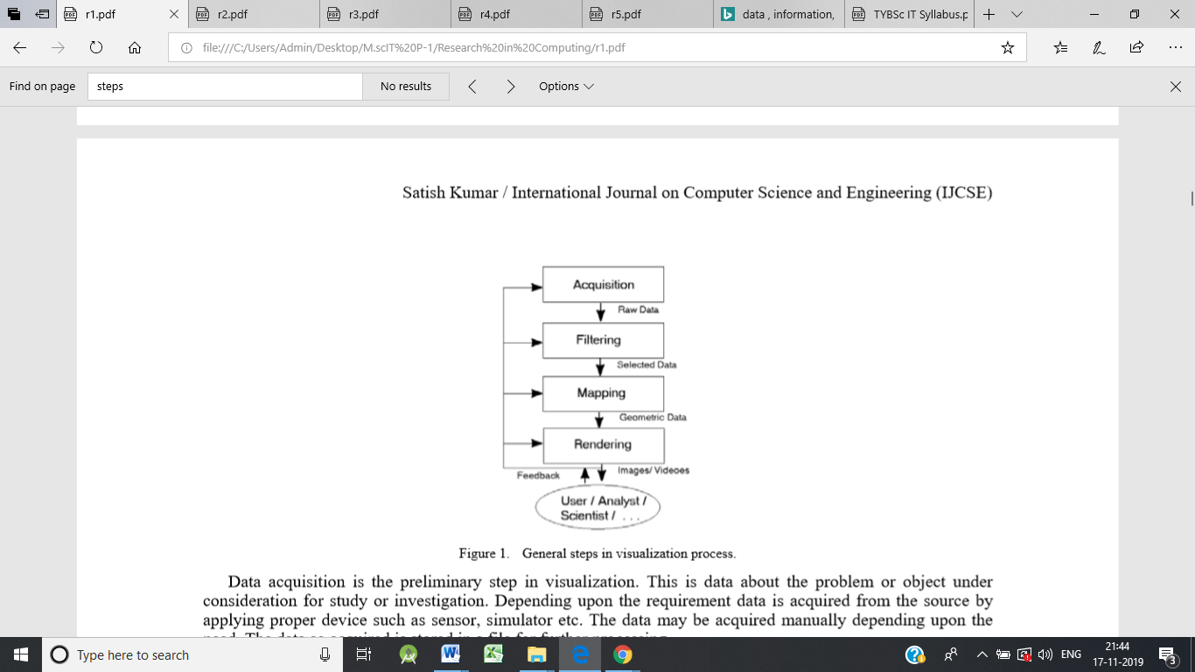
Fig-1: Data Visualization Basic Steps
The explanation of the Figure 1 is given below
- Acquisition
In that we are declare aim or objective of that data. Depending on the requirement data acquired. According to the requirement we are gathering that data from different sources. Gather that data through sensor or simulation. After gathering that data stored that data somewhere place so we can used that data for further process. This is nothing but raw data.
- Filtering
After gathering that data then filters that data. The important data which is useful select first that data and stored it somewhere so we can use it for further process. The commonly used filter technique is clustering.
- Mapping
Mapping process in that data is converted into lines, triangle or polygon, and have an attribute of colour, texture and size.
- Rendering
Rendering in that data is stored in videos or image format. Rendering is complex step. According to the images and videos user gives feedback on that.
III. DATA VISUALIZATION TECHNIQUES
Techniques are used for representation of the data in any format. There are some Techniques are listed below:
- Line graph
In line graph points are determined by variable. If points are changed then variable is also change. It is used for representation of the temperature at specific time period. [6]
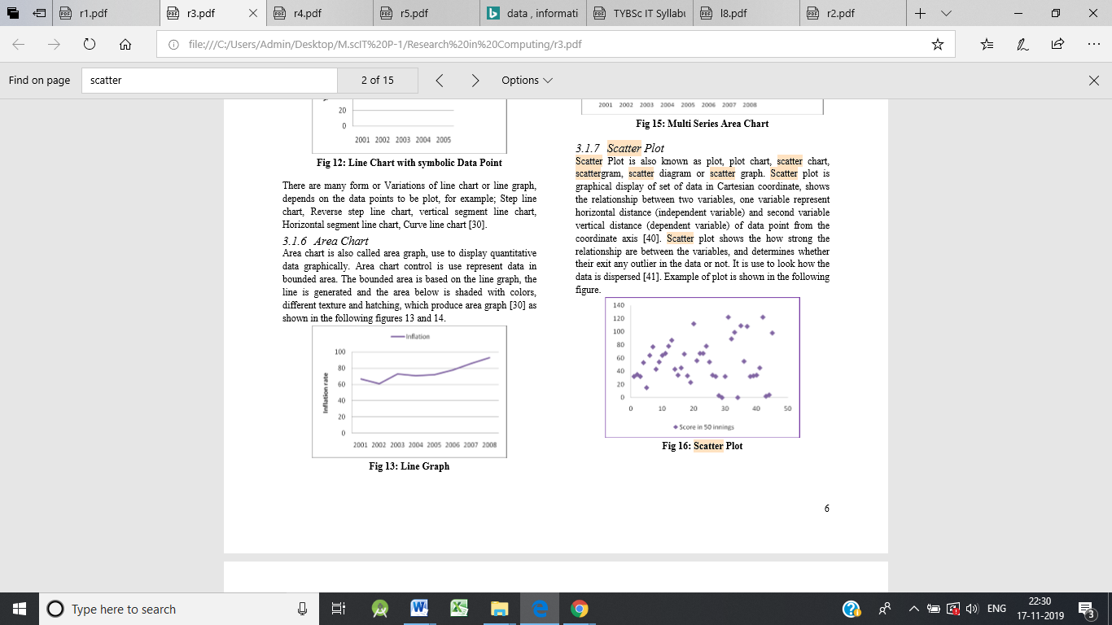
Fig-2: Line Graph
- Scatter plot
It is also called as scatter graph. The points represent relationship between two variables. One variable represent horizontal distance and Second variable represent vertical distance. Scatter plot represent how strong the relationship between scatter plots. [3]
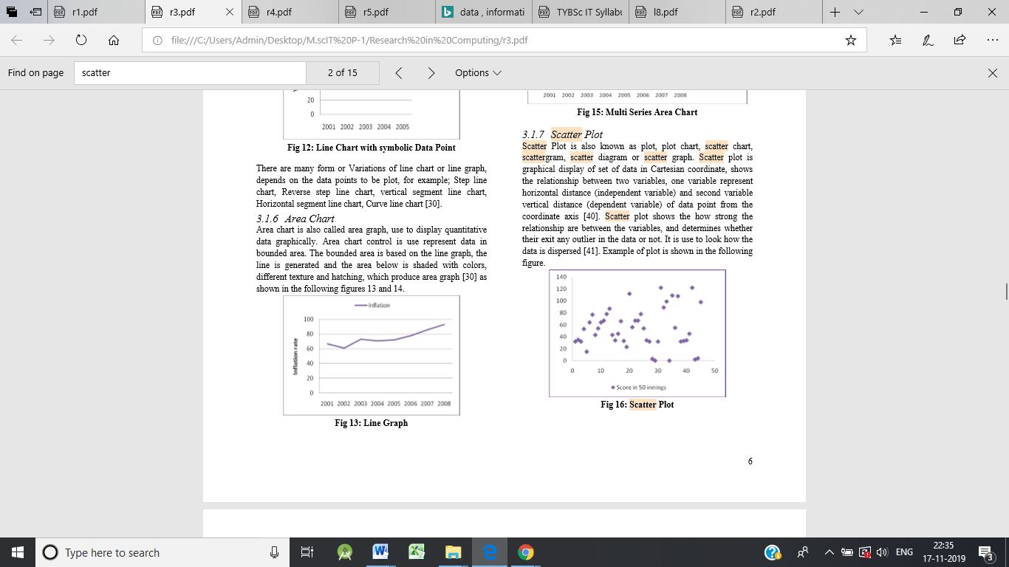
Fig-3: Scatter plot
- Tree Map
Tree map is also known as tree mapping. The data which is represent in the hierarchical format. In that nodes and sub nodes compare with each other and recognize the pattern. Each data or object is represented by the rectangle. Attribute depends on intensity of the colour. [3]
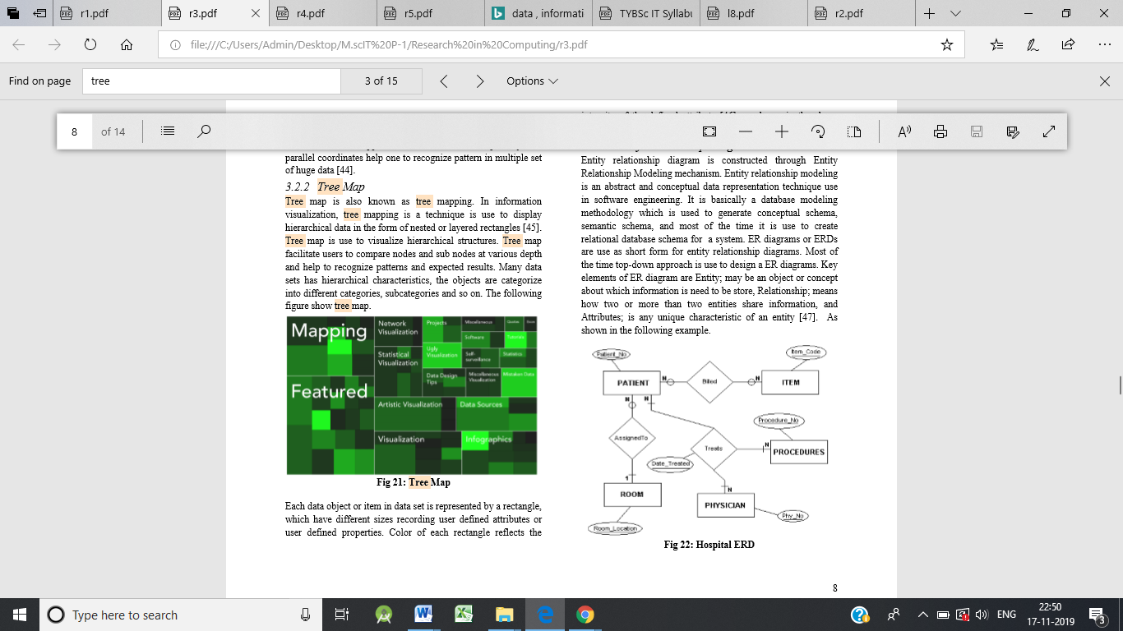
Fig-4: Tree Map
- Parallel Co-ordinates
It is used for plot individual different co-ordinate across many dimensions. Each element are plotted into the vertical line format and then connected with each other. It is used for multiple sets of huge data.
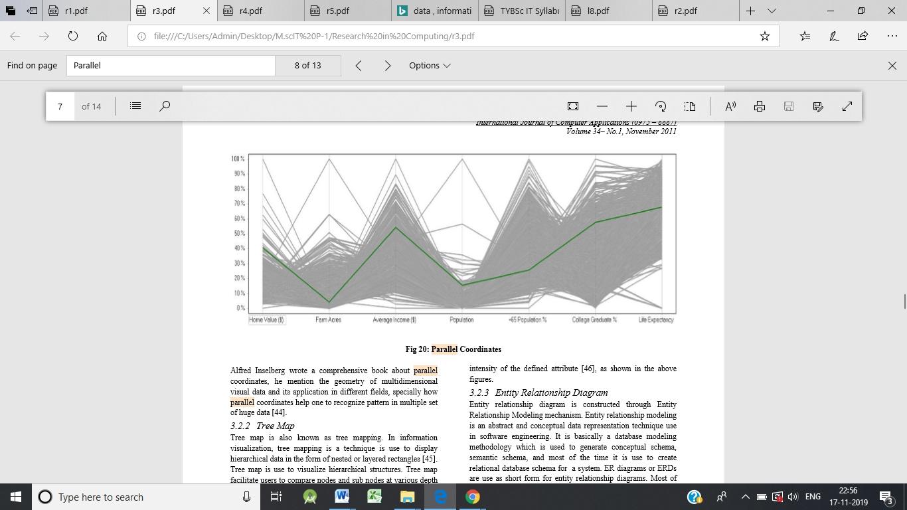
Fig-5: Parallel Co-ordinates
- Scatter Plot Matrices
Scatter plot matrices represented by small dot. So that it is fitted into the single page. It is used for multiple regression analysis.

Fig-6: Scatter Plot Matrices
- Spatial visualization
Spatial visualization actually dealing with local base data such as map, 3D maps, graphs, timelines. It is also dealing with relationship between different events.
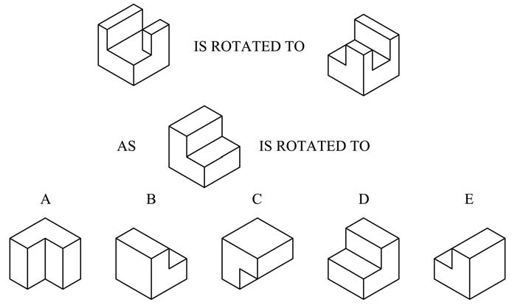
Fig-7: Spatial Visualization
- 2D isosurfaces
In 2D surface, there is certain boundary in that and we have to consider each point as a value. Interpolation is required in that for where the boundary is crossed. We are using contour lines for representing 2D isosurface.
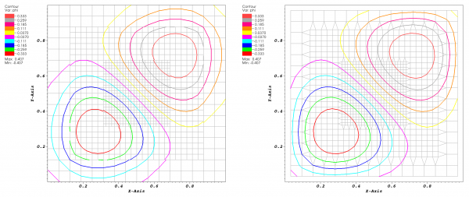
Fig-8: 2D isosurfaces
- 3D isosurfaces
3D surface is a same as 2D isosurface manner. In 2D isosurface it is shown by contour manner but in 3D isosurface it is shown in triangular manner.
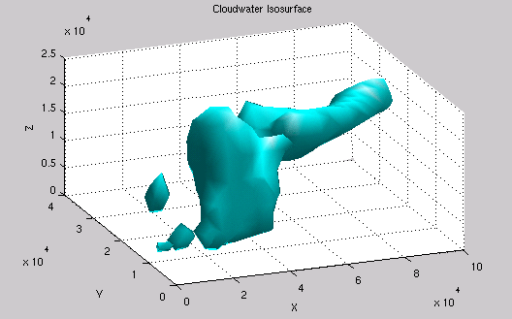
Fig-9: 3D isosurfaces
- Rubber sheet
In Rubber sheet there is 3D surface mapping the values into 2D surface. Points are connected in triangular format.
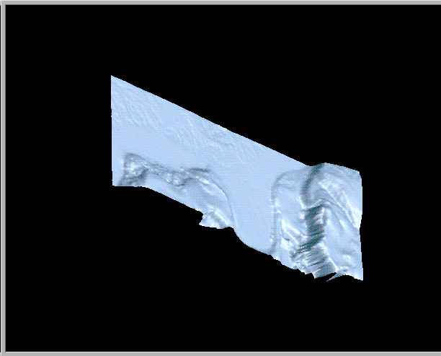
Fig-10: Rubber Sheet
- Volume visualization
A 3D scalar data grid by casting through projection plan into scalar field. There are three volume visualization methods isosurfacing, maximum-intensity projection and direct volume rendering.

Fig-11: Volume Visualization
- Scalar glyphs
Glyphs data visualization in that collection of different objects which is converted into glyphs. Glyphs have attribute size, shape and colour. Glyphs have single value.

Fig-12: Scalar glyphs
IV. DATA VISUALIZATION TECHNIQUES ISSUES
In today’s world visualization is most important technology. In that analyser collecting the data from different sources and give the proper output so that it helps to us make any decision. In market there are many business tools are available so that which gives us report of that data. But, there is some problem may occur while when we are dealing with big data we can take it as a challenge and opportunity also.
Some times when we are working with real world data that time problem may arise. Because there is enormous volume data. Time constraint, speed, size and diversity of the data that attributes need to be considered when study with big data.
One of the most issues occurs while doing visualization is knowledge gap. Most of the researchers are unaware about how to use tools of data visualization. They have lack of knowledge about current technology.
There are some areas where data visualization technique can be issue or challenge:
Area | Uses | Issues or challenges
Visualization in Digital Forensics | In that data which is collected from many sources. They are preserving that data. Analyse it. They are stored that data for investigation purpose. | Investigation on email so that they need one or more computers. Volume of the data is large so that there can be limitation problem occur.
Visualization in Network Security | In that analysing the data from active computers assist with network traffic audit, monitoring and instruction detection | multidimensional data  Lots of data, lots of sources  scalability and time usage visualization
Visualization in Data Mining | Exploring and analysing large amount of data for creating a pattern | multidimensional, heterogeneous data  Scalability, quality of the data  Dynamically data changing
Visualizing Knowledge | After gathering the data analyse that data. Expectation, perception and giving opinion on that data. | making mechanism for creating structure, retrieve and visualize the data  Quality of the data.
Visualization in Risk Management | To identified, analyse and giving priority according to that risk. | We can decrease the level of the risk using Qualitative assessment techniques: quantitative data need to be completed.
Uncertainty Visualization | Working with uncertain data simulations. Mathematical process on that data and visualize it. | Multidimensional, multilevel, multisource data.  Uncertainty in visualization and calculation of the data.
Qualitative Data Visualization | Developed a Qualitative data which is useful. | Qualitative Data visualization gives little bit information so we need to more space for storing that data. Need creative, discipline and structure.
V. CONCLUSION
This research paper work on data visualization techniques concept and issues. Basically data visualization means collecting a data from different sources, analyse that data, structure that data in specific manner according to that take a proper decision. In that first we are dealing with basic steps of that like acquisition, filtering, mapping and Rendering.
Different techniques of data visualization are listed in that paper according to requirement and pattern of that data we can use this techniques. While dealing with big data there can be issues occurred that issues are mentioned in this paper.
VI. REFERNECES
- Jiaying liu , tao tang ,wei wang , bo xu , xiangjie kong , (SENIOR MEMBER, IEEE), AND feng xia , (SENIOR MEMBER, IEEE) “A Survey of Scholarly Data Visualization”
- Zhao Kaidi School of Computing, National University of Singapore” Data visualization”
- Winnie Wing-Yi Chan Department of Computer Science and Engineering Hong Kong University of Science and Technology Clear Water Bay, Kowloon, Hong Kong “A Survey on Multivariate Data Visualization”
- Ismail Demir, Johannes Kehrer and Rudiger Westermann Computer Graphics and Visualization Group, Technische Universitat M ¨ unchen, Germany ” Screen-space Silhouettes for Visualizing Ensembles of 3D Isosurfaces”
- A. S. Syed Fiaz Assistant Professor, Department of Computer Science and Engineering, Dhirajlal Gandhi College of Technology, Salem, Tamil Nadu, India. VIT University, Vellore, Tamil Nadu, India. D. Sumathi Assistant Professor, SITE, VIT University, Vellore, Tamil Nadu, India A.S. Syed Navaz Assistant Professor, Department of Computer Science, Muthayammal College of Arts & Science, Namakkal, Tamil Nadu, India. “Data Visualization: Enhancing Big Data More Adaptable and Valuable”
- Matthew N. O. Sadiku , Adebowale E. Shadare , Sarhan M. Musa and Cajetan M. Akujuobi “data visualization”
- Thomas NOCKE, Till STERZEL, Michael BÖTTINGER and Markus WROBEL “Visualization of Climate and Climate Change Data: An Overview”
- Malu A. C. Gatto “Making Research Useful: Current Challenges and Good Practices in Data Visualisation”
- Viktorija STASYTYTĖ Vilnius Gediminas Technical University “RISK IDENTIFICATION AND VISUALIZATION TECHNIQUES FOR REASONABLE ENTERPRISE RISK MANAGEMENT”
- Kigongo UC Berkeley – School of Information akigongo Vanessa McAfee UC Berkeley – School of Information Vanessa” Visualizing and Exploring Qualitative Research: Interview Transcripts”
- Aileen R. Buckley Department of Geography University of Oregon Mark ,Gahegan Department of Geography The Pennsylvania State University State College, PA 16802, Keith Clarke Geography Department University of California, Santa Barbara Ellison Hall 3611 Santa Barbara, CA 93106-4060 “GEOGRAPHIC VISUALIZATION”
- Satish Kumar Panjab University SSG Regional Centre Hoshiarpur, Punjab(India) “A Review of Recent Trends and Issues in Visualization”
- David H. S. Chung Submitted to Swansea University in fulfilment of the requirements for the Degree of Doctor of Philosophy” High-dimensional Glyph-based Visualization and Interactive Techniques”
- Steven Parker, Michael Parker, Yarden Livnat, Peter-Pike Sloan, Charles Hansen, Peter Shirley ”Interactive Ray Tracing for Volume Visualization”
- Book Author: Usama M. Fayyad, Andreas Wierse, Georges G. Grinstein Book Name: Information visualization in data mining and knowledge discovery

The Impact of Viruses Attacks on personal computer users and its mechanisms
Ankita Suryakant Sutar¹ and Abhijeet Kale²
Student¹ and Head², Department of Information Technology, B. N. Bandodkar College of Science, University of Mumbai, Thane
ABSTRACT
The main important reason to do this research is to survey the impact of viruses attack and provides some suggestions on how single person can protect their personal computer against virus attacks. It is good to know the address the virus attacks and its protective mechanisms among the personal computer users in this global world. The data integrity and information must be maintained. There are thousand and thousand of different viruses these days which improve every day. From these virus performance of computer goes slowly, entire disk will be crashed, programs are modified and more.
Keywords: Personal computer, mechanisms, Virus attacks.
INTRODUCTION
The main thought of research paper is to find out the factors which leads the virus attacks some of users. A virus of computer is a very small code and this code replicates itself to another code and attacks other software by making copies of itself. Today's world has seen a dramatically increases in the use ofPC. Virus attacks on computer are more dangerous that shows up more damage to the computer. To study the actions that a virus performs in one's system and also the activities that are possible to occur over time, which is very important. This helps in protecting our PC secured with security mechanisms to the protective information. The intension of this research paper is to organize to the reader the threats that the computer viruses can create and provide Requirement on how individuals can protect them against viruses.
Computer Virus Attacks
There are different kinds of viruses but they form definite groups. They all operate differently and affect our computers and the information contained on them in different ways.
Email Virus: If the person opens the e-mail attachment, the word macro is activated then spread only with the opening of the attachment the email.
Eg. I LOVE YOU.
File Virus: This virus also known as FTP virus.
Eg. Sunday and Cascade.
Boot Virus: this virus is known as boot sector virus. Destroy programs and data.
Eg. Disk Killer, Stone virus.
Macro Virus is computer virus occur mostly in Microsoft world and damages a sequence of actions this virus  Written in micro languages for programs.
LITERATURE REVIEW
When a virus code replicate itself to other programs then virus infection occurs. a proper host program and copying its code to the host program such that the infected programme find out another program to infect further(n.d.).etc
The 'computer virus' was firstly named by Fred Cohen in 1983. viruses never occur naturally. They are always occured by people.
Definition of virus is that a computer program code that extends by copying itself. Computer virus attacks have become very critical issue and can fastly spreads using the Internet, causing even more damages, which is not good. Mostly viruses are very active in memory until we turn off our system in general. But when we off the pc we just temporarily remove the virus from memory, but not permanently .
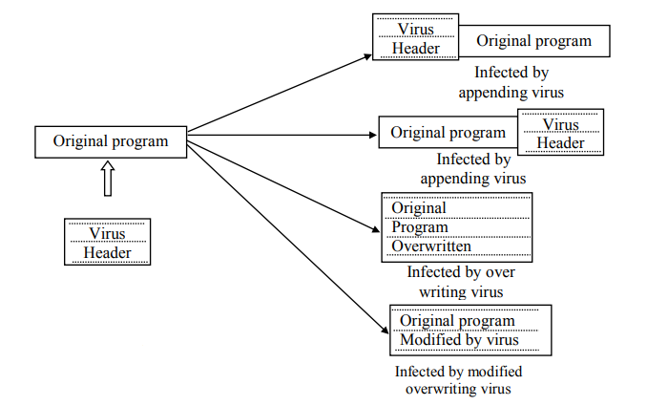
Computer viruses have become an worldwide issue and can travel fastly through the Internet and causing even more dangerous.
Today every single person who uses computers need to have a complete virus protection scheme to face the growing threat of these old and new viruses.
Objectives of this research are
•Analysing the reasons which cause virus attacks among the personal computer users.
•Recommend the possible softwares and mechanisms to protect their computer resources from virus attacks.
Results
The No of the peoples replied that viruses have high affect on personal computer usage. From the collected data 68 peoples revealed that their PC infected by virus attack more than 5 times within in just last three months.
File infection has been recognized as a critical problem by the PC users and it affected the PC harshly.
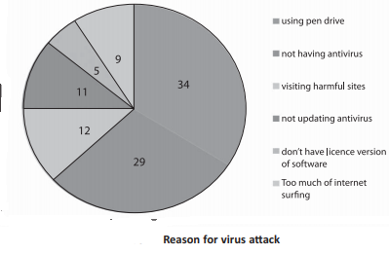.
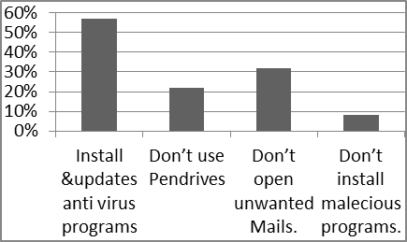
Mechanisms for virus attacks
Following are the some ways for personal computer users to protect their own computer system.
Keep your the system updated and anti-virus software installed on your system and update it regularly.
This mechanism protect our system by checking for viruses each time when computer accesses an executable file. Install any software firewall and keep it enable specially when the computer is connected with the internet.
CONCLUSION AND FUTURE SCOPE
All peoples replied that virus attack has high effect on their personal computer usage. This research release number of lucrative mechanisms which would help to the personal computer users to protect their computers from the virus attacks. The modest recommendation for this research is the virus prevention and detection mechanisms. It is the simple and least expensive ways for the virus attack by practicing such as keep the antivirus program up to date for the latest threats, patching OS loophole, application software loophole and browser loophole frequently, avoid unsafe internet surfing such as visiting doubtful websites, surfing on the cracked websites and downloading from unsafe websites. By following these safety measures the personal computer users can save important resources and their computer system. When any type of virus is found, it should be displyed immediately to take appropriate action.
The PC users revealed the symptoms they felt when their PC infected like the system slows down in performance (48%) places the first place, failure in application functionality and unnecessary messages & error messages (20%) lays second place and system continuously restarted (12%) placed in third place. From this research the peoples revealed the reasons for PC’s virus infections are just because of o using pen drives(43%), not having antivirus(29%). Further this research highlighted installing and updating antivirus (57%), not using pen drive / using USB devices (22), do not open unwanted mails / unsecured sites (13%) and do not install malicious programs (8%) are the best preventive mechanisms to reduce the virus attacks.
Appendix
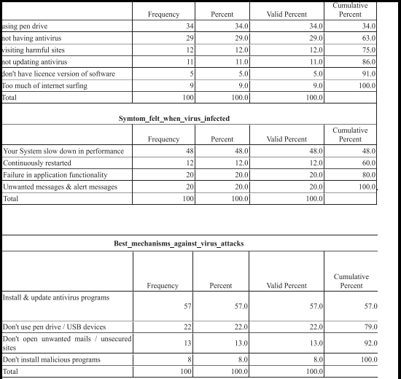
References
- An Overview of Computer Viruses in a Research Environment Matt Bishop Department of Mathematics and Computer Science Dartmouth College Hanover, NH 03755.
- The Working and Problems of Computer Virus in Enterprise Areas Bhaskar V. Patil1 .
- Yusuf, M.S. et al, International Journal of Computer Science and Mobile Computing, Vol.6 Issue.2

The Art of Computer Virus Research and Defense (Symantec Press) Paperback – 3 Feb 2005 by peter szor
- Prabhat K. Singh, Arun Lakhotia. “Analysis and Detection of Computer Viruses and Worms: An Annotated Bibliography“. Center for Advanced Computer Studies University of Louisiana,
- Awosusi, A.I., and Oriye, O. (2015).Functional basis of Anyigba, Nigeria as a fastgrowing university town. Mediterranean Journal of Social Sciences,
- A study of Past, Present Computer Virus & Performance of Selected Security Tools Mr. Bhaskar V. Patil, Bharati Vidyapeeth University
- Analysis and Detection of Computer Viruses and Worms' An Annotated Bibliography Prabhat K. Singh, Arun Lakhotia Center for Advanced Computer Studies University of Louisiana, Lafayette, LA 70504

Virtual Farm Monitoring And Security Techniques
Chinmai Shivaji Dandekar¹ and Dr. Rajendra B. Patil²
Student¹ and Head², Department of Information Technology, S. K. Somaiya College of Arts, Science and Commerce, University of Mumbai, Mumbai
ABSTRACT
Several techniques are being introduced regarding the faming and the agriculture. As a result there is a need for advancement and updating the methods in agriculture. By Implementing such techniques we can reduce the rate of crop loss and increase the rate of profit to the farmers. Which will enhance and improve crop productivity and quality. It is mandatory to determine and compare the environmental conditions as well as the crop production condition in the selected field of farm. Monitoring and Security can be achieved using different sensors and electronic components. Virtual farming will help farmers to stay connected to farm from any were.
Keywords: Agriculture, Security, spider cam, Virtual Monitoring.
INTRODUCTION
Farmers are our main resource of agriculture. In our country traditional way of farming is utilized. We can prevent this by modern farming techniques and by inventing new. Agriculture is important for our countries economy as India is known as the agricultural country worldwide. By using monitoring and security techniques we can automate and change the view of farming. Using this techniques by embedding with sensors, actuators, software’s and internet based electronic components. Better irrigation techniques can enhance the productivity and quality of crop production. We can change the way of farming by deploying automation techniques. When this techniques were first introduced they only contain static pages. The content describes the efficiency of the system used for monitoring and security of the farms. What if we combine different techniques regarding farm monitoring and security. The research paper defines the efficiency in farming. This research states the steps and techniques we can adapt to overcome the problem with maximum number of positive outcome. Introducing new technique for monitoring fields using modern components will be discussed in this research ahead.
LITERATURE SURVEY
This research paper was developed with help of different research papers and some innovative ideas. The research string includes different types of strings like “Comparison between different Monitoring and Security Systems” and “Performance of the systems”. Research papers regarding this topic are very few. While many of them are about the evolution of systems and adapting new techniques. The research papers the literature survey yielded are the following:
1. The system for dry soil detection is used to detect the moisture and water contingency of the soil and maintain the water need for the crops from as per required. The sensors detects and passes the output to the system so as to perform actions accordingly.
2. The system used for security is the fungal detection system using thermal imaging. This system provides us the defected crop image accordingly and gives alert to the system. By which the farmer can perform action accordingly to avoid great loss.
3. The system used for security from Birds by using motion sensors for detecting the motion of the passing by object and avoiding them by switching the sprinklers.
4. Thermal imaging can provide similar reading as thermometer. For temperature in close range, thermal imaging leads to in accurate results and informative data differentiable.
Comparing these system of Virtual farming and security to get a better results is essential for future farming methodologies to overcome farming techniques.
RELATED WORK
The comparison of the systems are done by the percentage of accuracy of solving the problems accordingly and percentage of results. This is shown by the graphical format of readings given by the system and readings given by making changes in the system. The changes are made by combining two different methodologies or adapting new updates to enhance the performance of the system.
The components in the system may vary accordingly for more stable and quick outcome of the data using updated technologies. The graphical representation of performance of components is also compared. This will make easy selection of system to propose accordingly.
HARDWARE COMPONENTS
NodeMCU VS Arduino
1. Expense- Slight cost difference in both Components.
2. Flash - 32KB for Arduino , 4MB for NodeMCU.
3. SRAM - 2KB for Arduino, upto 50KB for NodeMCU.
4. Clock Speed -16MHz(ATMEGA328 can handle up to 20MHz) for Arduino, 24–52MHZ(CPU can handle 80MHz) for NodeMCU.
5. GPIO pins - 14(6 PWM) for Arduino, 17(All PWM) for NodeMCU
6. ADC - 6 for Arduino , 1 for NodeMCU
7. Operating Voltage - 5V for Arduino(board is powered from jack then 7–12V) , 3.3V for NodeMCU
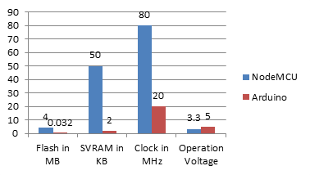
Graph-1.1: NodeMCU VS Arduino
Cameras for thermal imaging
Thermal imaging cameras draw images by detecting the heat in the object. This camera can also be used to detect the fungal on the plant by comparing the thermal images captured at the point previously and after infection of the plant.
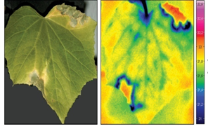
Figure-1.2: Plant Thermal Image
A the image justifies the heat of the plant comes from the infected area as red and the green and blue color defines the healthy tissues of the leafs. By using this technique we can secure the crops by applying right fertilizers at right time.
The model of camera used with this components is OV7670 640×480 VGA CMOS Camera Image Sensor Module. The image of the component is given below.

Figure-2.2: OV7670 640×480 VGA CMOS Camera Image Sensor Module
Structuring the Cameras
By analyzing the problem of whole field we cannot set up cameras for each crop to monitor regarding the crop damage and security. This problem can be resolved by adapting moving cameras using gear system and wheels that will move as per directed in the system. Placing the camera in such way will help the system to monitor the whole field and get accurate data. Viewing the camera from the top location will lead to better image capturing. This technique of using the cameras is also known as spider cams. The below images illustrates the use of spider cams. This technique will be a great asset for monitoring crops virtually and acquiring accurate results of the crop condition. The distance of the camera from crop must be less than 1 meter to get more accurate results. Spider cams can be organized so as to follow a pattern as given in the system so to capture and monitor entire field area.
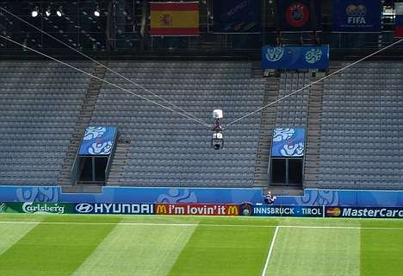
Figure-3.1: Spider cams
Motion Sensors
Motion Sensors can be used for detecting the activities of animals and birds near to the farm area. Placing the motion sensors on the spider cams can provide better results. The sensor module is shown in the figure below.
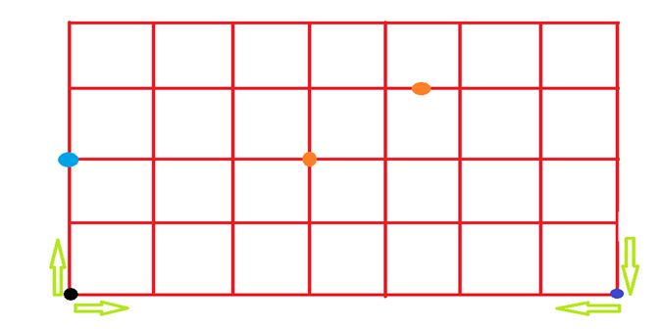
Figure-3.1: Pattern of moment of the camera

Figure-4.1: Motion Sensors
MOMENT OF CAMERA BY GRAPHICAL PATTERN FOLLOWING TECHNIQUE
Moment of the camera is essential for monitoring the entire field. There should be a fixed pattern to be followed by the rotating machine pre install and also there should be a system for custom graph pattern design. So the service man can analyze the field size and shape to design pattern accordingly. For illustrating the graphical pattern of the system is given below in graph plotting system. This can be customized per meter of half a meter.
PATTERN EXPLANATION
This is can be the default pattern than can be pre implemented in the system.
1. The black dot represents the initial position of the spider cam. From this position the camera will follow Up-Right-Down sequence for the line to be monitored as shown in the graph the distance inputs if each block should be filled in the system.
2. After reaching the Dark Blue dot the Camera will fallow Left-Up-Left-Down sequence so the camera can travel the whole field and get better results.
3. Light blue dot represents the spider camera.
4. The orange dots represents the defected area located by the camera. Which will provide coordinates to the system, by which the farmer can easily rectify the area of problem occurred.
SYSTEM COMPARISON
In this research the comparison phase which are to be discussed. Here we compare the existing system with the updated systems. The brief of comparison is as follows:
COMPARING THE SYSTEMS WITH UPDATED SYSTEM
Now the system used are compared with the updated pattern system which is explained above. As analysis both the techniques are dependent on each other. Hence the updated system has both system techniques gives more security and accurate results as compared to the distinct systems. The comparison is done on the basis of percentage of accuracy, performance and reliability for computing the results. The comparison is essential to show the difference of product usage and one can easily rectify the better technique to be used for Virtual farming and security needs. The table below shows the percentage of Features of Distinct and Updated system.
Features | Virtual monitoring and Security Distinct | Virtual monitoring and Security Updated
Performance | 84 | 98
Accuracy in results | 89 | 95
Reliability | 79 | 89
Table-4.1: Comparing The Systems With Updated System
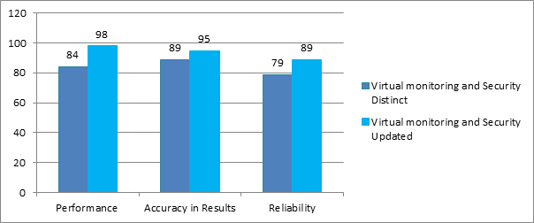
Graph-4.2: Comparing The Systems With Updated System
CONCLUSION
Based on the research work it could be concluded that the updated pattern techniques used is more effective and performs better as compared to the distinct system. As the combination of two techniques will make the system expensive but cost can be handled by using alloys of plastic with metal which makes the products more durable. By using such practice can predict the crop infection and apply remedies to take actions accordingly. Using this techniques farmers can easily monitor farm and produce good quality of goods as the crops have been taken good care. This will reduce human effort and cost of farming to a certain extent.
REFRENCES
1. Design and Implementation of Farm Monitoring and Security System in International Journal of Computer Applications 181(9):10-15 • August 2018
2. IoT Based Intelligent Agriculture Field Monitoring System. January 2018
3. Farm security solution modeling: Information and communication technology (ITC) Perspective. 11 October 2015.
4. Isaac BO : Information and communication technologies as driver of growth experience from selected small scale business in rural southwest.
5. Abhinav, V. D. Design and Implementation of an Intelligent Security System for Farm Protection from Wild Animals. International Journal of Science and Research.
6. Willig, A. and Karl, H. Protocols and the Architectures for Wireless Sensor Networks. John Wiley and Sons Ltd. 2005
7. Maheswari R. Development of Embedded Based System to Monitor Elephant Intrusion in Forest Border Areas Using Internet Of Things. International Journal of Engineering Research.

